1. ***ARRAY***

5 . Keep all negative elements in right and all other in left

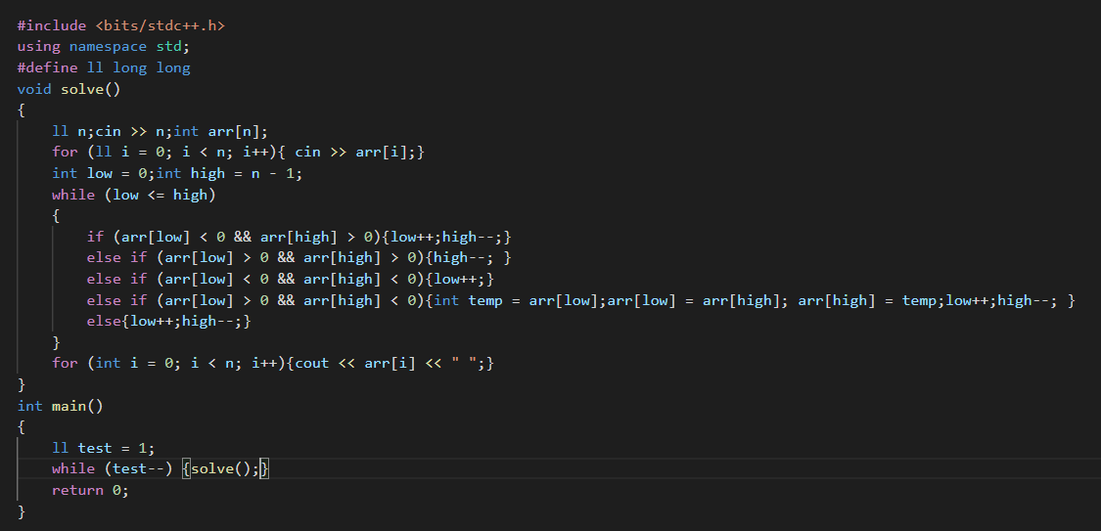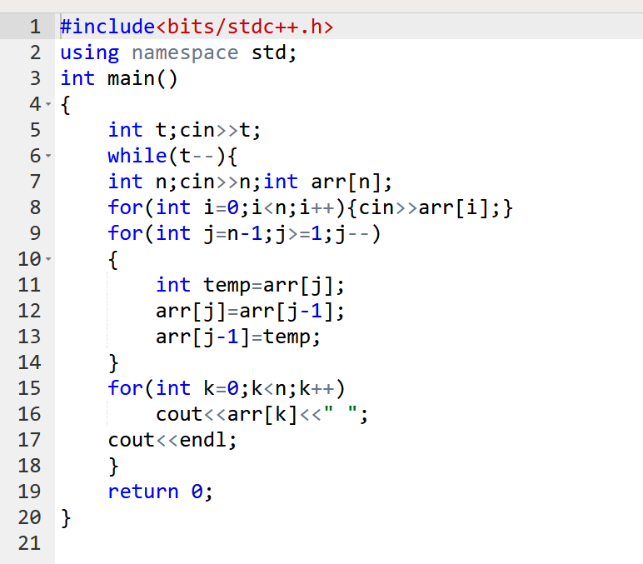

1. Rotate the array by one element

Arr = =1 2 3 4 5

Arr== 5 1 2 3 4

13 . Kadane algorithm

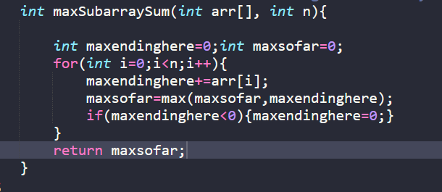

3 Kth smallest element using lomburt partition method

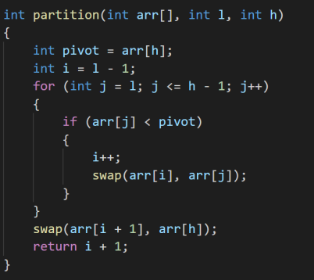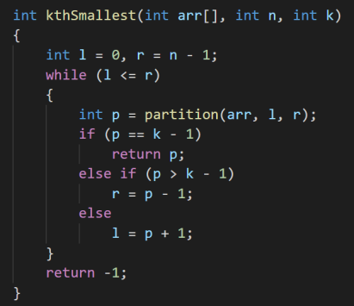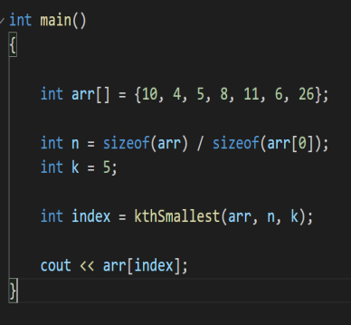

1. Minimizing the height difference

int getMinDiff(int arr[], int n, int k)

{

    vector<pair<int, int>> v;

    vector<int> vis(n);

    for (int i = 0; i < n; i++)

    {

        if ((arr[i] - k) >= 0)

        {

            v.push_back({arr[i] - k, i});

        }

        v.push_back({arr[i] + k, i});

    }

    sort(v.begin(), v.end());

    int left = 0;

    int right = 0;

    int ele = 0;

    while (ele < n && right < v.size())

    {

        if (vis[v[right].second] == 0)

        {

            ele++;

        }

        vis[v[right].second]++;

        right++;

    }

    int ans = v[right - 1].first - v[left].first;

    while (right < v.size())

    {

        if (vis[v[left].second] == 1)

        {

            ele--;

        }

        vis[v[left].second]--;

        left++;

        while (ele < n && right < v.size())

        {

            if (vis[v[right].second] == 0)

            {

                ele++;

            }

            vis[v[right].second]++;

            right++;

        }

        if(ele==n){

            ans=min(ans,v[right-1].first-v[left].first);

        }else{

            break;

        }

    }

}

Pair vector is made storing the value of elements having arr[I]+k, arr[I]-k. then we sort the vector and hence we apply sliding window.in window take all that elements in which all index part come, and then keep sliding the element.

Ques no 11) Find the duplicate element using hare and tortoise approach

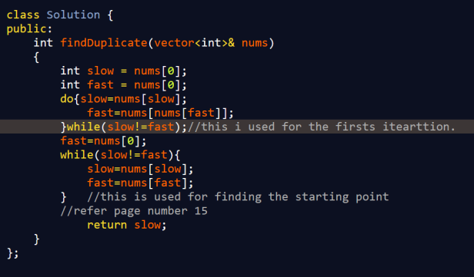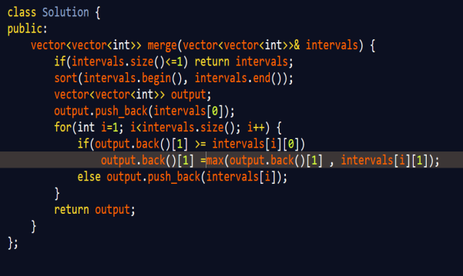

Ques 14) Merge intervals from leetcode, (hint---just compare back element of our output with current first element)

Ques 15) Next greater permeutation

Ques 16) Count inversions

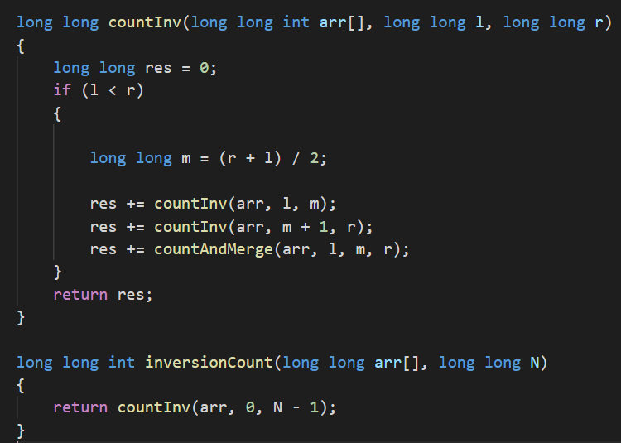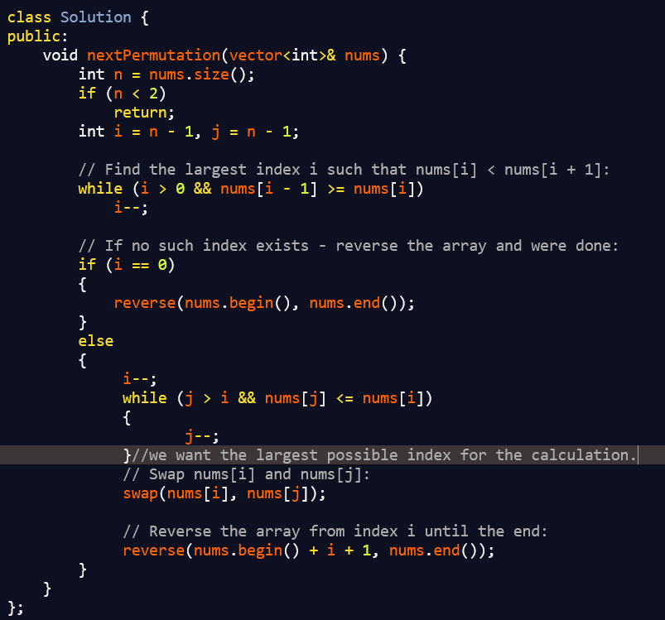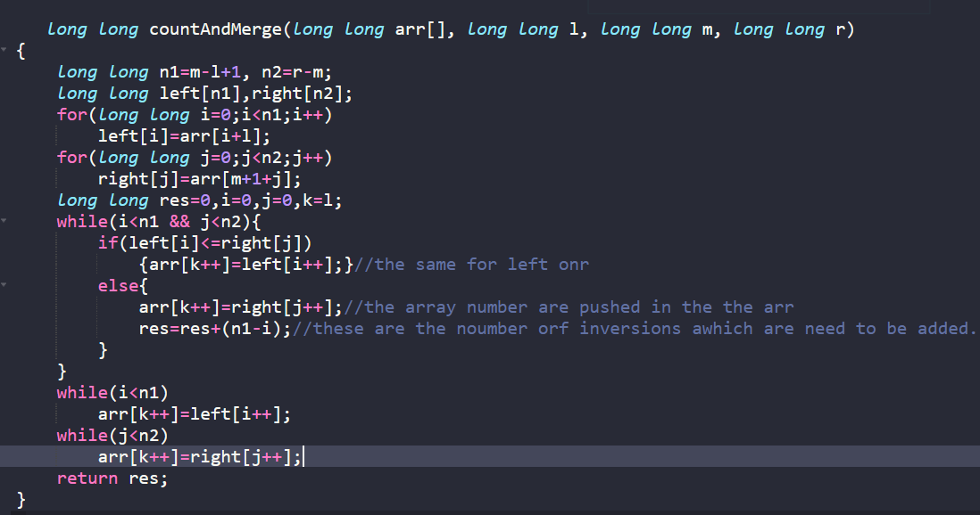

Her we have used merge sort, and with the use of recusion the count is being calcualted.

Ques 17)Best time to buy and sell the stock

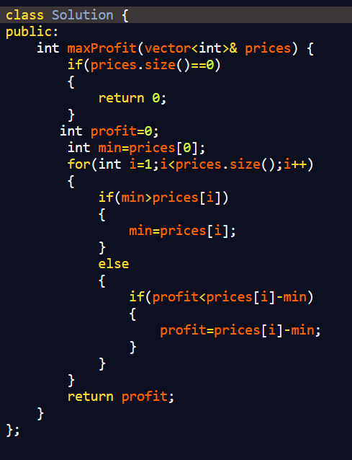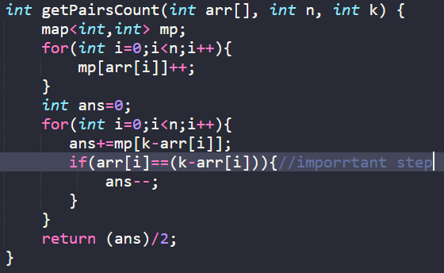

Ques 18) find pairs whose sum are equal

Ques 19) Common elements present in three sorted arrays

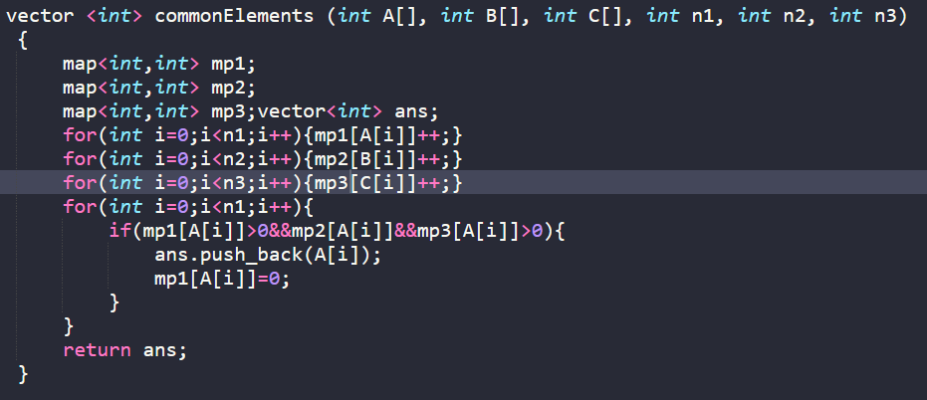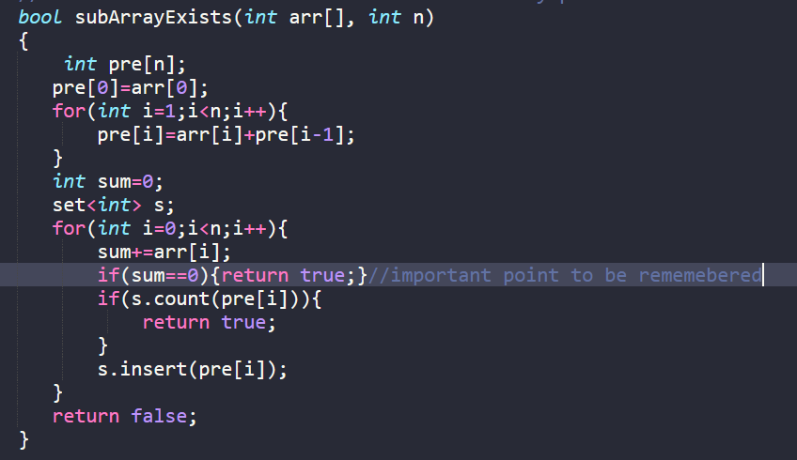

Ques 21) Subarray with zero sum

Ques 22) Factorial of large number

// C++ program to compute factorial of big numbers

#include <iostream>

using namespace std;

// Maximum number of digits in output

#define MAX 500

int multiply(int x, int res[], int res_size);

// This function finds factorial of large numbers

// and prints them

void factorial(int n)

{

    int res[MAX];

    // Initialize result

    res[0] = 1;

    int res_size = 1;

    // Apply simple factorial formula n! = 1 * 2 * 3 * 4...*n

    for (int x = 2; x <= n; x++)

        res_size = multiply(x, res, res_size);

    cout << "Factorial of given number is \n";

    for (int i = res_size - 1; i >= 0; i--)

        cout << res[i];

}

// This function multiplies x with the number

// represented by res[].

// res_size is size of res[] or number of digits in the

// number represented by res[]. This function uses simple

// school mathematics for multiplication.

// This function may value of res_size and returns the

// new value of res_size

int multiply(int x, int res[], int res_size)

{

    int carry = 0; // Initialize carry

    // One by one multiply n with individual digits of res[]

    for (int i = 0; i < res_size; i++)

    {

        int prod = res[i] * x + carry;

        // Store last digit of 'prod' in res[]

        res[i] = prod % 10;

        // Put rest in carry

        carry = prod / 10;

    }

    // Put carry in res and increase result size

    while (carry)

    { res[res_size] = carry % 10;carry = carry / 10;res_size++; }

    return res_size;}

// Driver program

int main()

{

    factorial(100);

    return 0;

}

Ques 23) Maximum product of subarray Ques 28)   
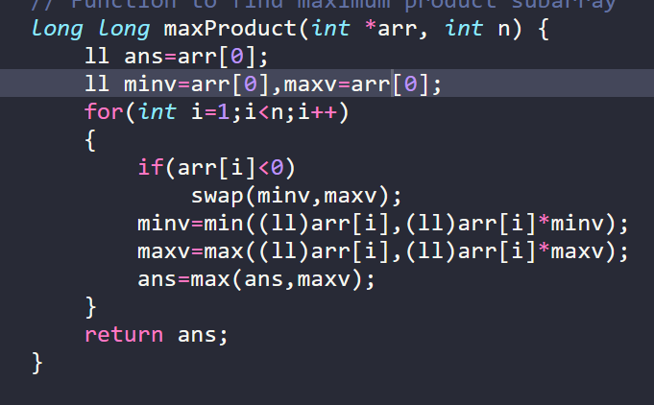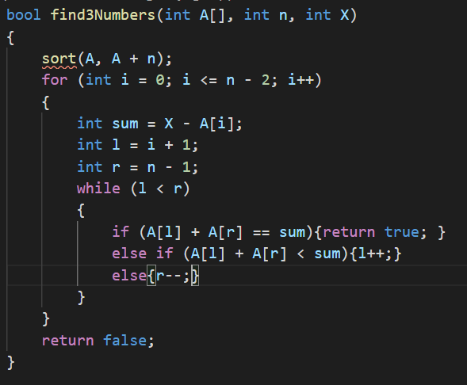

Ques 26) Count elements having occurrences greater than n/k.

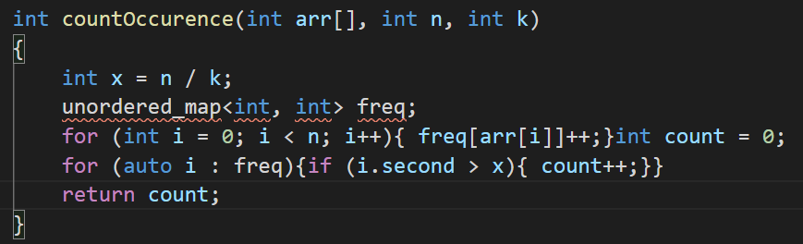

Fibonacci different approaches

1. O(n),O(n) 2. O(2^n),O(1) 3. O(n),O(1) 4. O(logn),O(1)

Ques 29) Trapping rain water problem

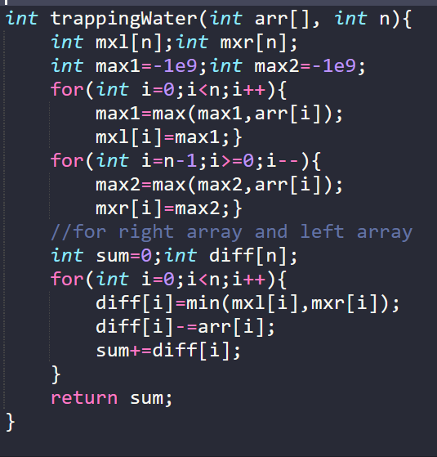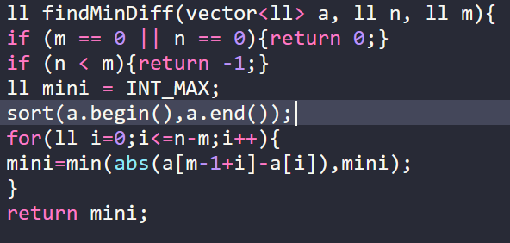

Ques 30) Chocolate distribution problem

Ques 31) smallest subarray just greater than a given value of x

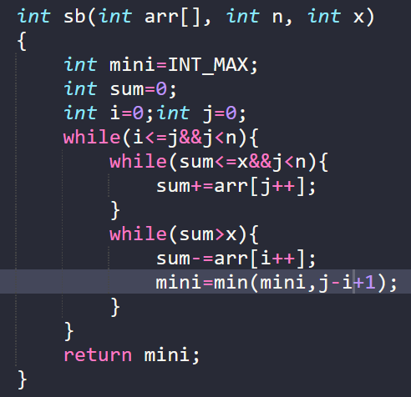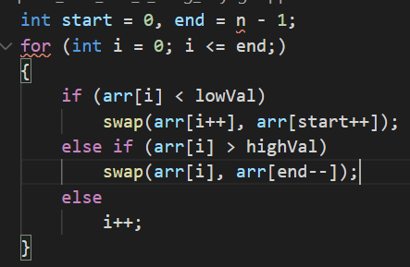

Ques 32) Three way partitioning of a array

Ques 33)Minimum number of swaps required to put all same elements all together

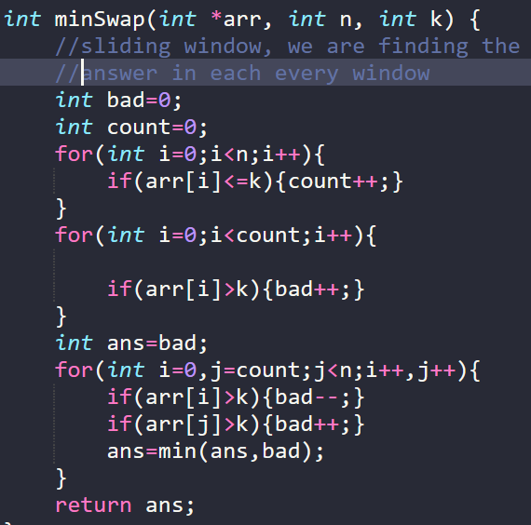

Ques 36)Fine the median of two sorted arrays of unequal sizes

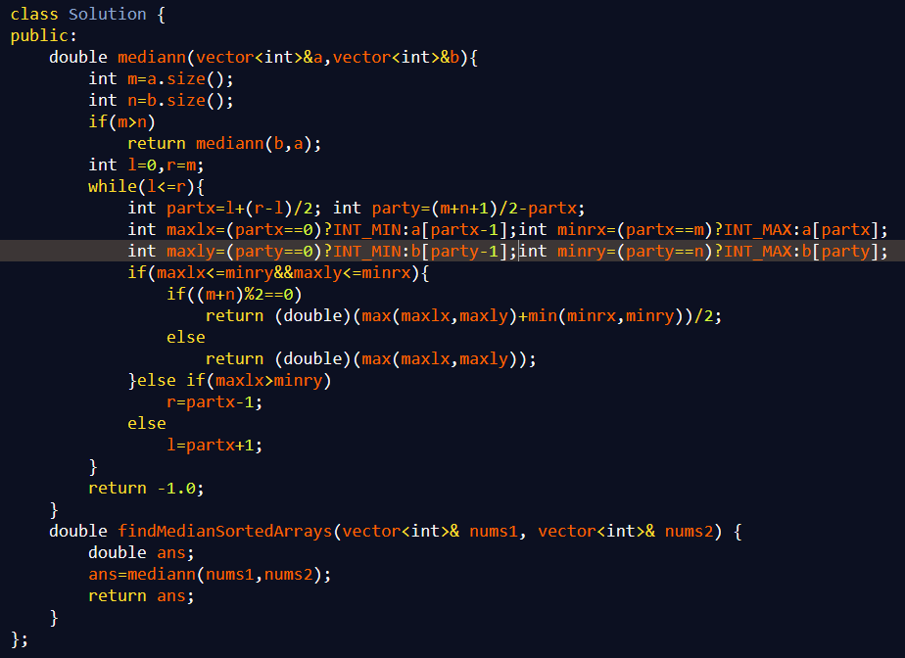

Ques matrix 2) Search an elemnts in a given spiral

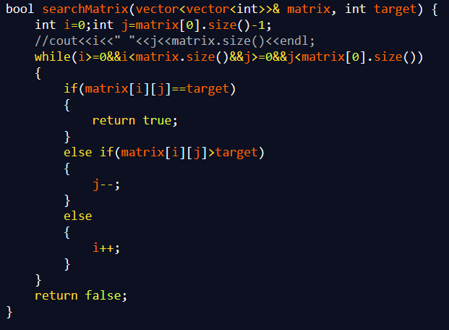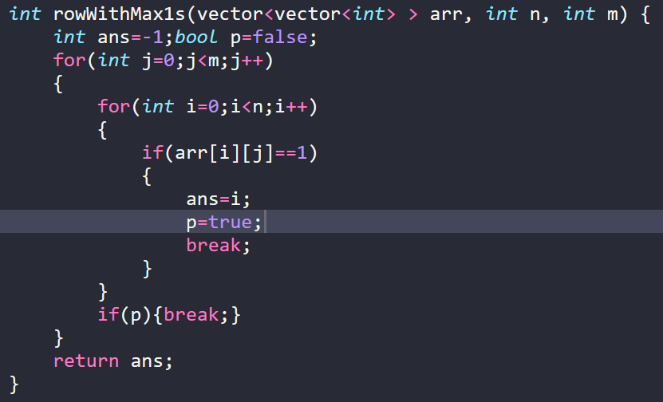

Ques matrix 4) find row with maximum number of zeroes.

Ques matrix 8) Rotate by 90:

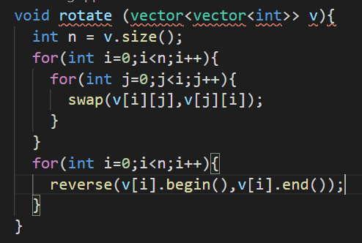

**STRING**

Ques string 8) Count and say

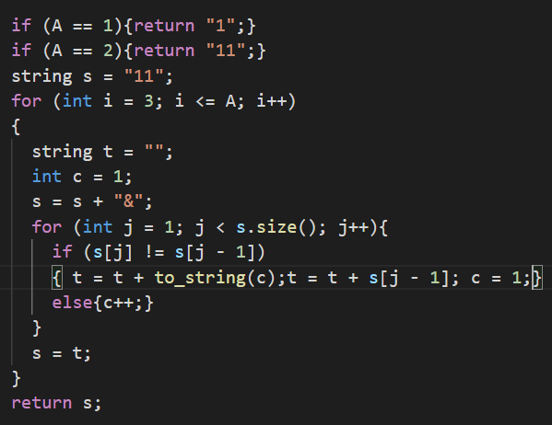

Ques string 9) Longest palindromic substring continous

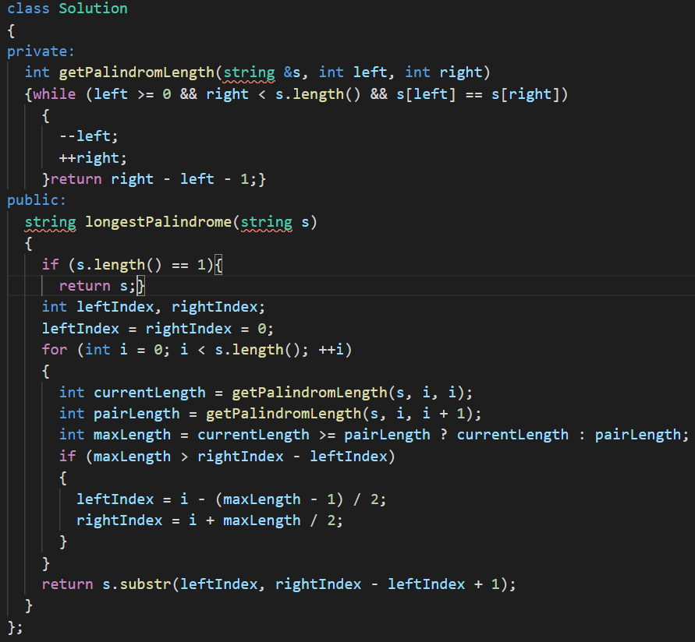

Ques string 10) bit set use

Ques string 11) Print all permeutations of a string

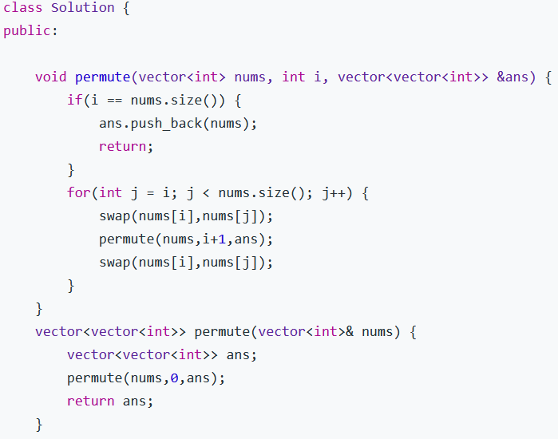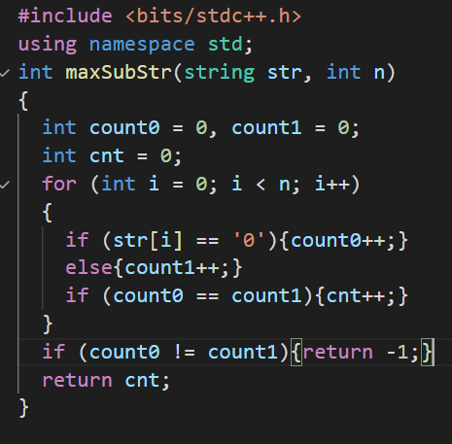

Ques String 12) Number of substrings having number of ones and zeroes as same

Ques string 14) Edit distance dp

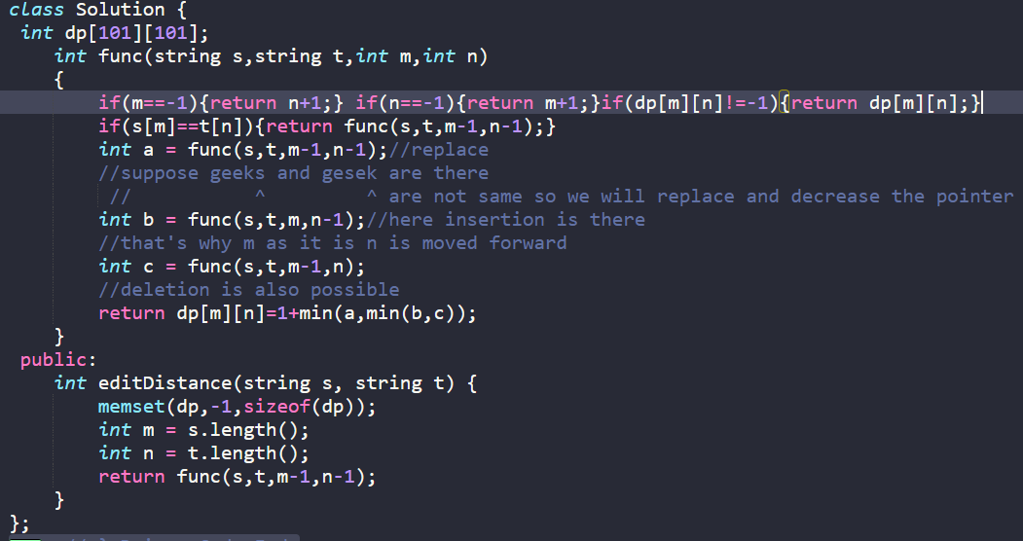

Ques string 15) Next greater permeuatation  
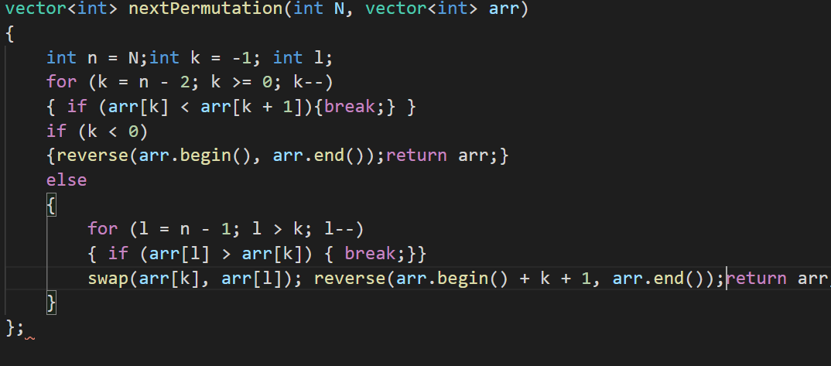

Ques 16) Balanced parenthesis problem

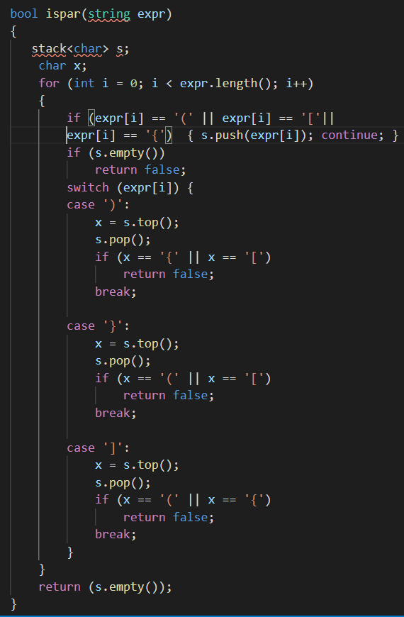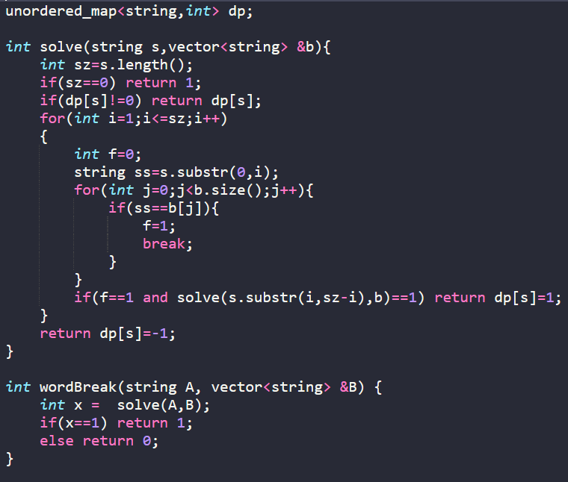

Ques string 17) word break problem

Ques string 18)Rabin karp algorithm

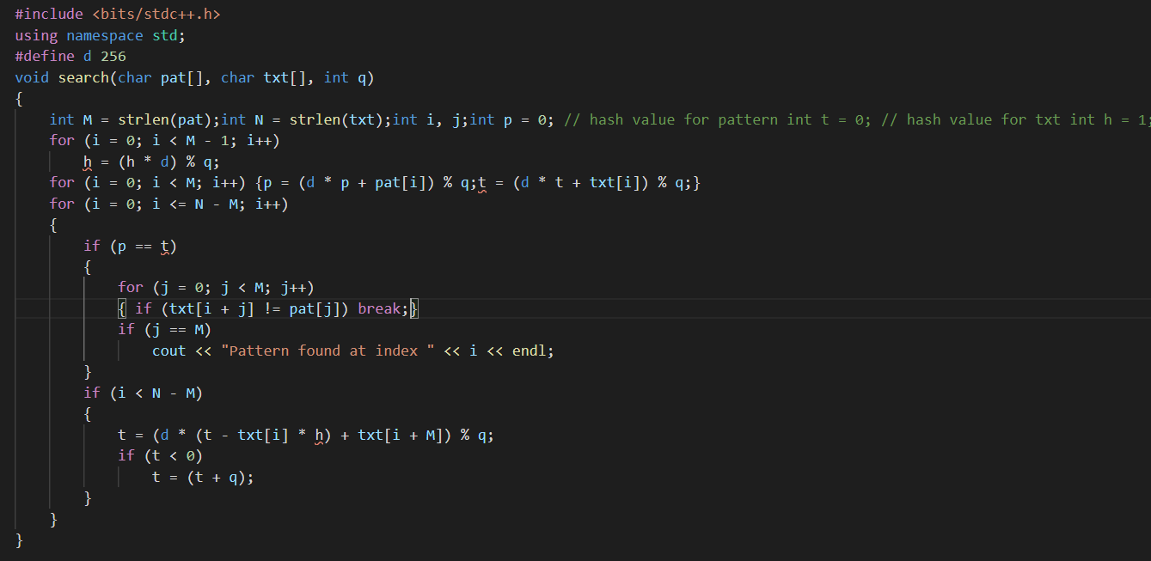

Ques strting 20) letter to number conversion

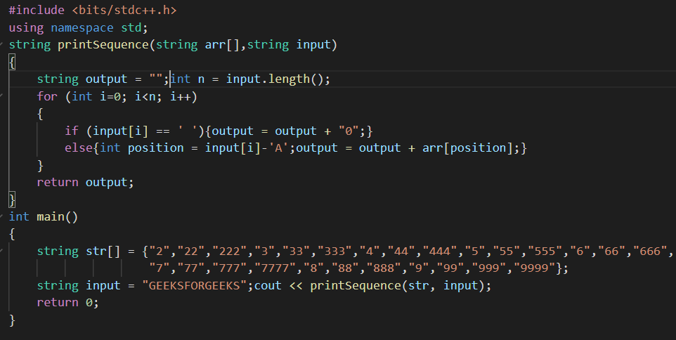

Ques string 21)

Ques string 22) Minimum number of brackets traversal needed

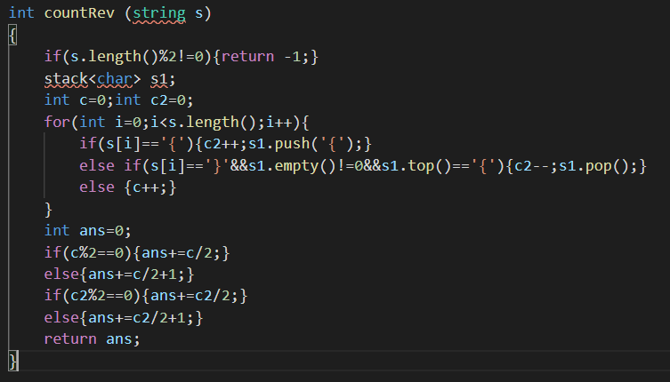

Ques string 22) count all palindromic subsequence(non-continuos)

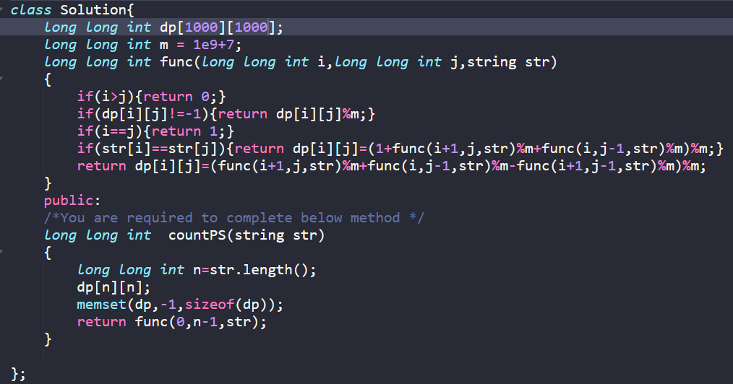

Ques string 23) Check if a word is present in a matrix or not

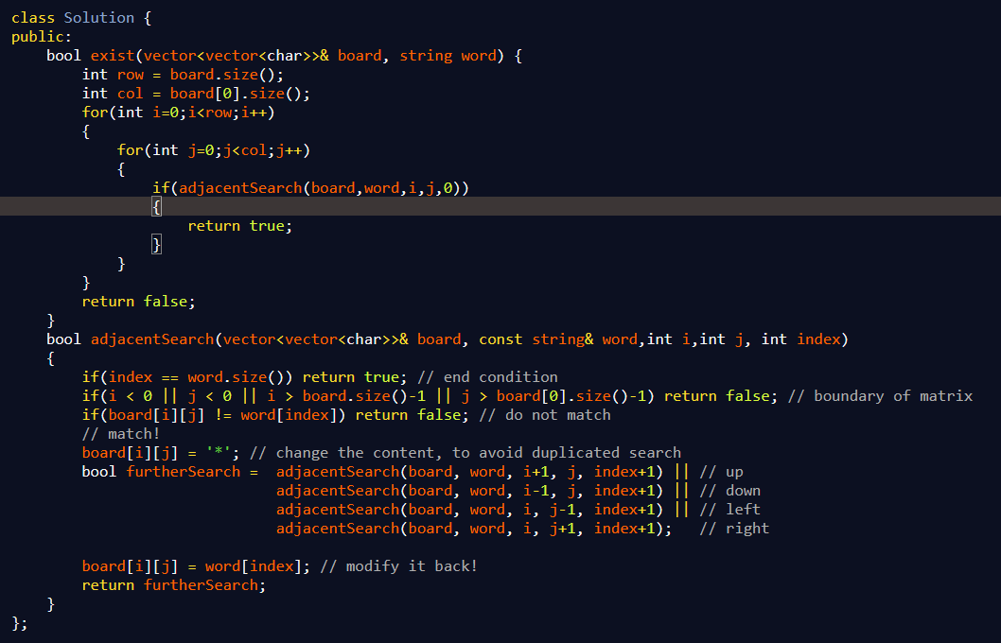

Other version

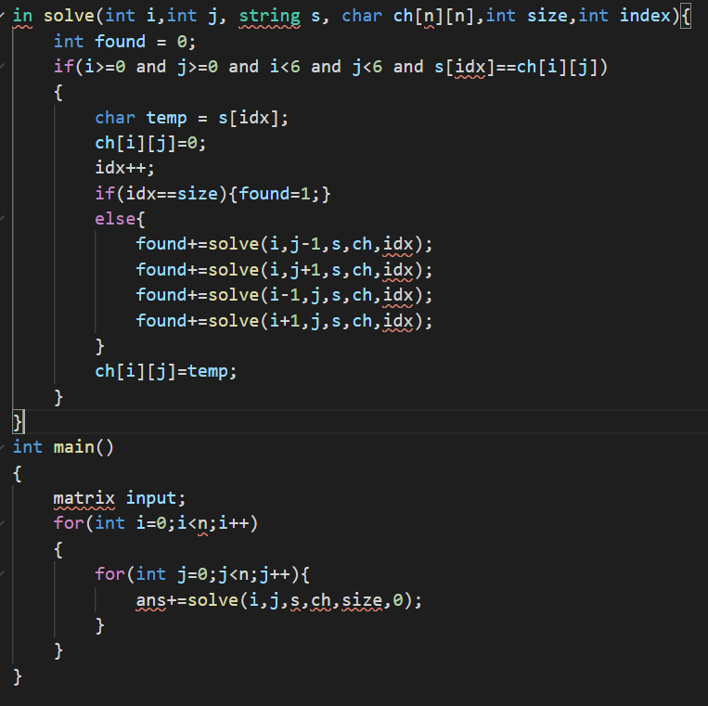

Ques string 26)Roman number to integer

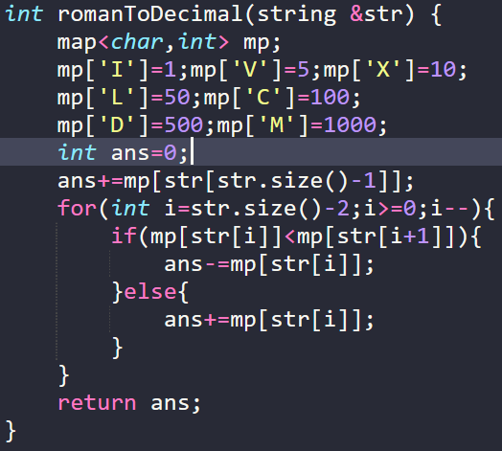

Ques 28 strings) Minimum number of flips required to make alternate bits

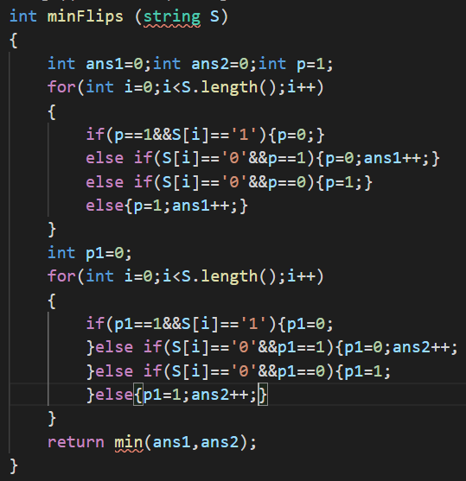

Ques string 30) Minimum number of swaps required to make a string balanced

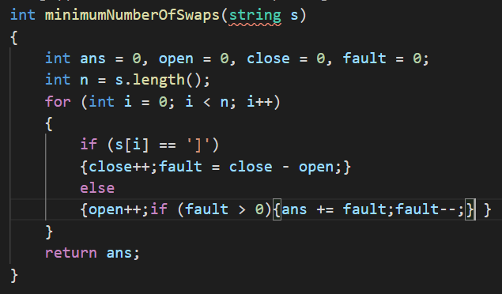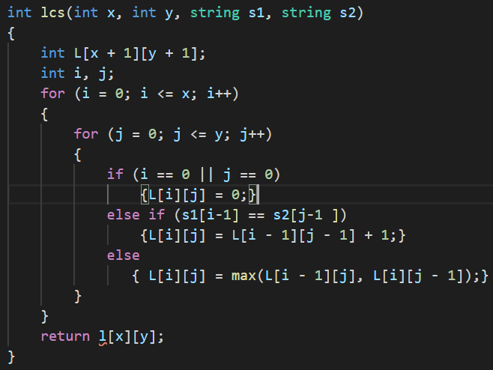

Ques string 31) Longest common subsequence (can be discontinuos) in two strings

Ques string 32) All possible IP address

#include <bits/stdc++.h>

using namespace std;

#define ll long long

#define mod 1000000007

//ip address are divided into four parts withthree dots

// having each subsegemnt <=255 and length<=3, also

//011,001 are not valid, 0 valid

bool isvalid(string s)

{

    if(s.length()>3){return false;}

    if(stoll(s)<=0||stoll(s)>255){return false;}

    if(s[0]=='0'&&s.length()>1){return false;}//011,001 are not valid, 0 valid

    return true;

}

void computeAllValidIPAdress(string &str, vector<string> &res)

{

    for (int i = 1; i <= 3 && i < str.length(); i++)

    {

        string first = str.substr(0, i);

        if (isvalid(first))

        {

            for (int j = 1; j <= 3 && i+j < str.length(); j++)

            {

                string second = str.substr(i, j);

                if (isvalid(second))

                {

                    for (int k = 1; k <= 3 && i+j+k < str.length(); k++)

                    {

                        string third = str.substr(i+j, k);

                        string fourth = str.substr(i+j+k);

                        if(isvalid(third)&&isvalid(fourth))

                        {

                            res.push_back(first+'.'+second+'.'+third+'.'+fourth);

                        }

                    }

                }

            }

        }

    }

}

void solve()

{

    string str;

    cin >> str;

    vector<string> res;

    computeAllValidIPAdress(str, res);

    for (auto i : res)

        cout << i << "\n";

}

Ques sting 33) Smallest window conataining all distinct charachters

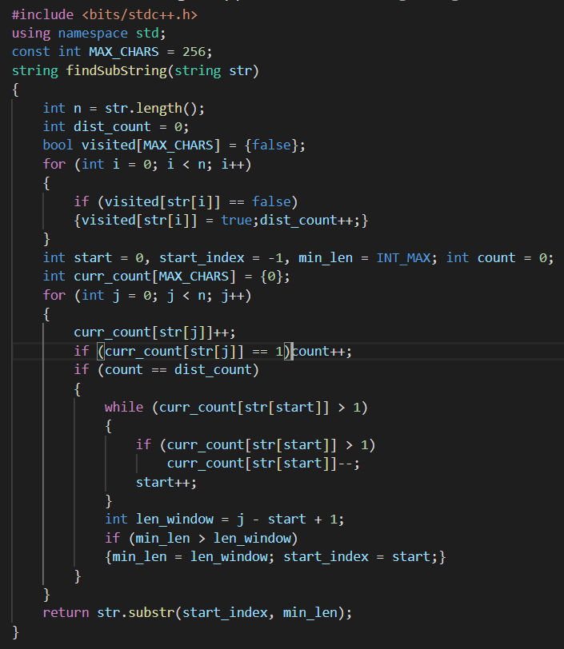

Ques 36) string) Anagrams

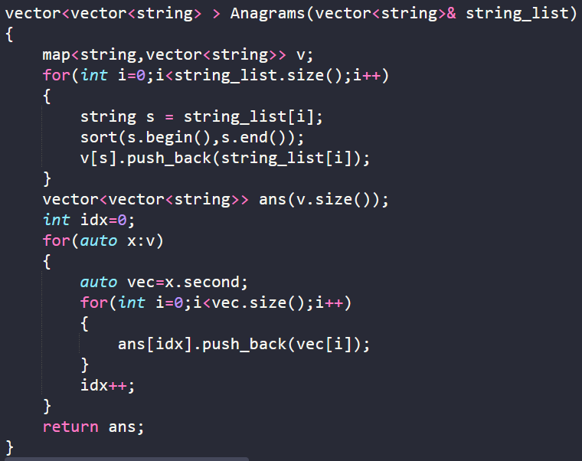

Ques string 29) Wild and pattern matching

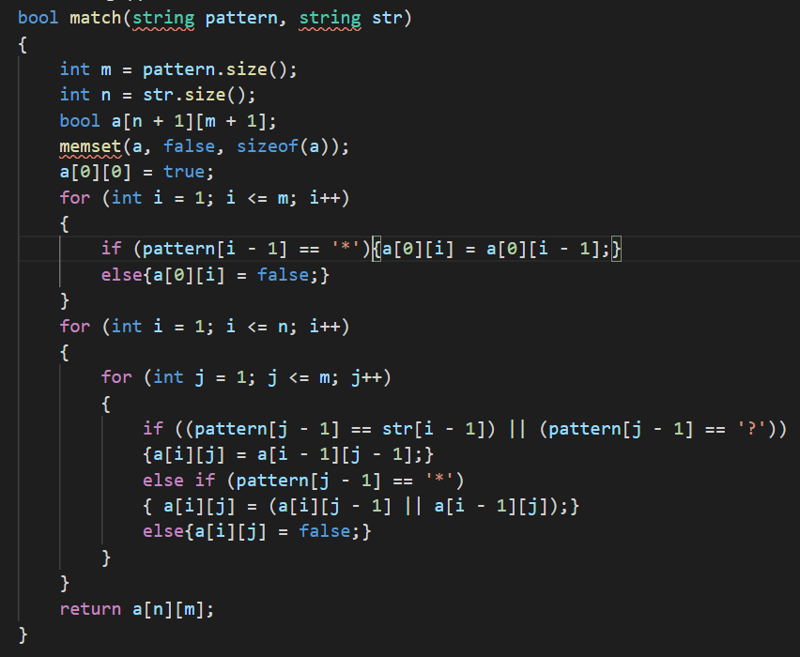

Ques 41 string) transforming one string to other using minimum transaitions

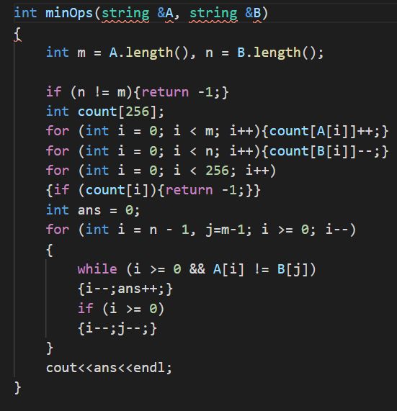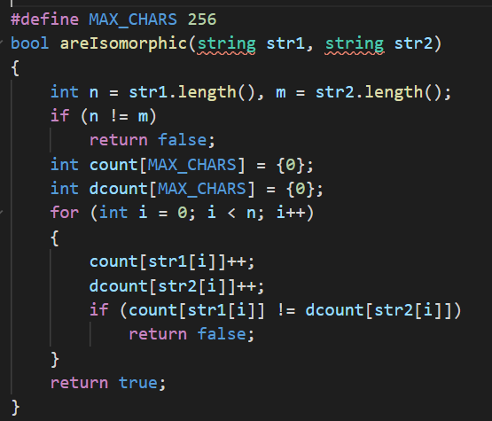

Ques string 42) isomorphic strings

Ques searching an sorting 1) Find first and last position of element in a sorted array

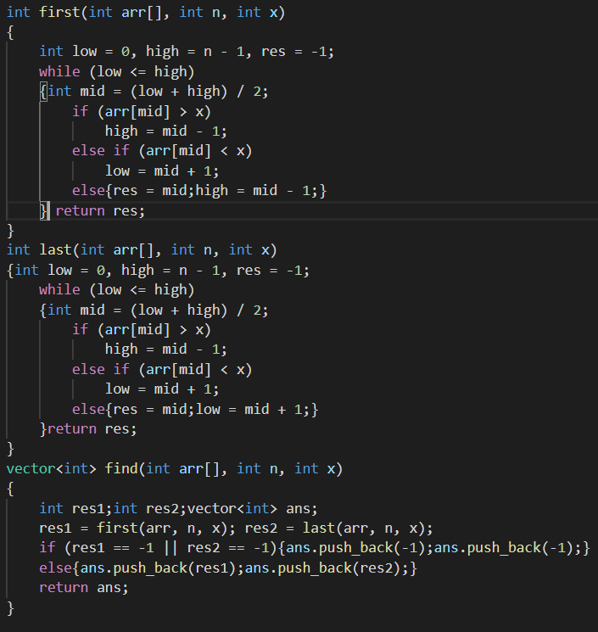

Ques Searching 3) Rotated array

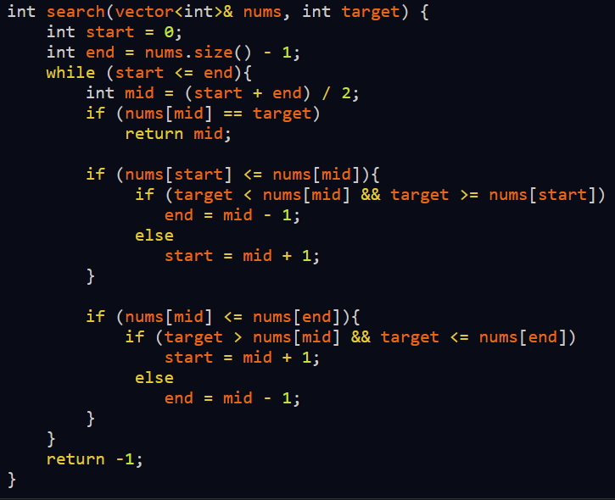

Ques searching 5) maximum and minimum of three numbers using minimum number of operations

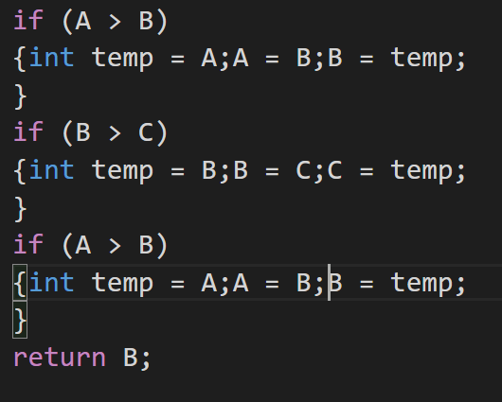

Ques searching and sorting s7) find the repeating and missing

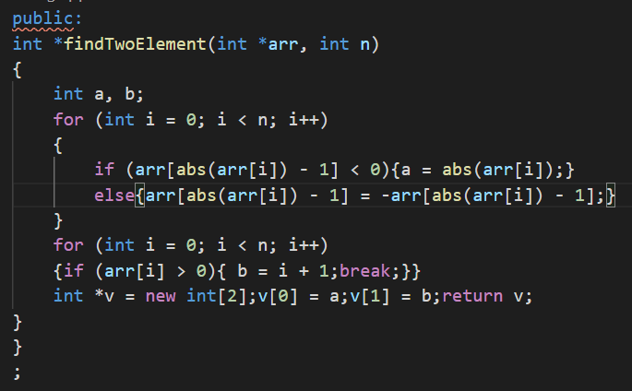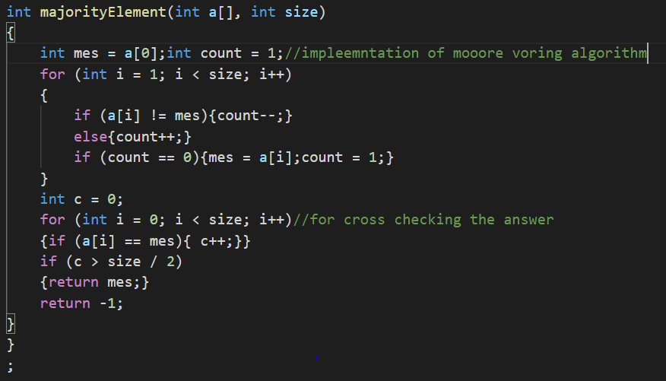

Que searching and sorting q8) find the majority element (moore voting algorithm)

Ques searching and sorting q9) find element in a array where adjacent differ by at most k

Ques searching and sorting q11) four sum

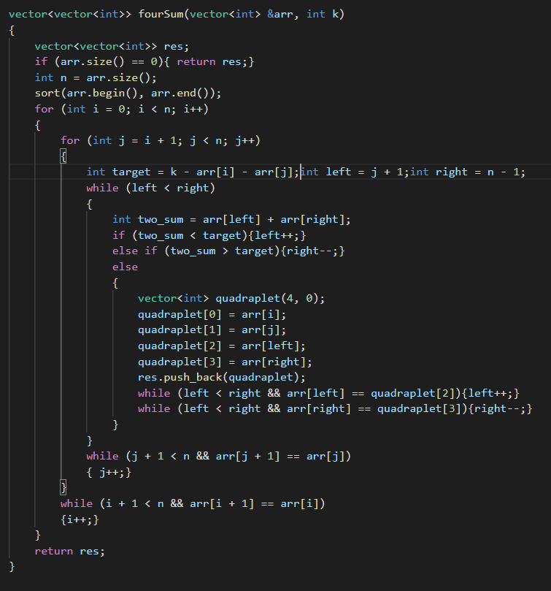

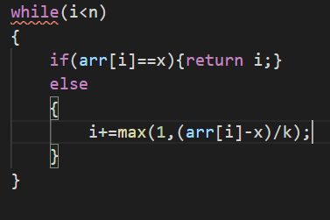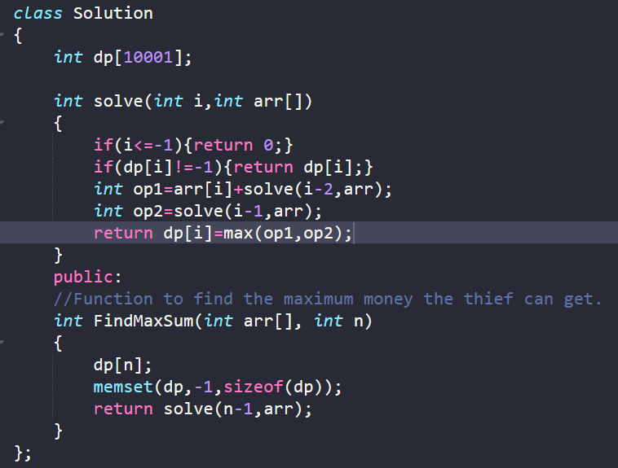

Ques searching 12 ) Thief and houses

Ques seraching 13) Three sum value less than a value x

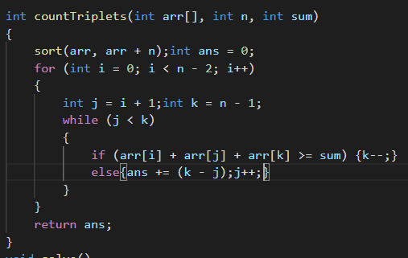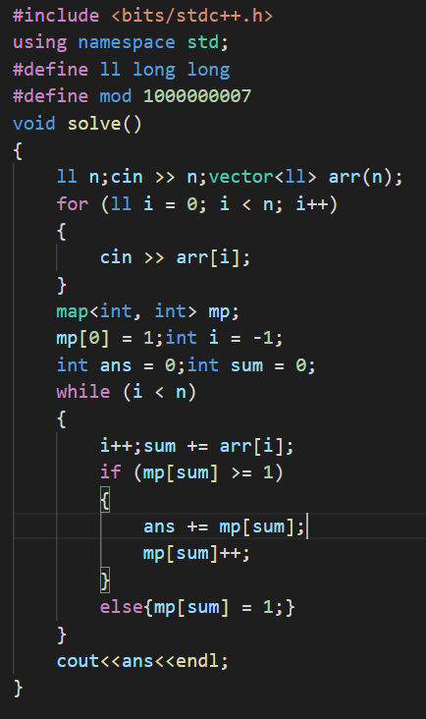

Ques searching and sorting 15) Count of subarrays having sum=0;

Ques searching and sorting 16) Product array puzzle

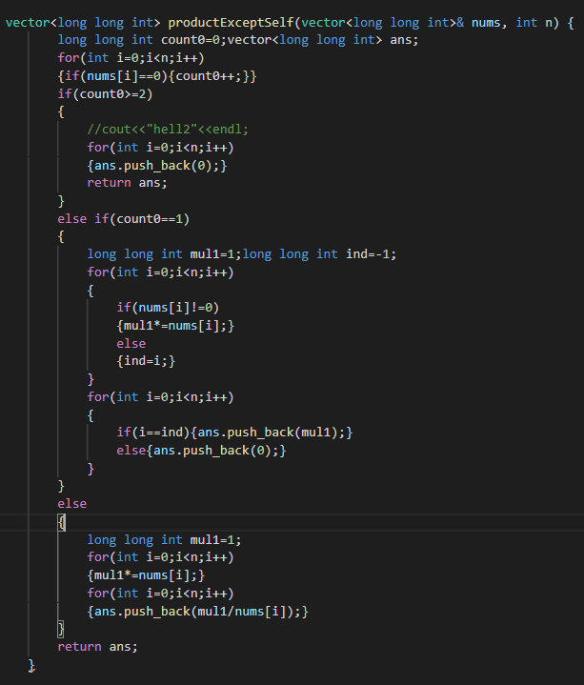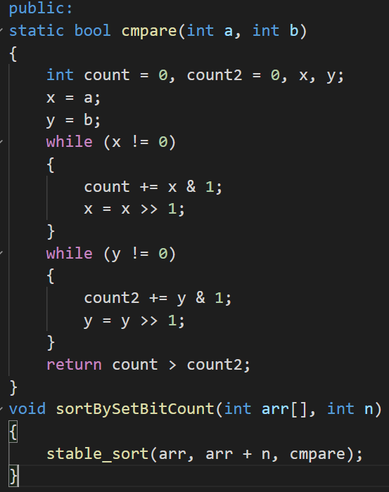

Ques seraching and sorting 17 ) Sort according to the number of set bits

Ques searching and sorting 18)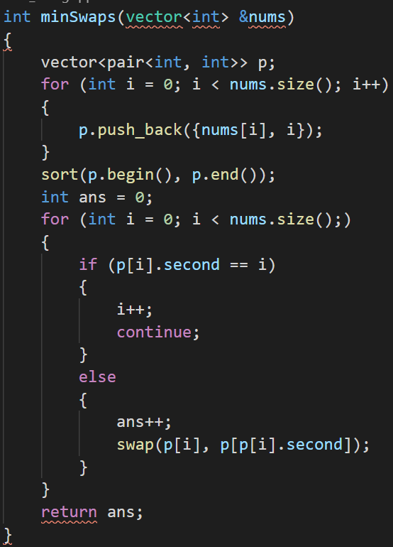

Ques 22 Seraching and sorting ) pivot elemnt in a sorted array

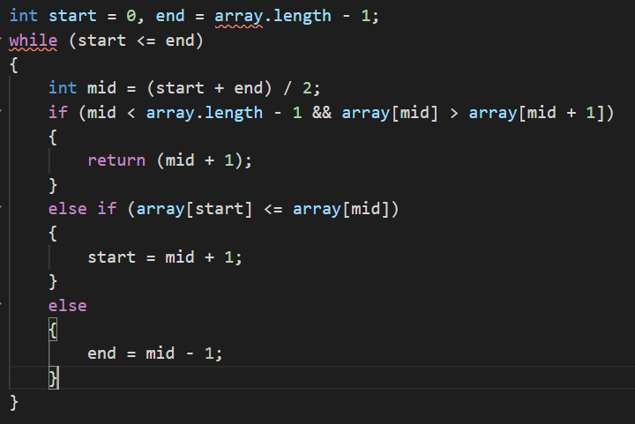

Ques searching and sorting ques 23) k th element in two sorted arrays

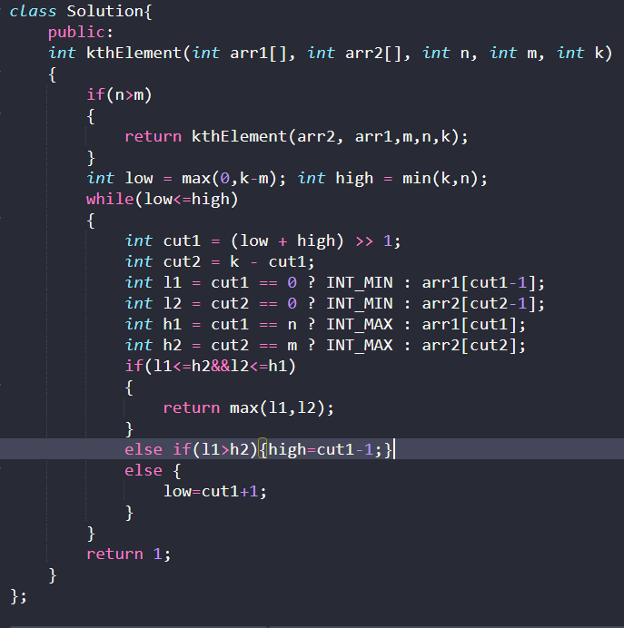

Ques 24 ) Aggressive cows

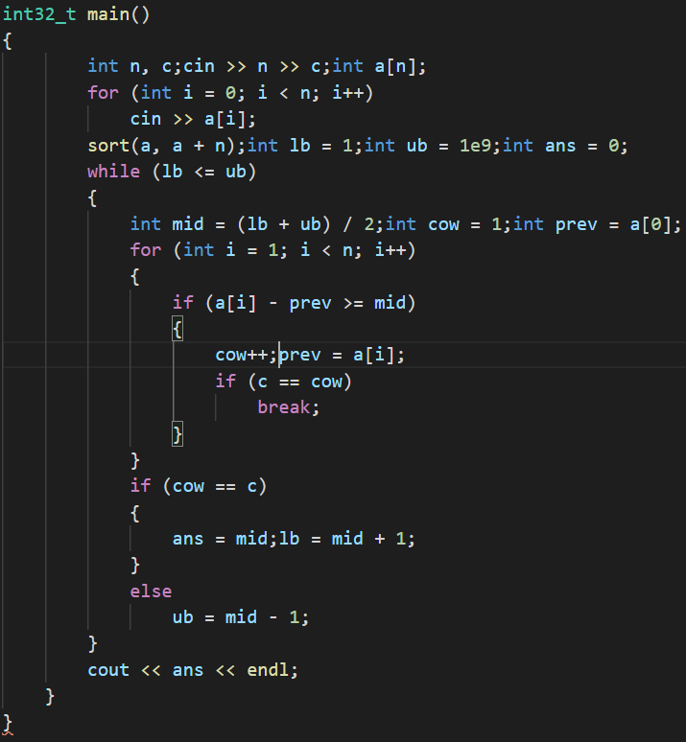

Ques searching and sorting 28)

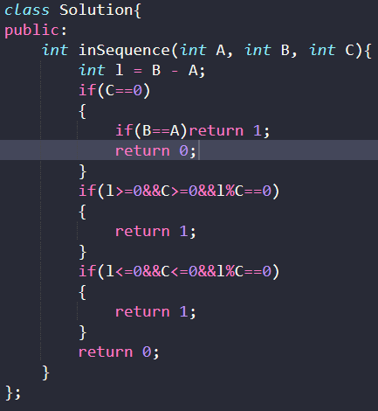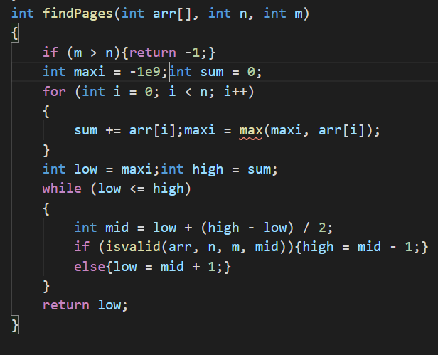

Ques searching and sorting 25 ) allocate minimum number of pages

Ques searching and sorting 30) tree cutting problem ecofriendly

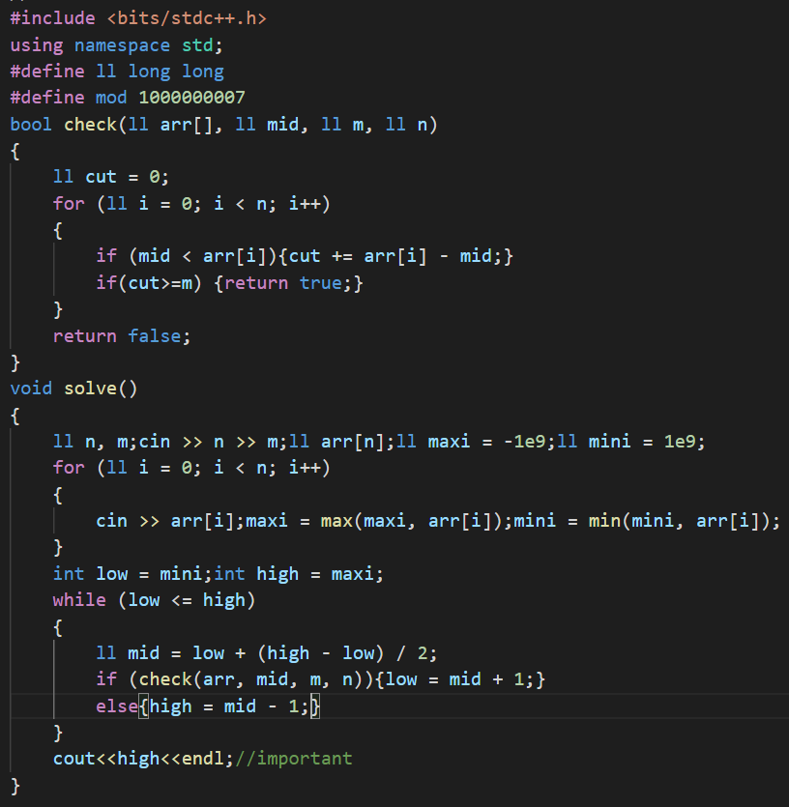

Ques searching and sorting 29) trailing zeroes minimum number

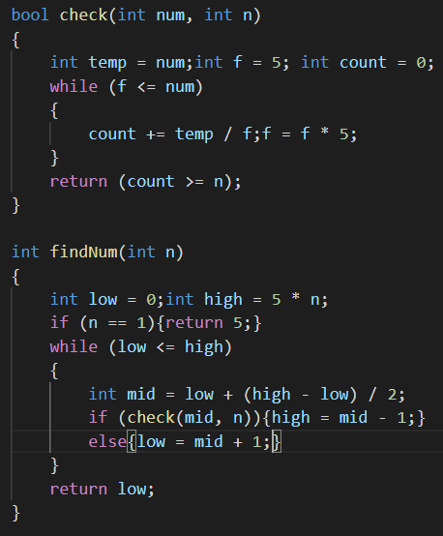

Ques searching and sorting 30) painter and partition problem

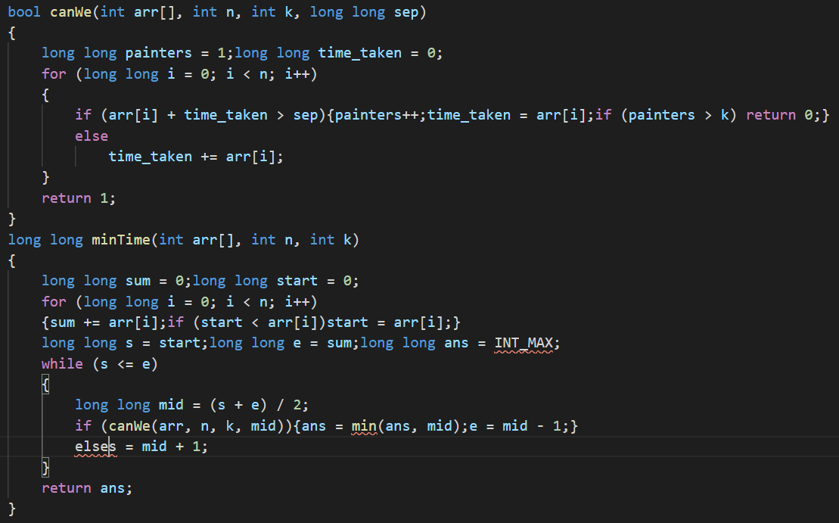

Ques 31 searching and sorting) Roti paratha

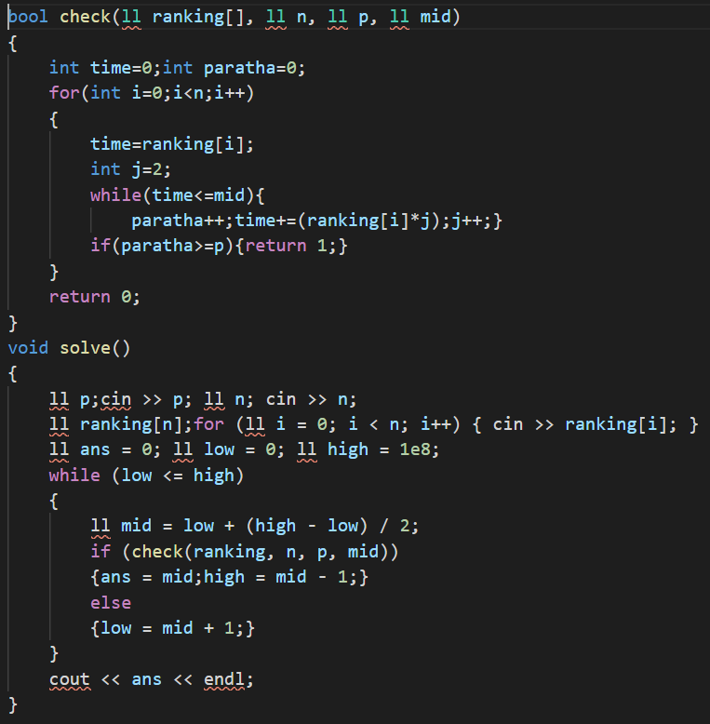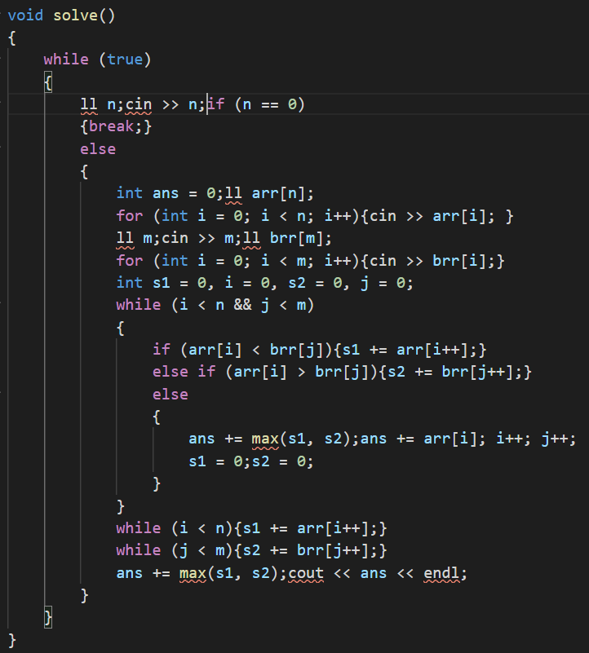

Ques searching and sorting 32) Double helix

Ques searching and sorting 33) Subset sum

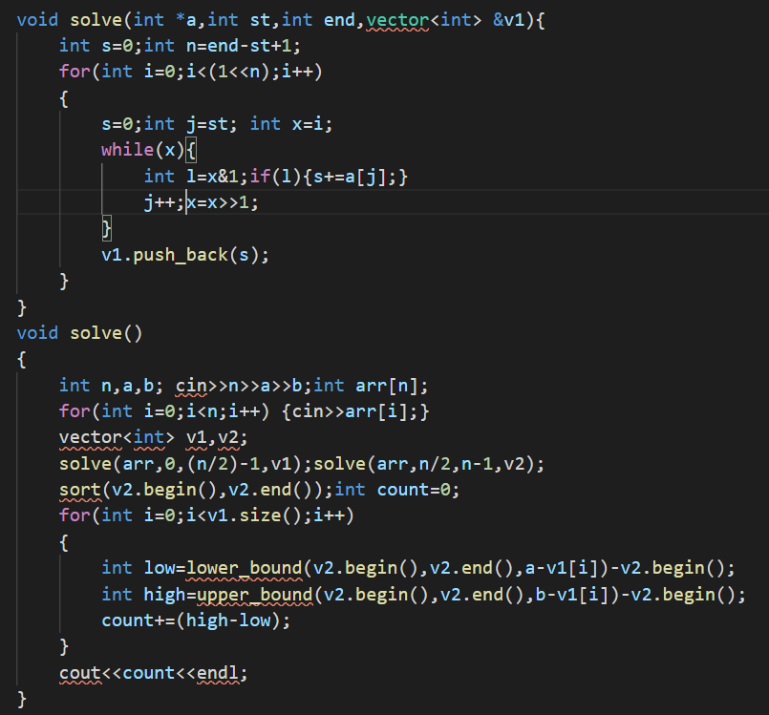

Ques searching and sorting 34 ) Inversion and count

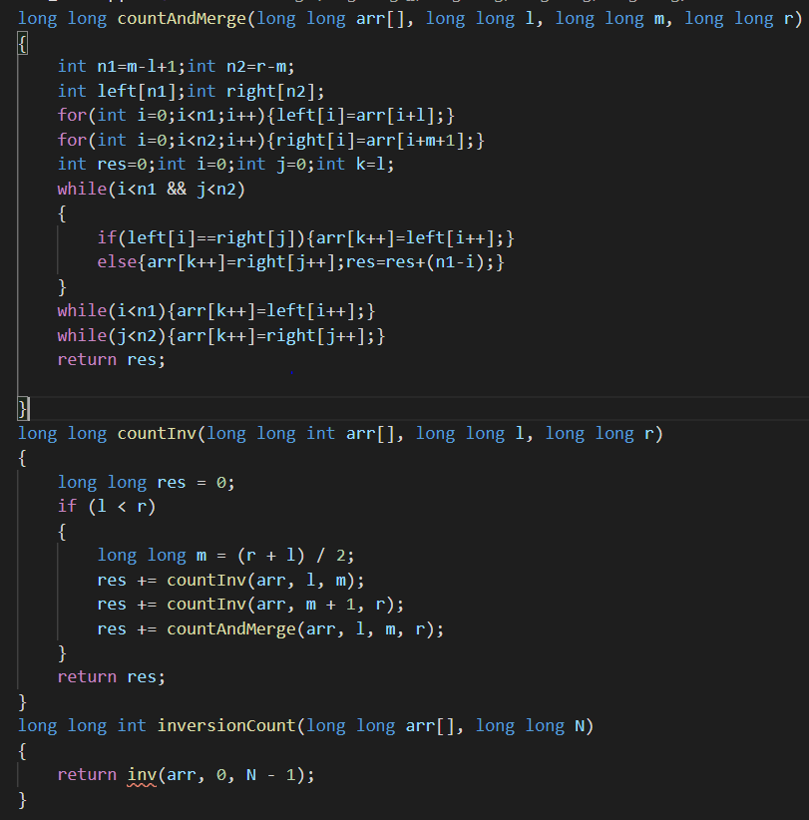

**Backtracking**

1. Maximum number after k swaps

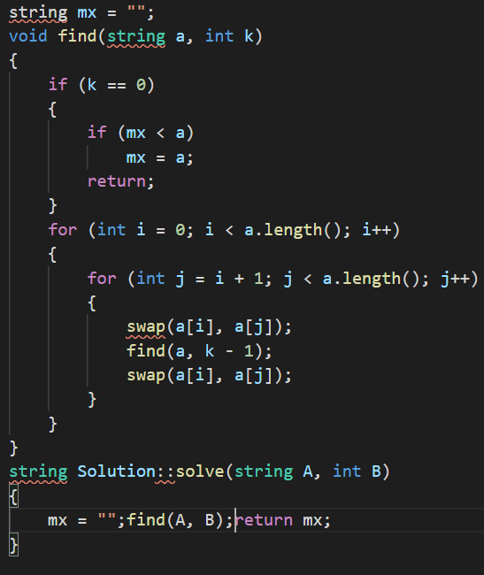

1. Create all subsets

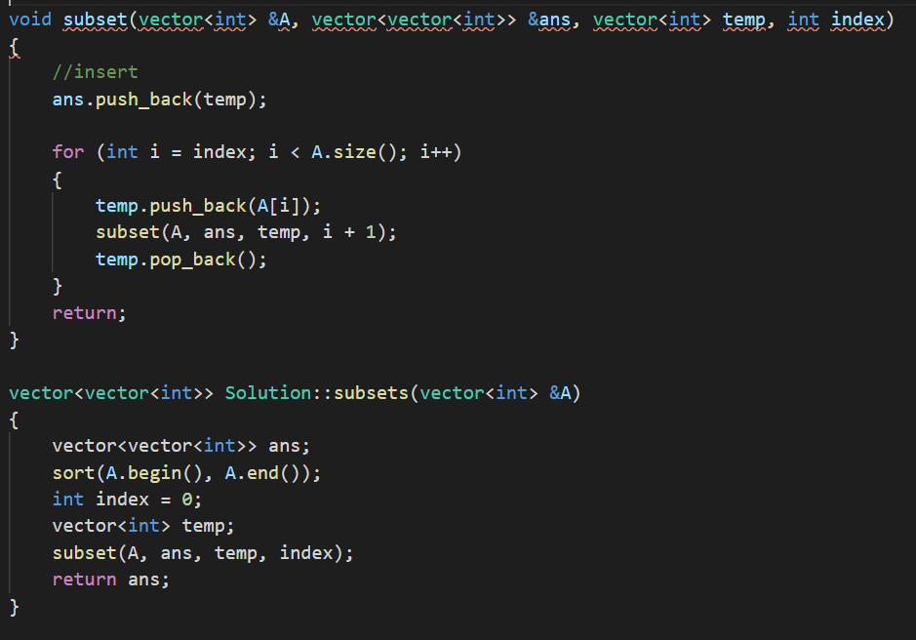

1. Combination sum, repetition of elements is allowed
2. Cominations

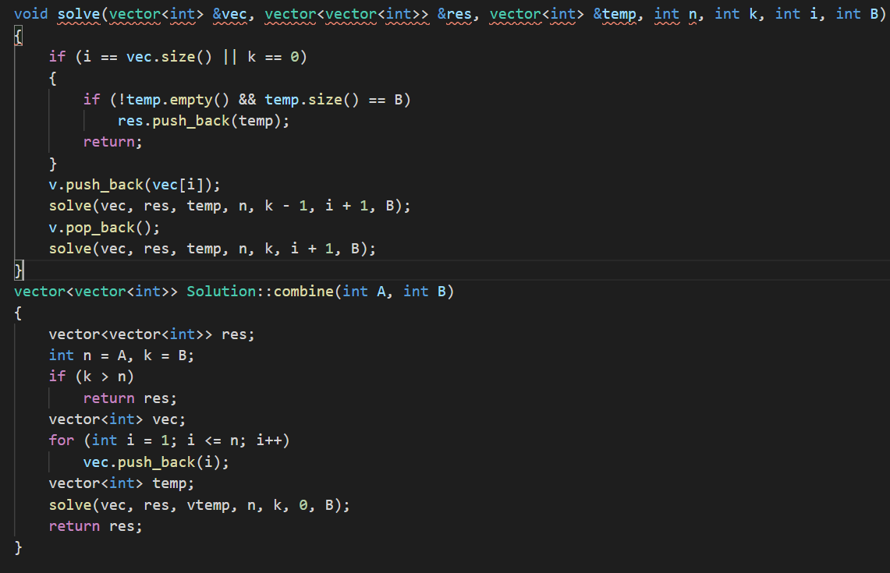

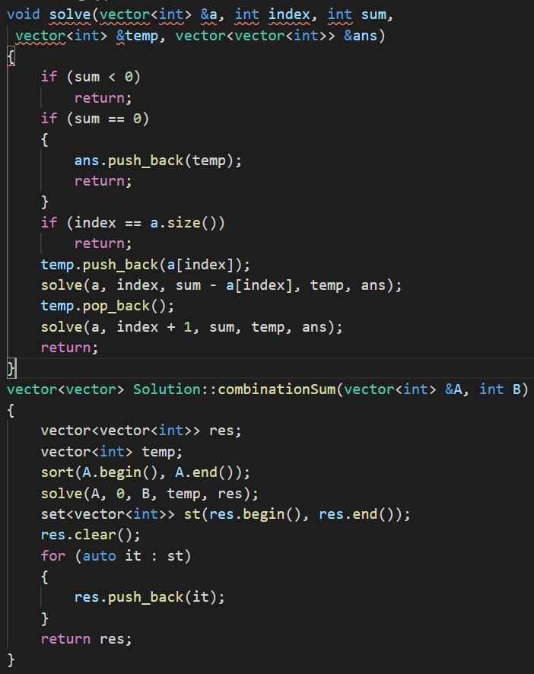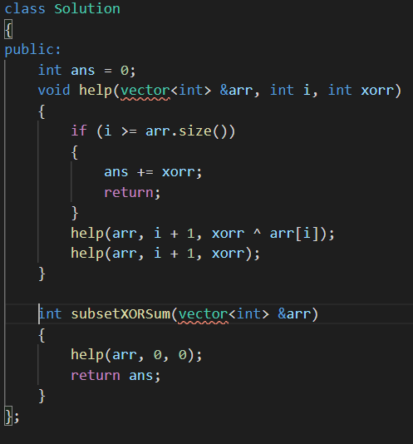

Ques ) sum of xors of subsets.

**LinKEDLIST**

Ques ll1) Reversing of a linked list

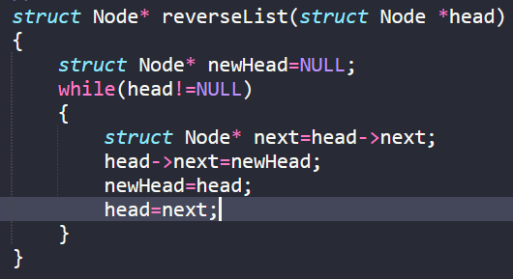

Q ll2) Reversal in groups

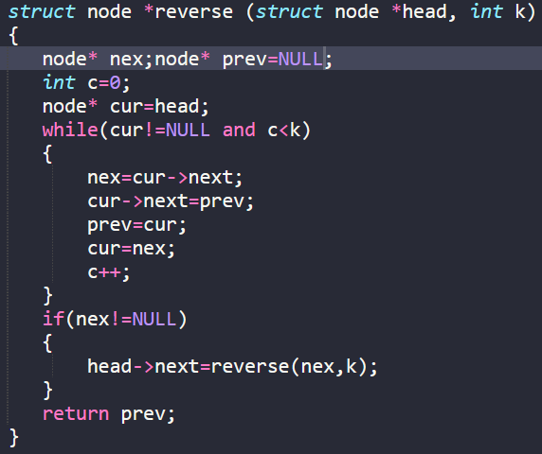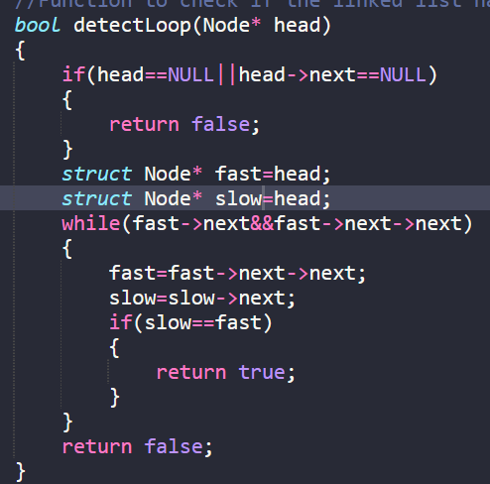

Ques ll3) detecting of a loop in a linked list

Ques ll4) deleting a loop in ll

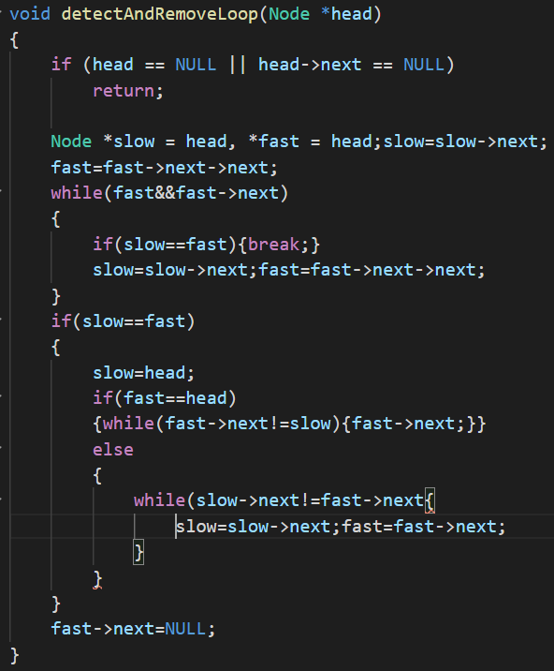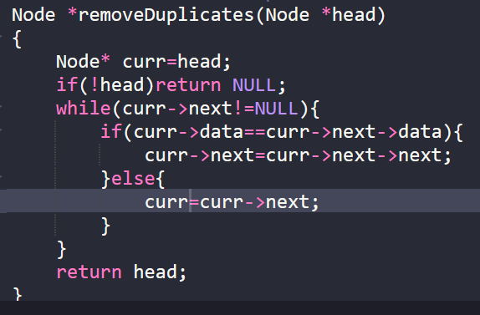

Ques ll5) remove duplicate elements form linked list

Ques ll7) Remove duplicates form a linked list(ll is unsorted)

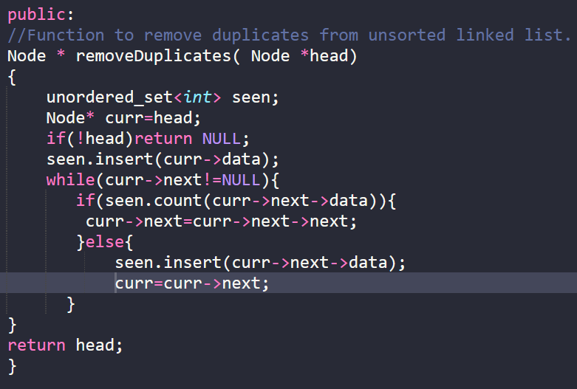

Ques ll7) MOVE THE LAST POINTER TO FIRST

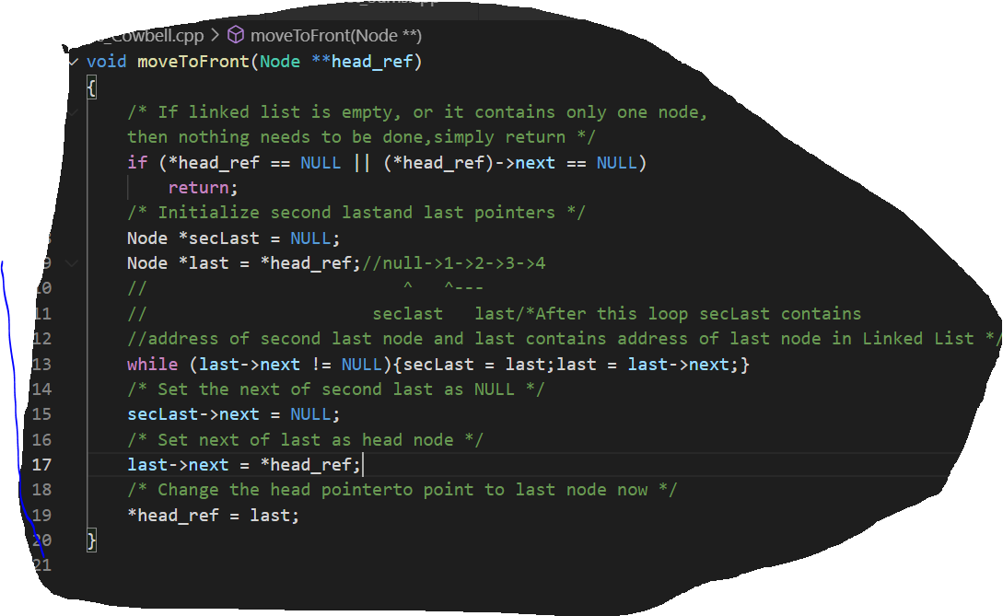

Ques ll 9) Add 1 to the linked list int he number generated by the number

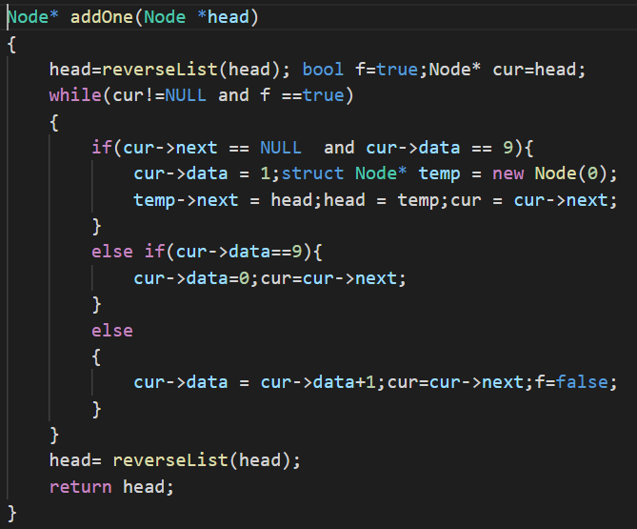

Ques ll 10) add two numbers using linked list

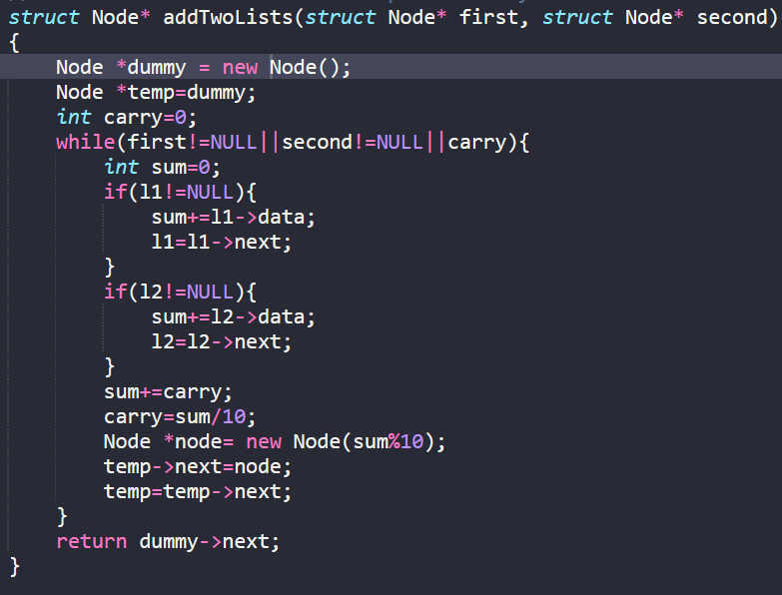

Ques ll 11) Intersection of two linked listss

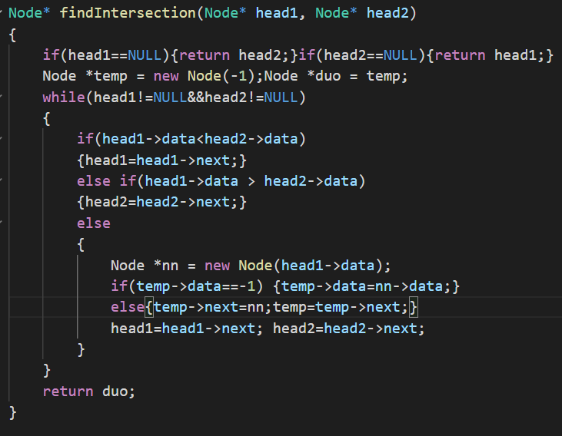

Ques ll12) intersection point of two linkedlist

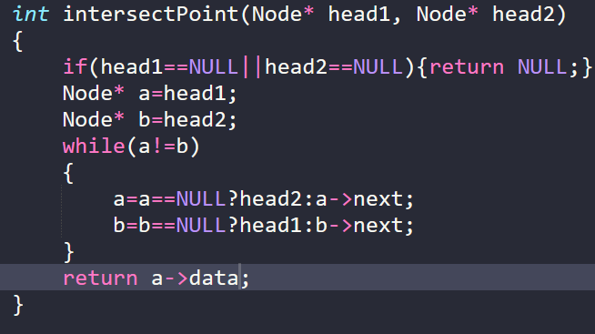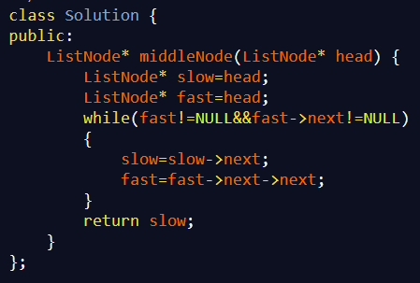

Ques ll15) middle of the libnked list

Ques ll16) linkedlist is circular or not

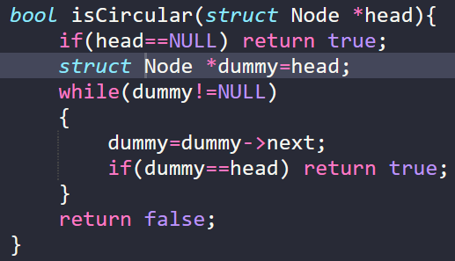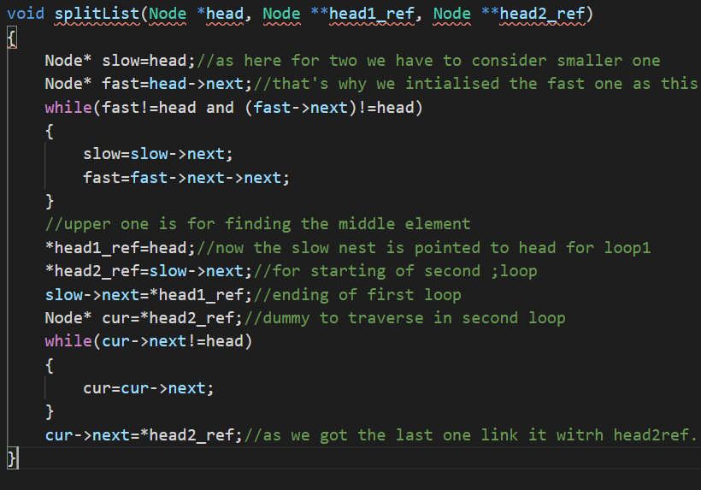

Ques 17) split the linked list

Ques ll 18) Check if a linked lsit is palindrome or not

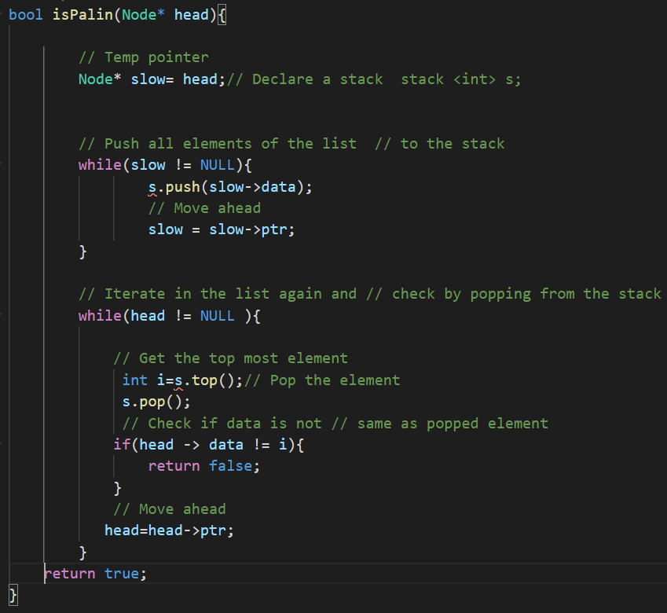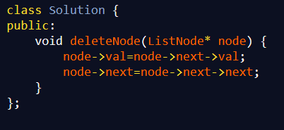

Ques ll19)Delete from a circular linked list

Ques ll23)sort k sorted doubly linked list

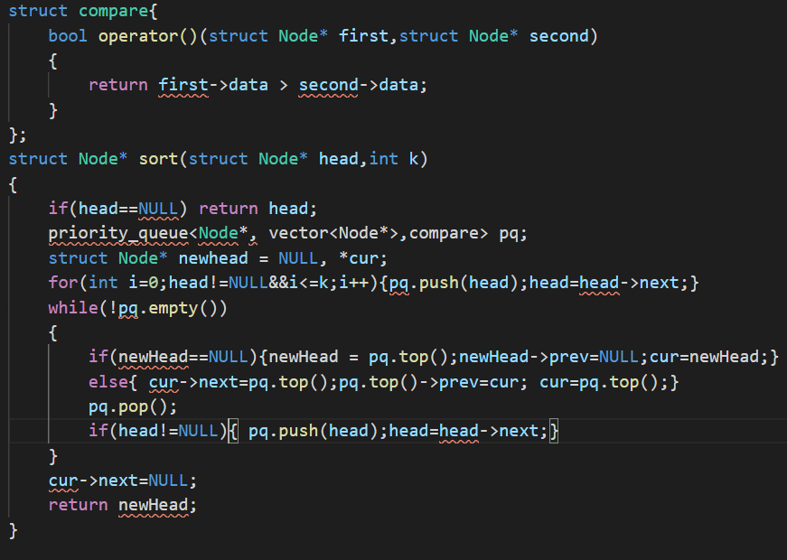

Ques ll 24) rotate doubly linked list

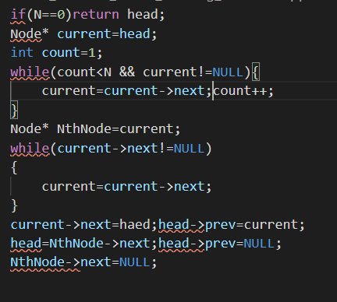

Ques ll 28) flatten the linked list

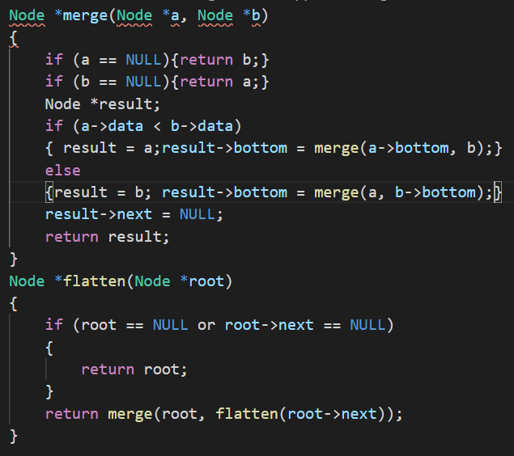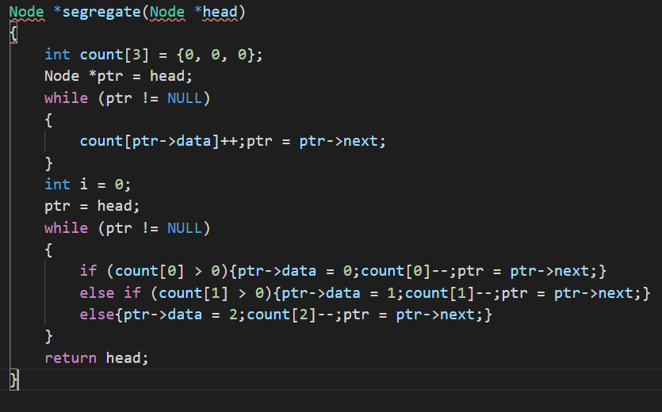

Ques ll 29) sort liked list containing elements 0,1,2

Ques ll 31)Merge k sorted linked list

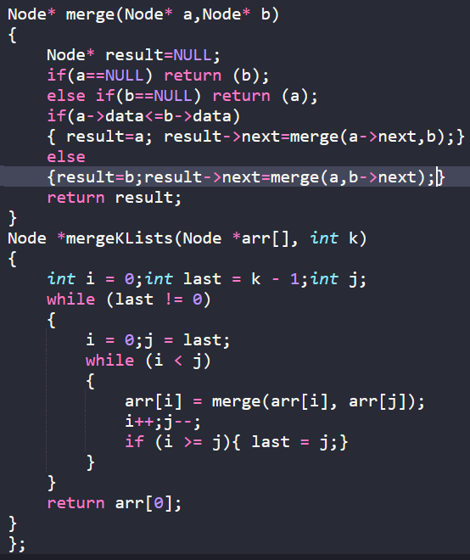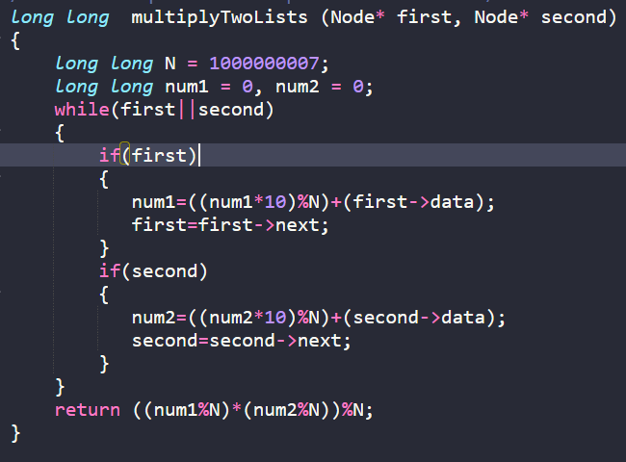

Ques 32) multiply two numbers represented in the form of linked list

Ques 33) 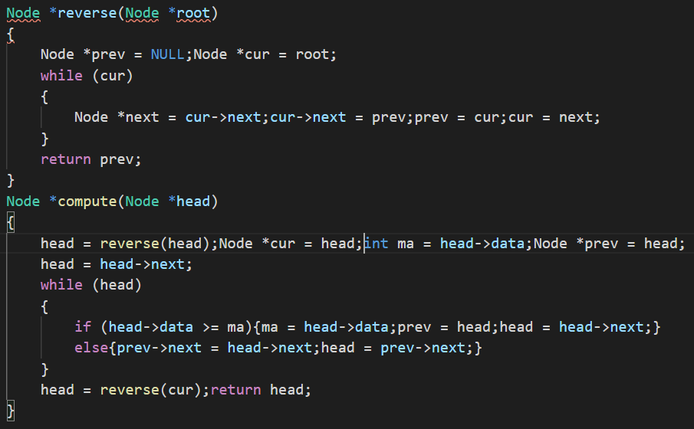

Ques 34) seggregate all even and odds

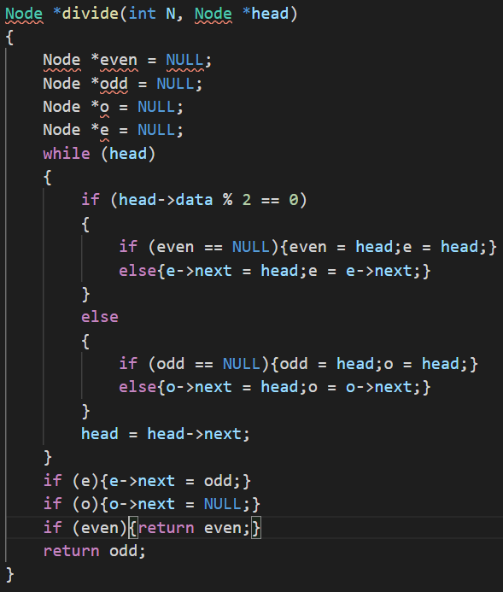

Ques 35) nth node from the end of the linked list

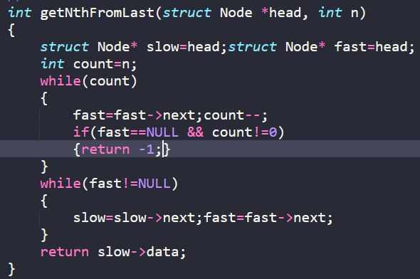

**GREEDY**

Ques g1) activity selection problem

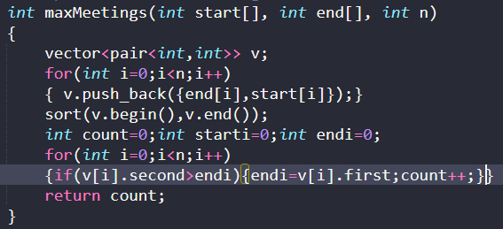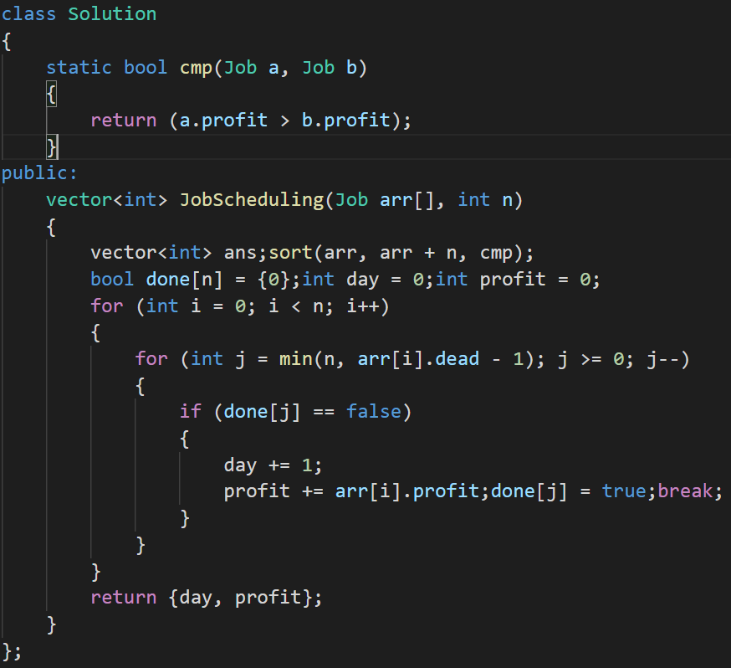

Ques g2) Job sequencing problem

Ques g5) Fractional knapsack problem

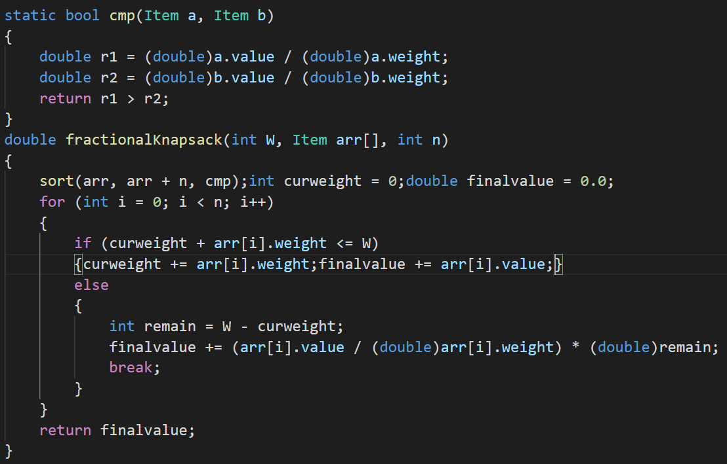

Ques g6)

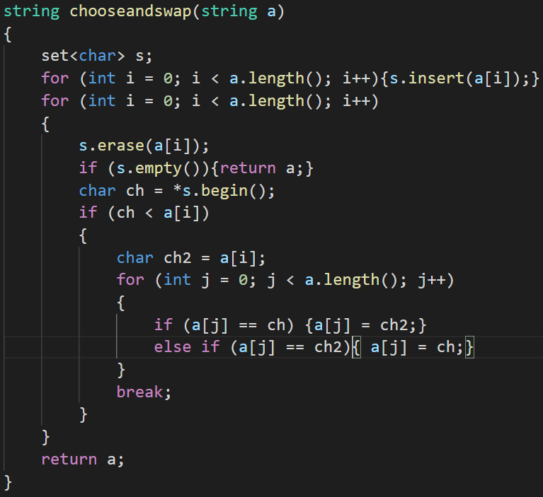

Ques g7) Trains accomodation

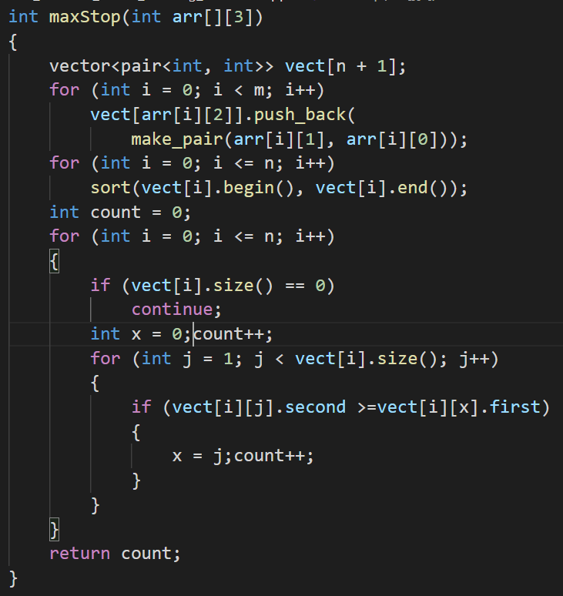

Ques g8) train accomodation

Ques g10) Find the minimum and maximum amount

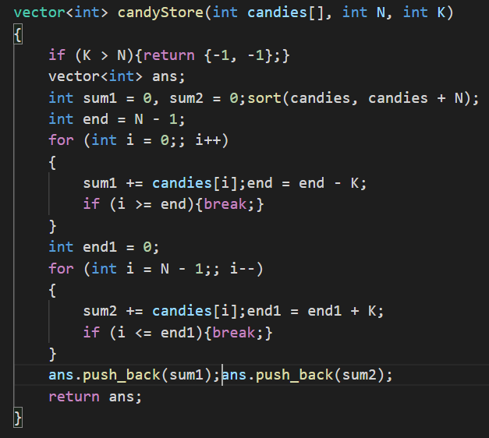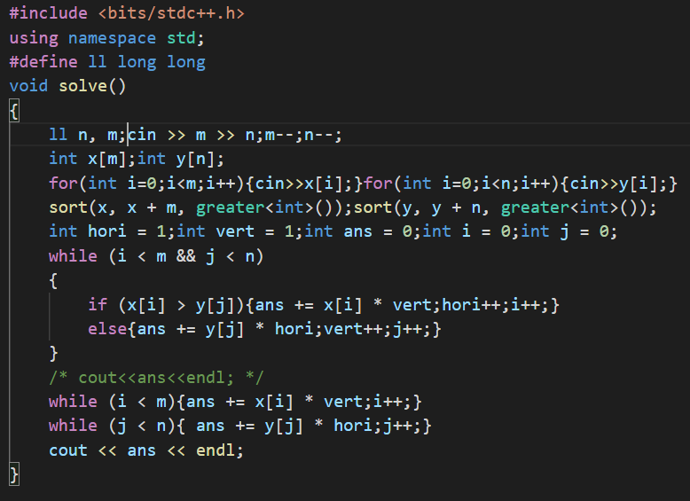

Ques g12 and g29) chocola chocolate

Ques g13) check if possible to survive on island

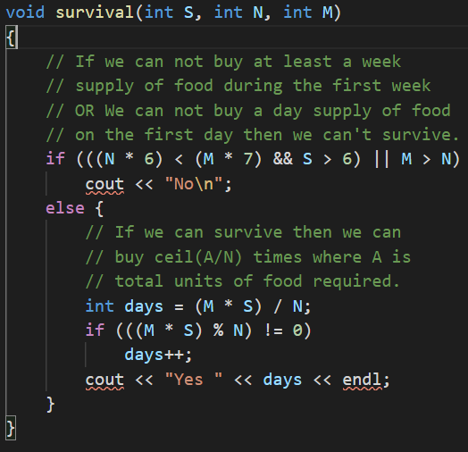

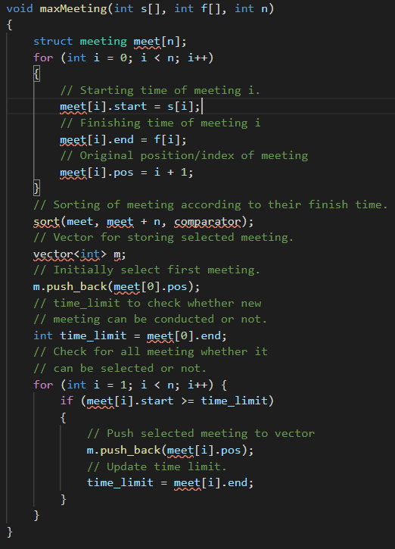

Ques g14) above

Ques g15) maximum product subset of array

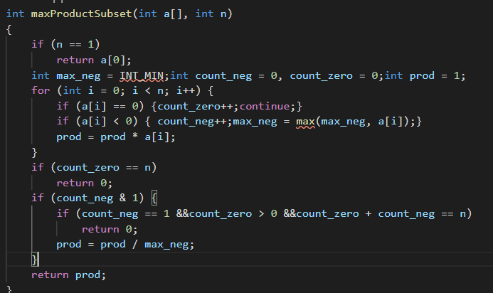

Ques g16) maximum array sum after k negotiations

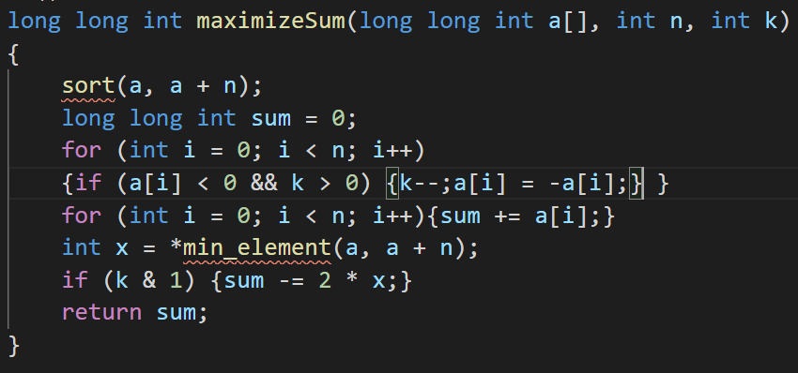

Ques g17) Maximise the sum of arr[I]*I

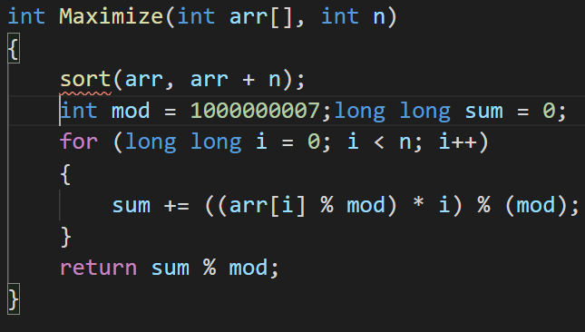

Ques g18) Maximum absolute sum of difference

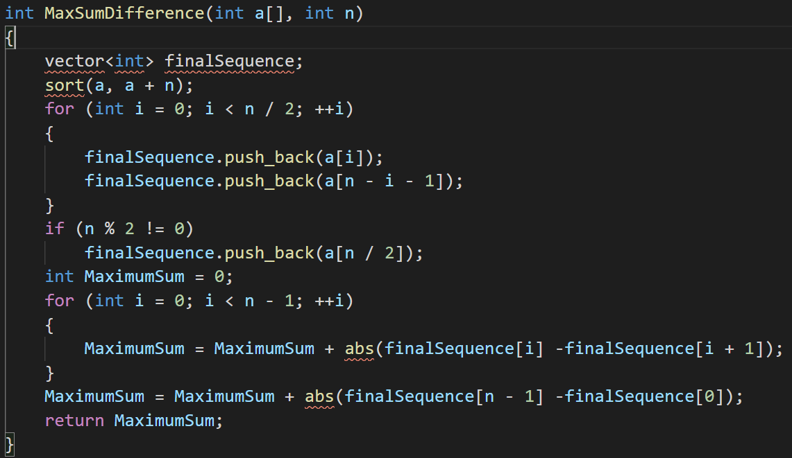

Ques g19)Swap and maximize

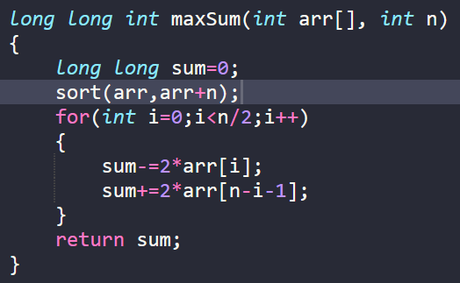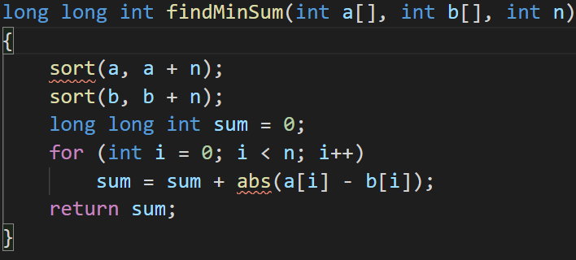\

Ques g20) minimum possible sum absolute differnce between two arrays

Ques g21)

Ques g22)

Ques g23) smallest subset having sum greater then rest of elements

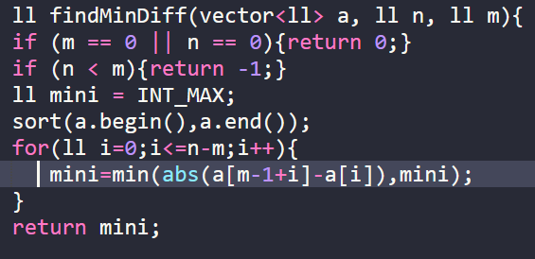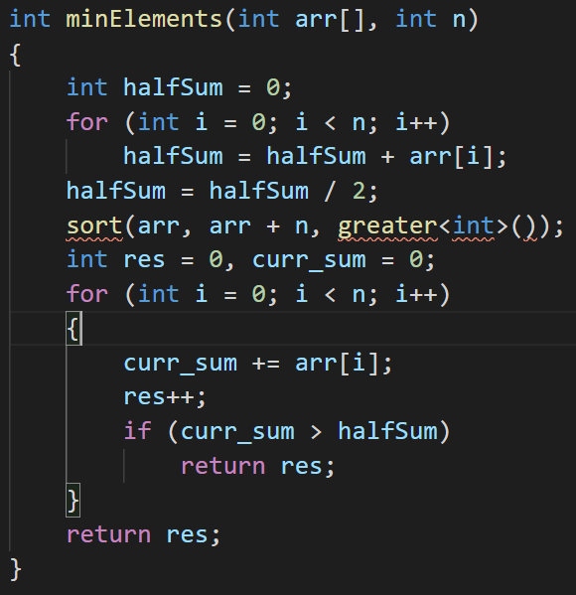

Ques g24) chocolate distribution problem

Ques g25)defkin-defense of kingdom

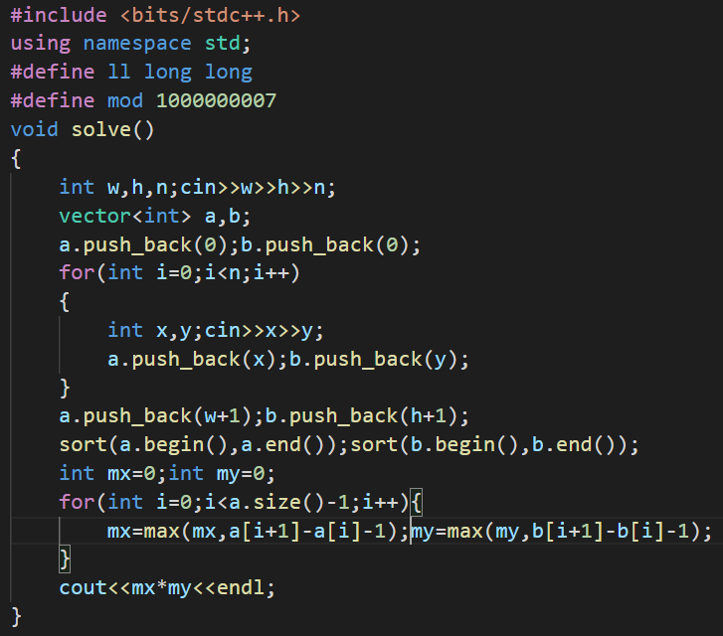

Ques g36) diehard-diehard

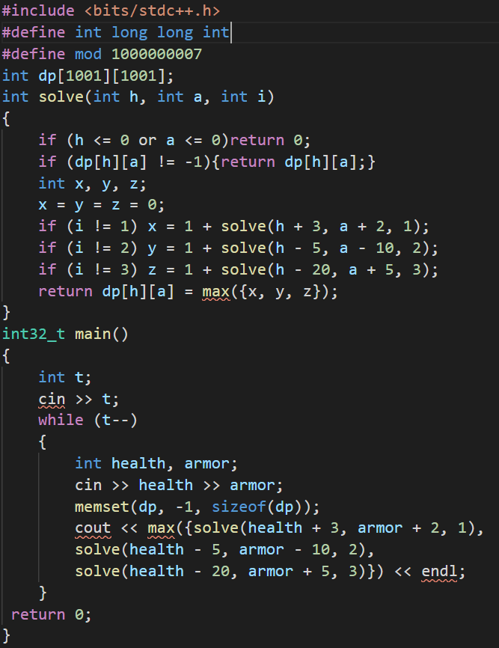

Ques g27) gergoia -wine trading gergovia

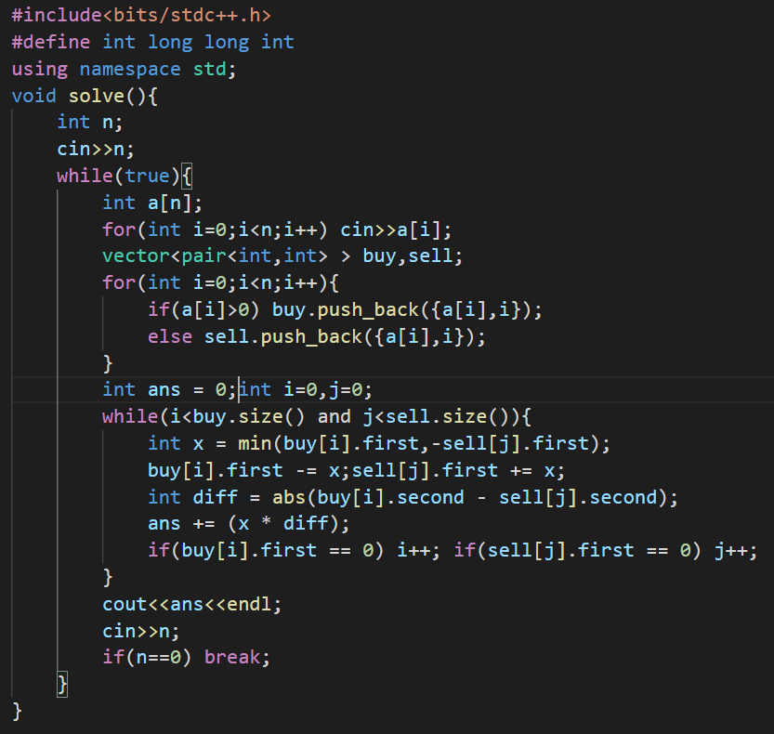

Ques g30) amplifiers

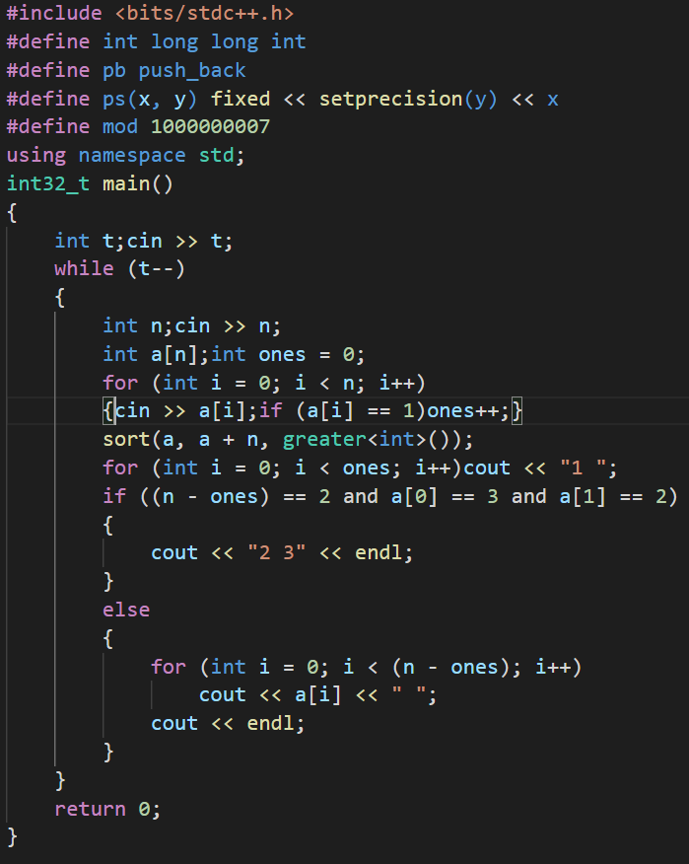

Ques g32) mimium cost of ropes

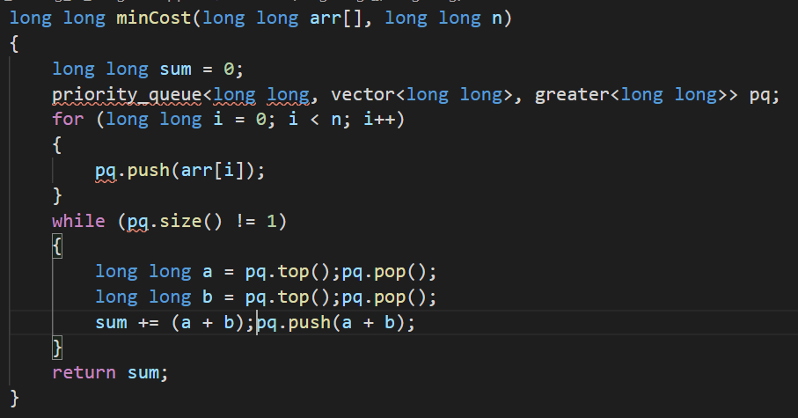

Ques g33) smallest number with given no of digits and sum

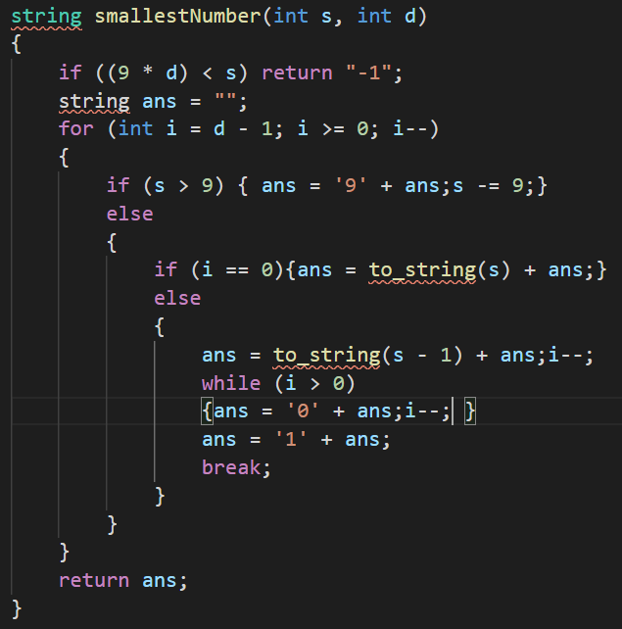

Ques g34) Rearrange charachters

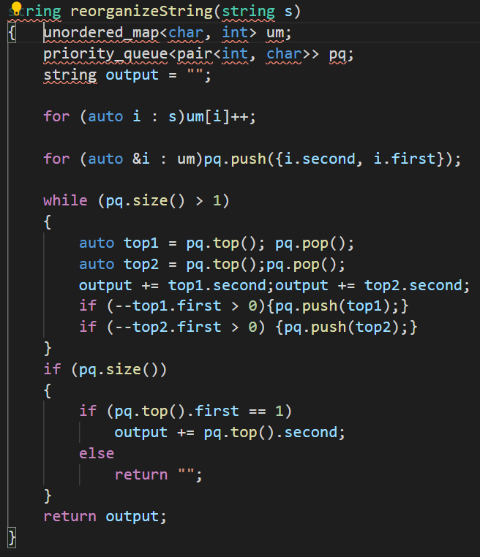

Ques g35) Maximum stack problem

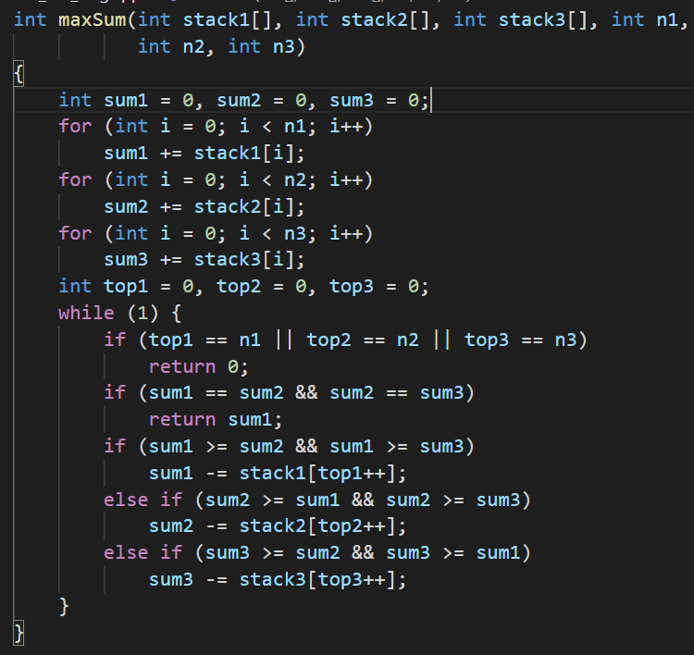

**STACK**

QUES 3) Delete middle element and return the original stack

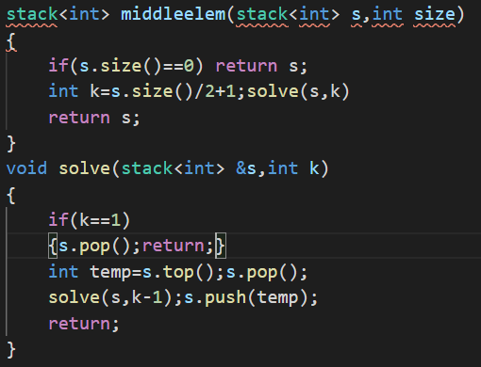

Que 6) Valid parenthesisis checker

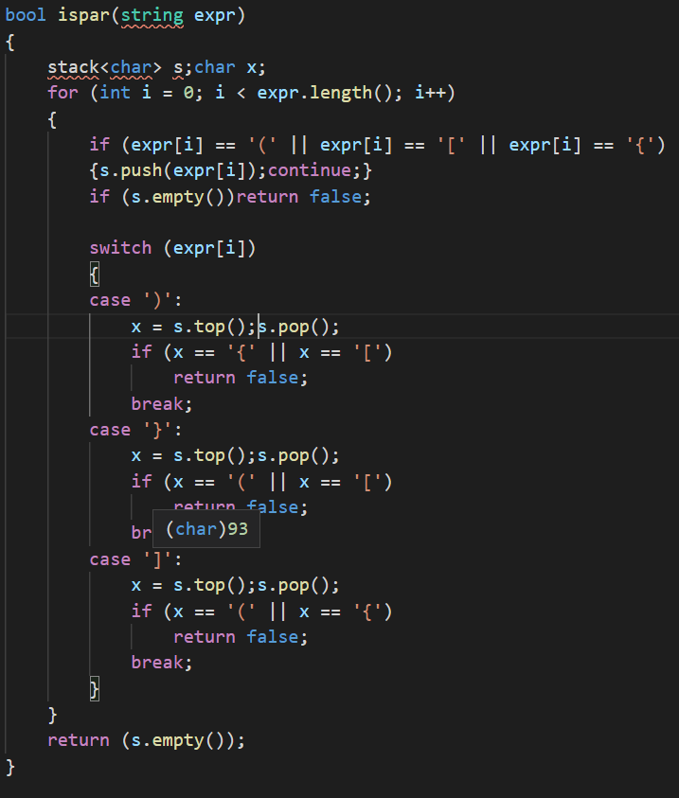

Ques 7) Reverse string using stack

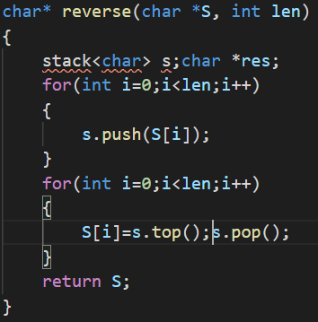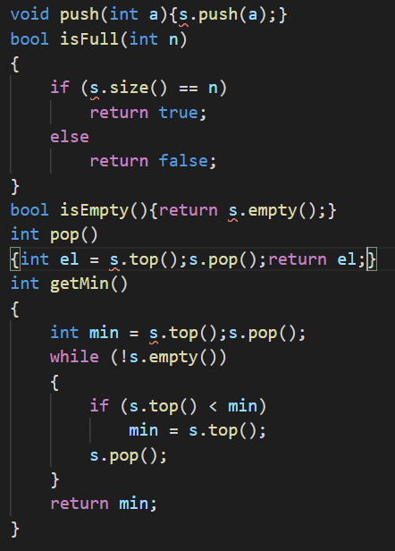

Ques 8)getmin in o1 time

Ques 9) next greater element

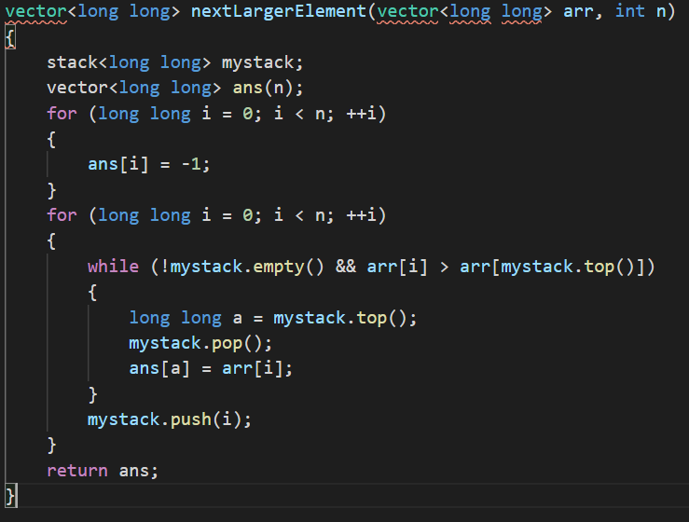

Ques 10) The celebrity problem

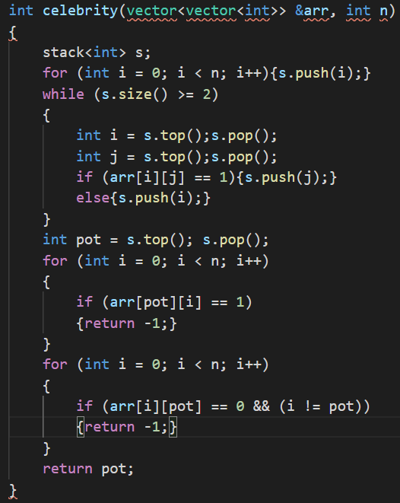

Ques 11) Evaluate expression

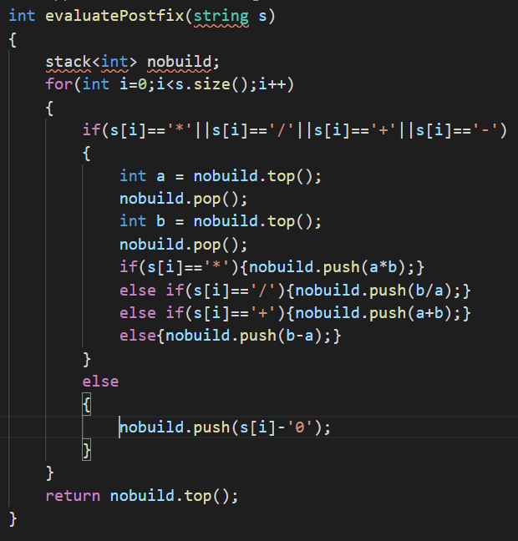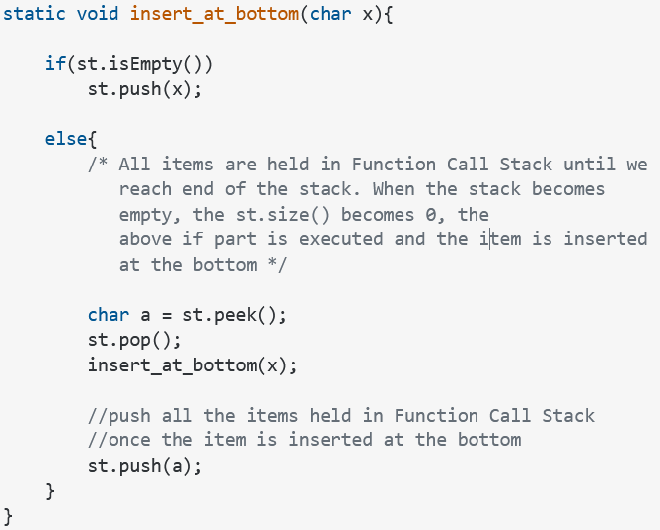

Ques 12) insert at bottom of stack

Ques 14) reverse a stack using recursion

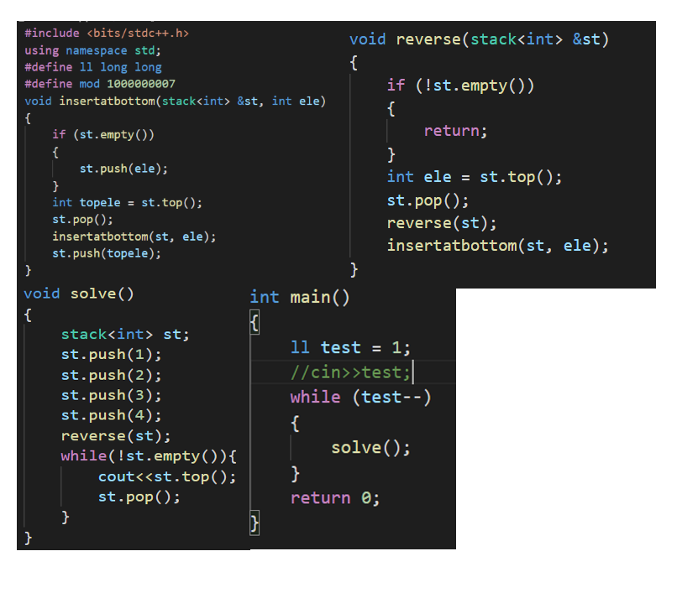

Ques 15) sort a stack using recursion

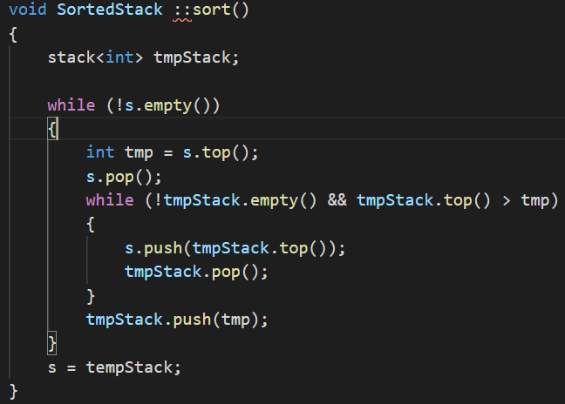

Ques 16) Merge intervals

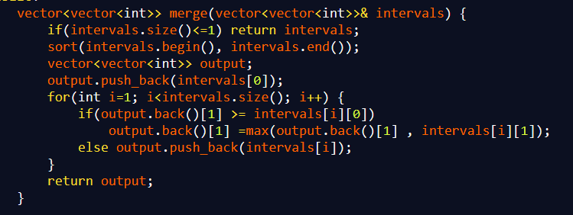

Ques 17)

Ques 18) Longest valid substring parenthese

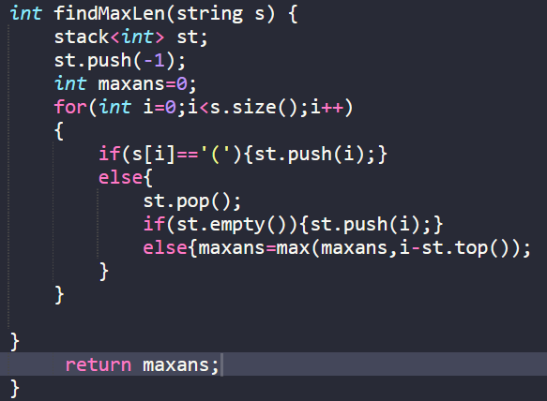

Ques 19) redundancy check for expressions

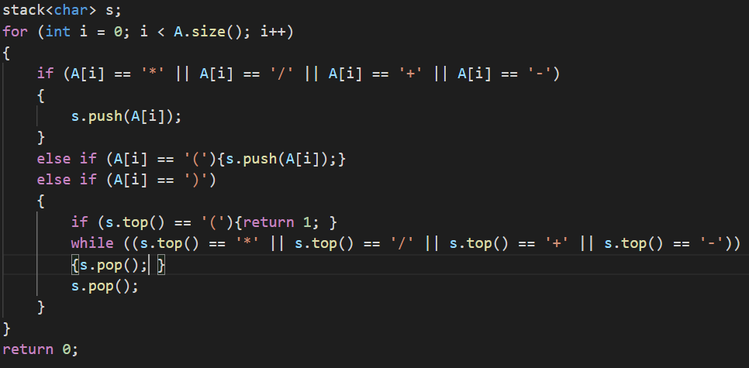

Ques 20) Implement stack using queue

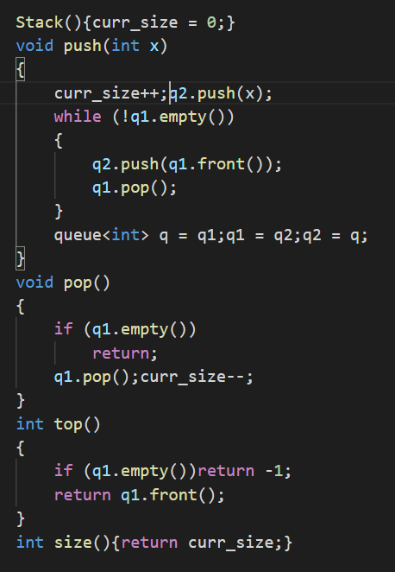

Ques 38) next smaller element

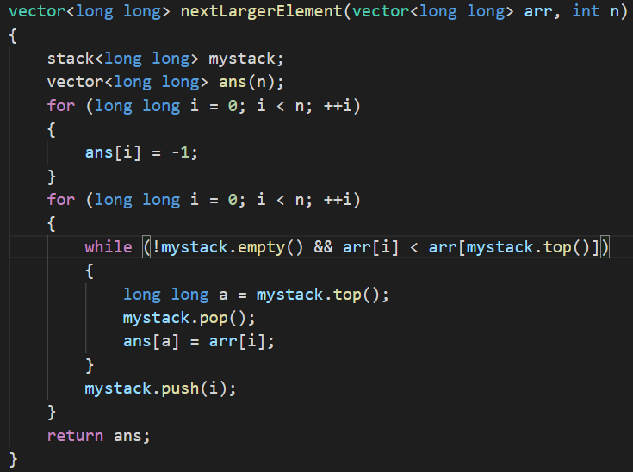

Ques 28)Reverse first k elements of queue

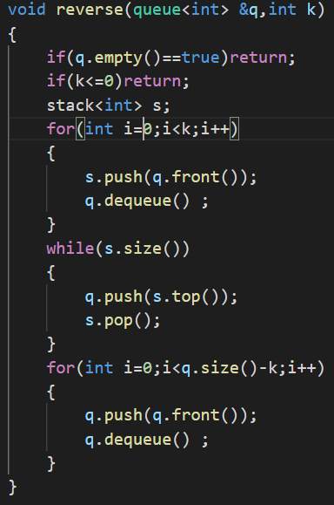

Ques 29) interleaving of charachters of queue

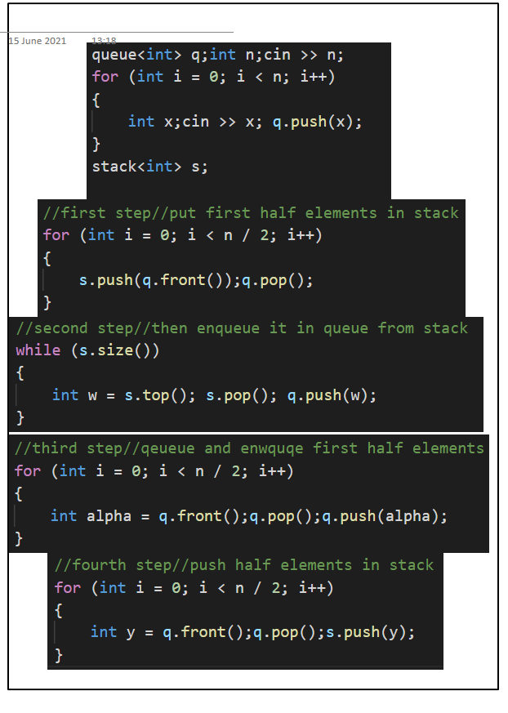

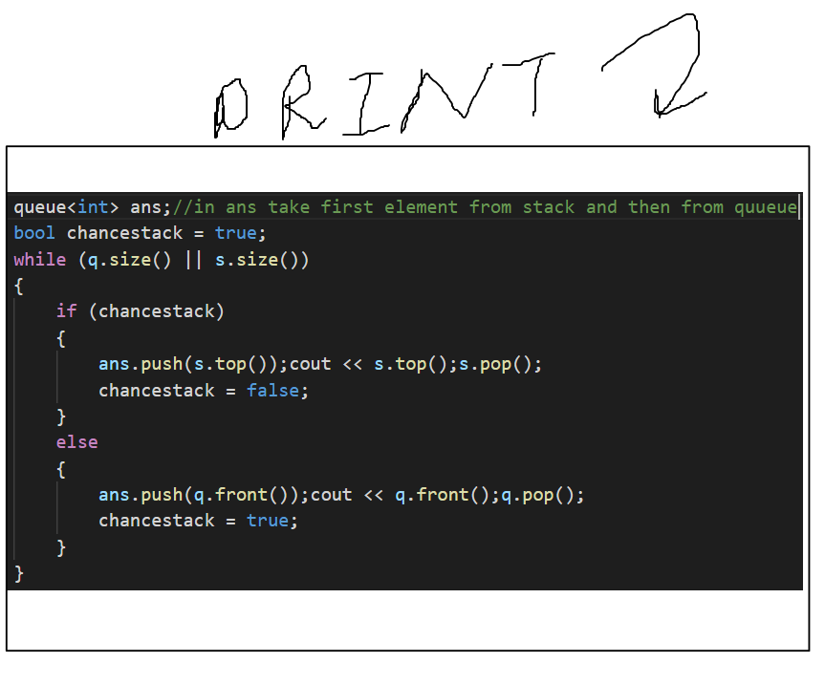

Ques 36) Minimum sum of charachters count

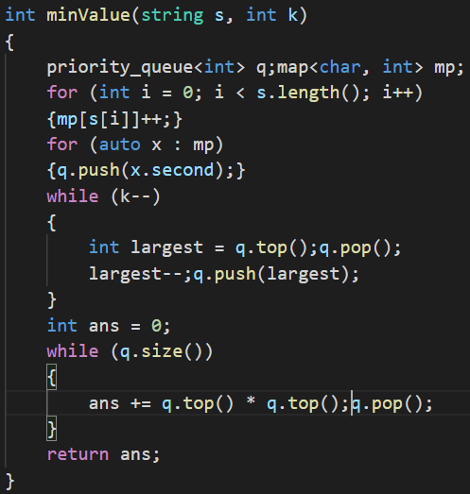

Ques 25)sum of minimum and maximum elements of all subarrays

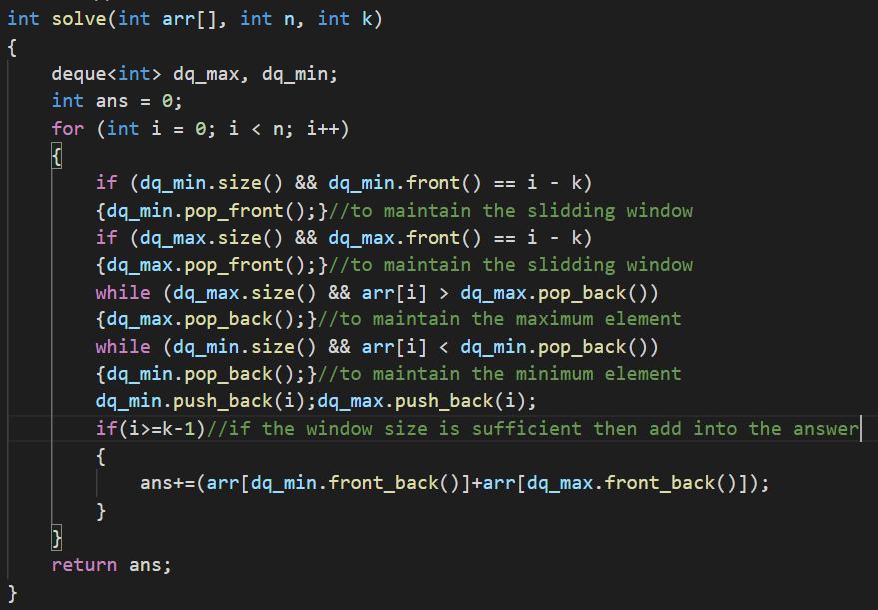

Ques 34) check if the levels of trees are anagrams or not?

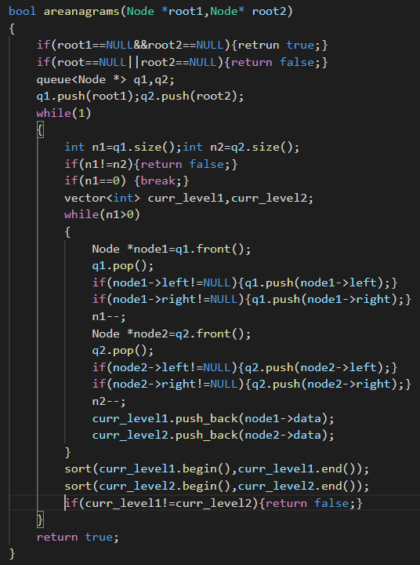

Ques 33)first negative in subarray of size k

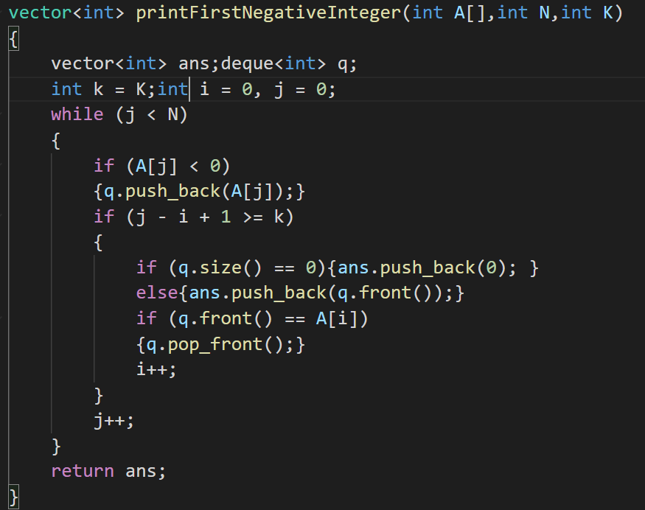

**BIT MANIPULATION**

Ques 1) Count number of set bits

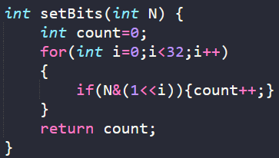

Ques 2) Find two elements in an array whose frequency ==1 others ==2

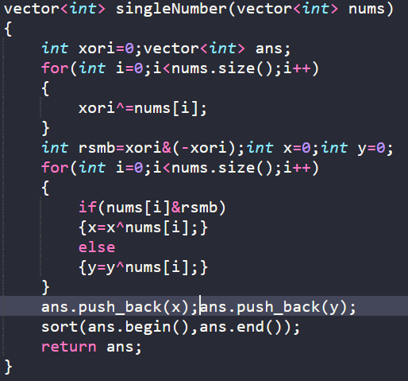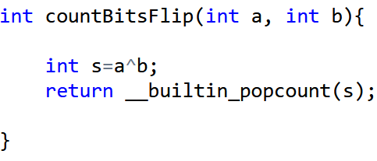

Ques 3)

Ques 4) Count total set bits till n

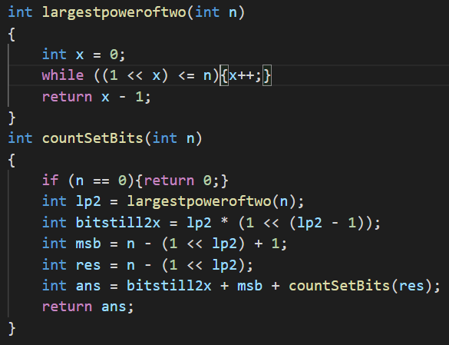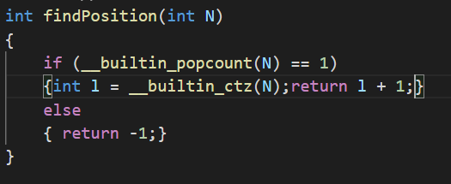

Ques 5) position of the only set bit

Ques 7) Copy set bits in a range

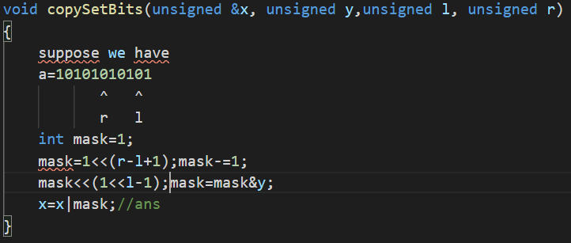

Ques 10) power sets

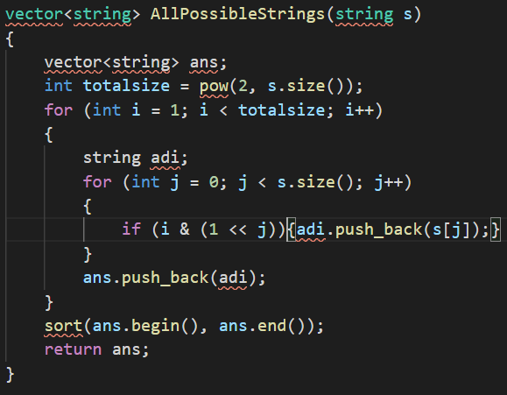

Ques 8) Divide two integers without using multiplication

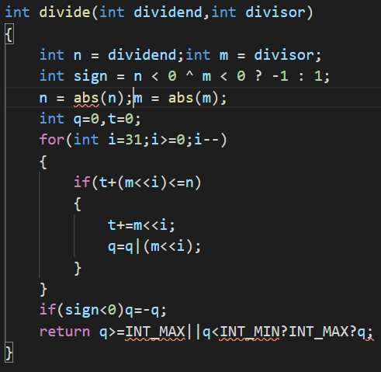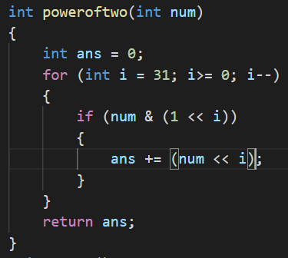

Ques 9) power of a number using bit manipulation

**BACKTRACKING**

Ques 1) Rat in a maze-1

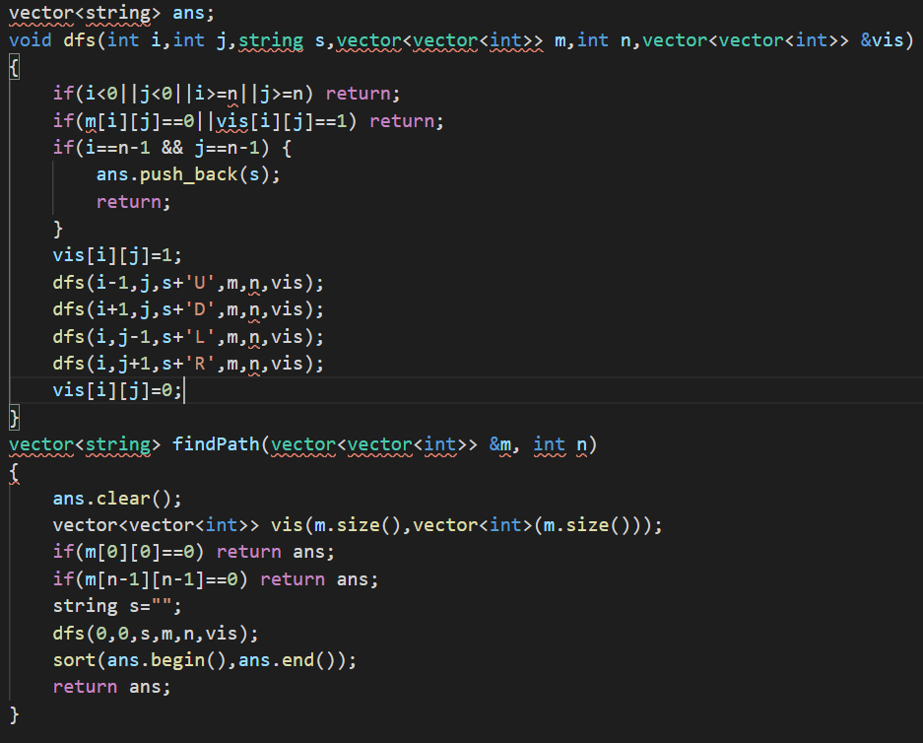

Ques 8) Subset sum problem, check whether complete array can be divided into two subsets having same sum

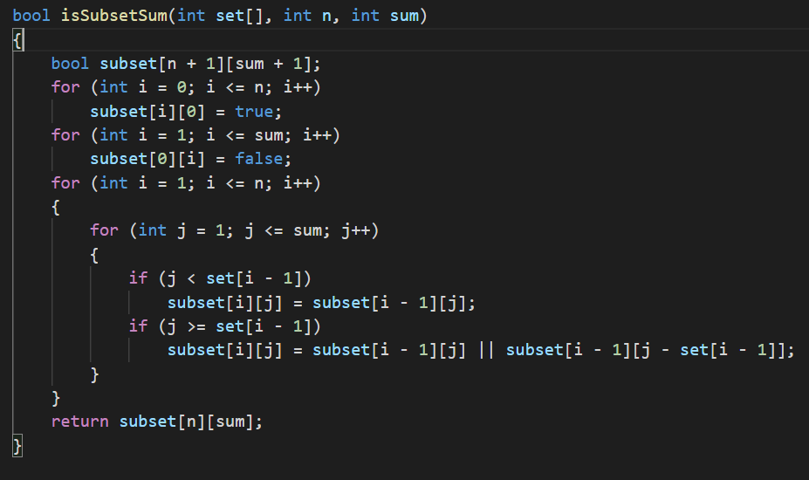

Ques 12) Combinational sum

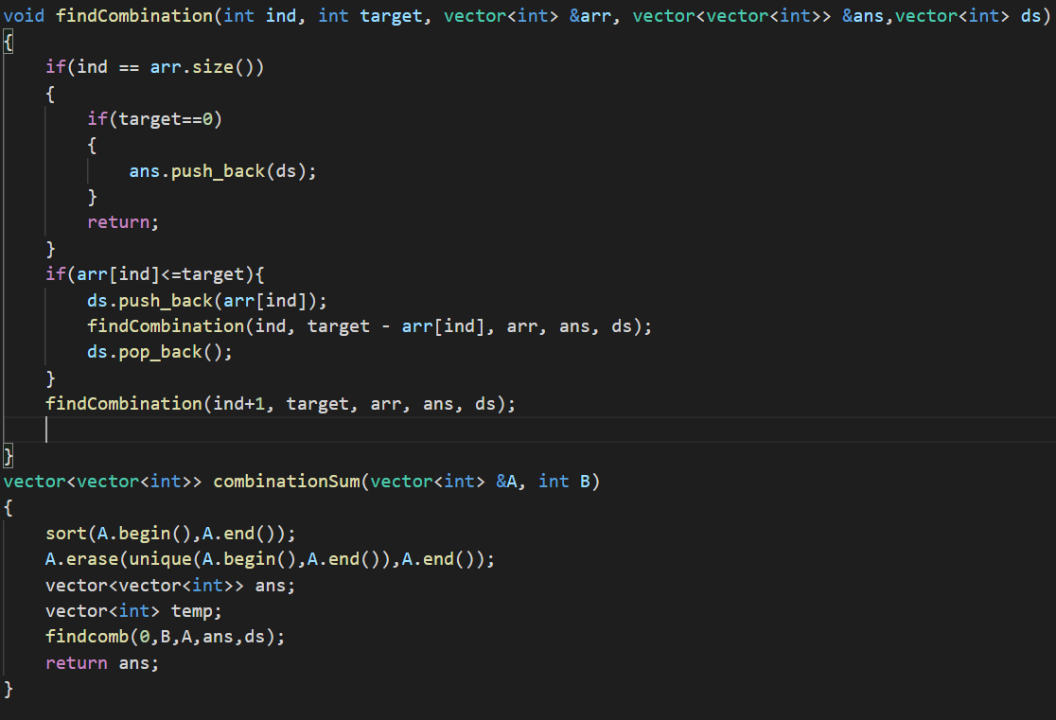

Ques 14) Print all permeutaton of a string  
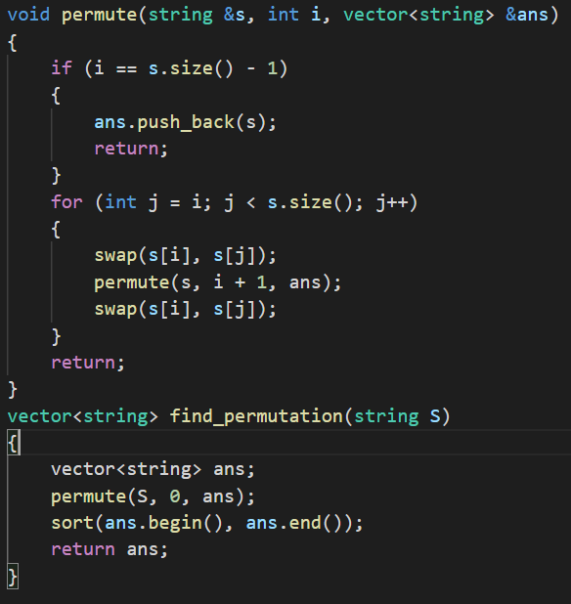

Ques 18)partition of a set into k subsets of equal sum

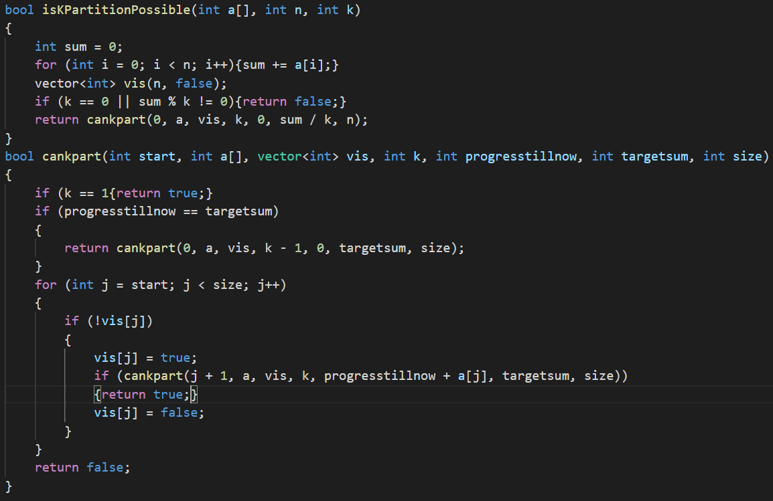

Ques 19) Fid kth permeutation of a sequence containing n nATURAL NUMBERS

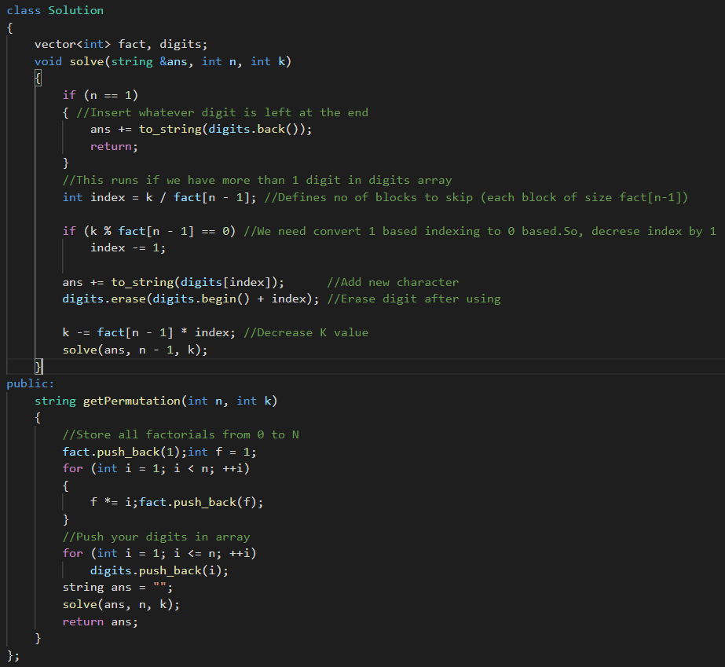

Ques 16) longest possible path in a matrix with hurdles

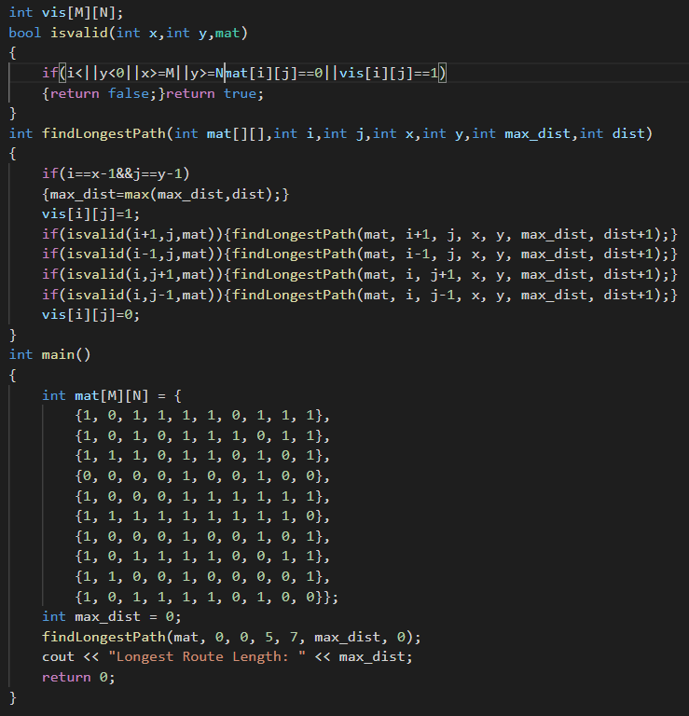

Ques 15) Find if there is path of more than length k from a source to other position

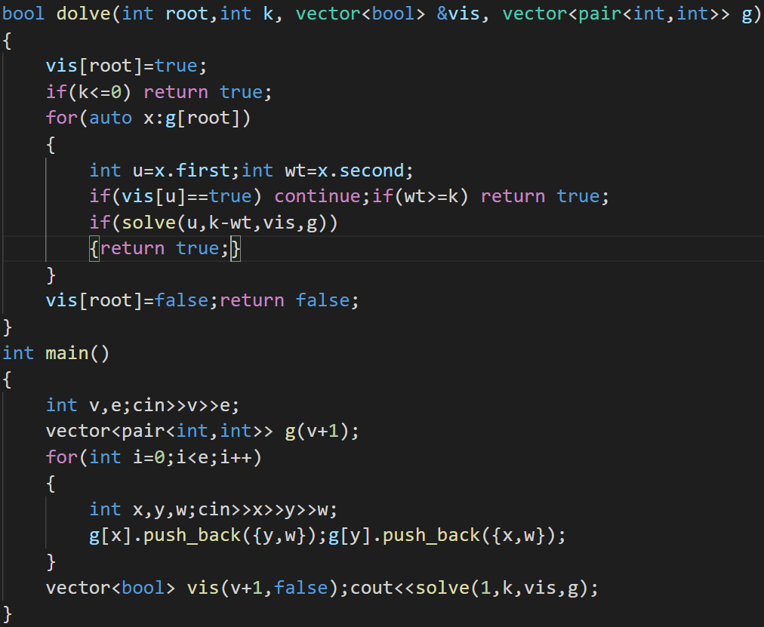

Ques 13) maximum possible number by doing at most k swaps

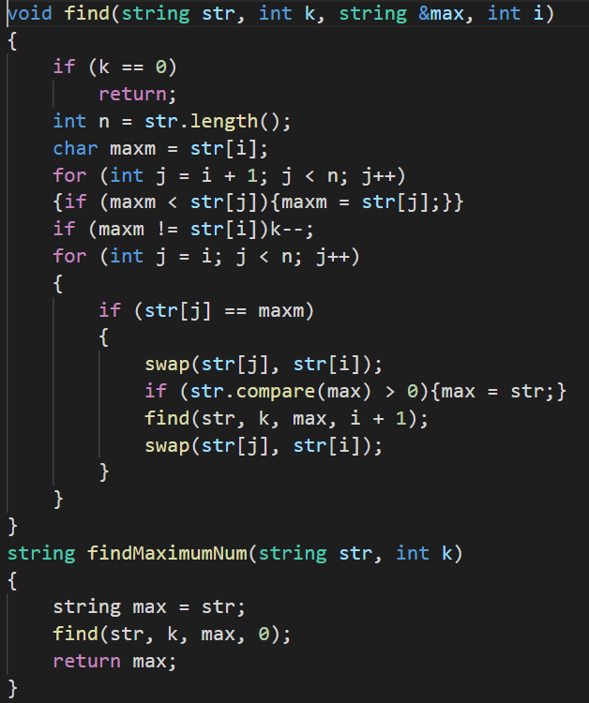

Ques 10) Tug of wars

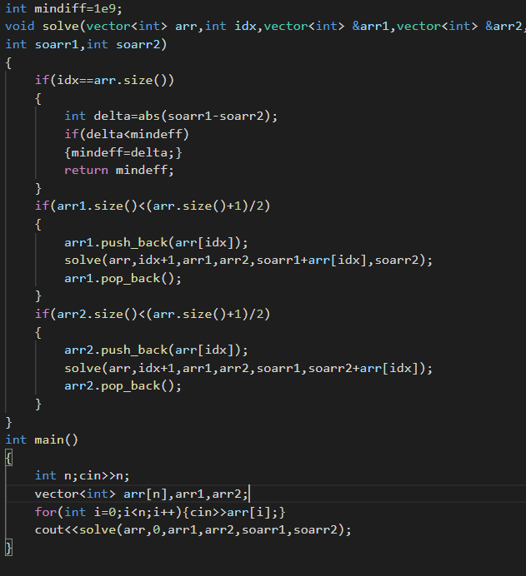

Ques 9)knight tour problem

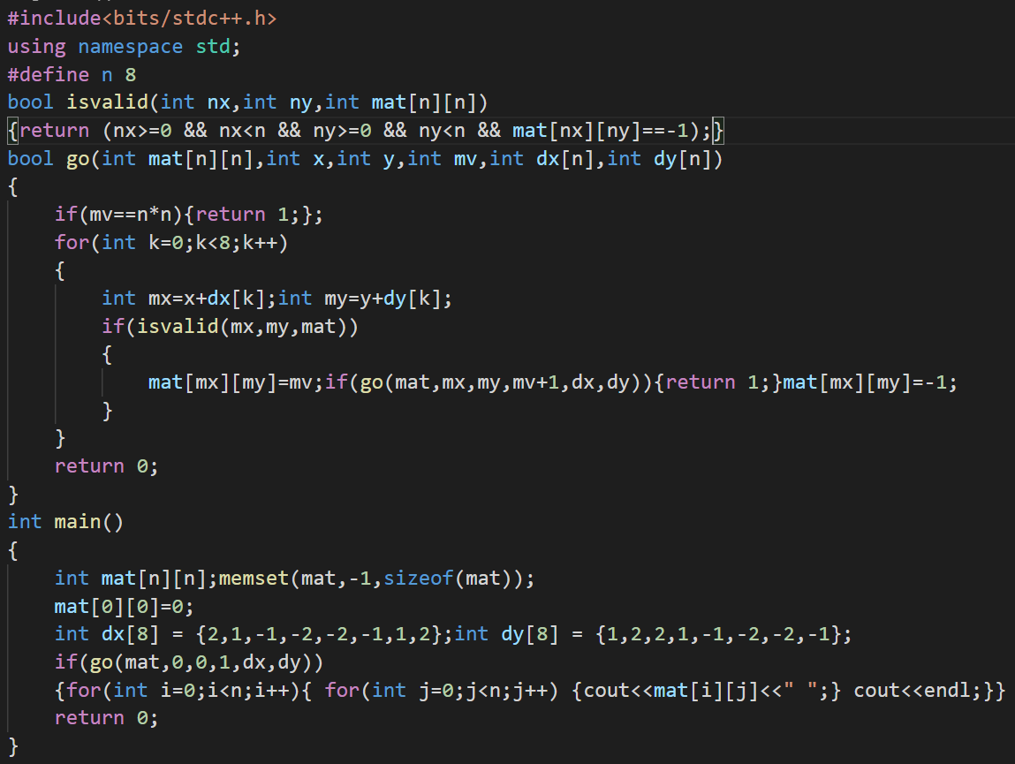

Ques 7) print all palindromic partitions of a string

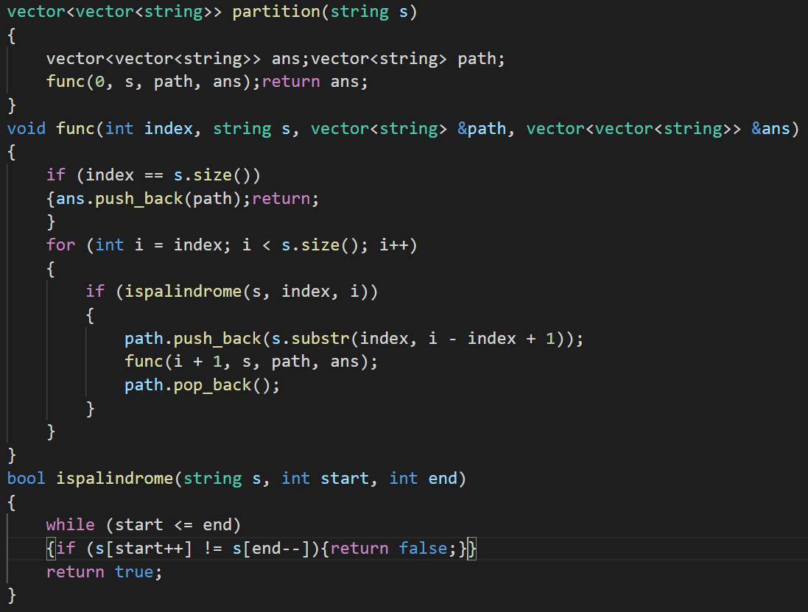

Ques 6) m coloring problem

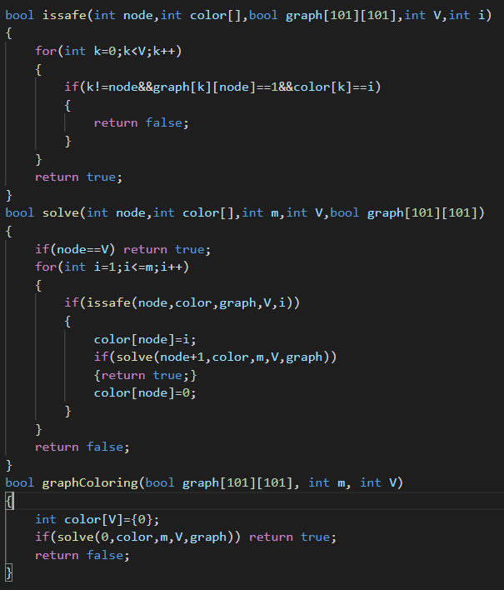

Ques 5) Suddoku solver

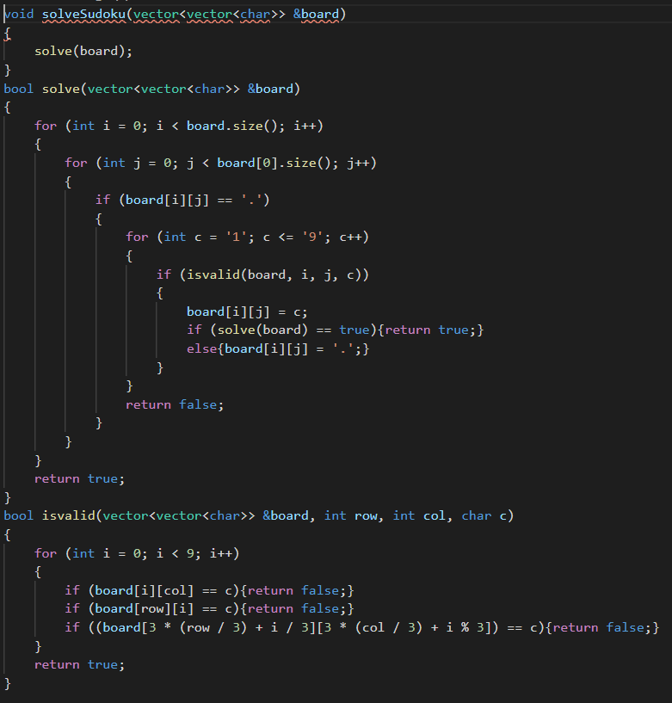

**HEAP**

18.Minimum sum formed by addition of element of a string

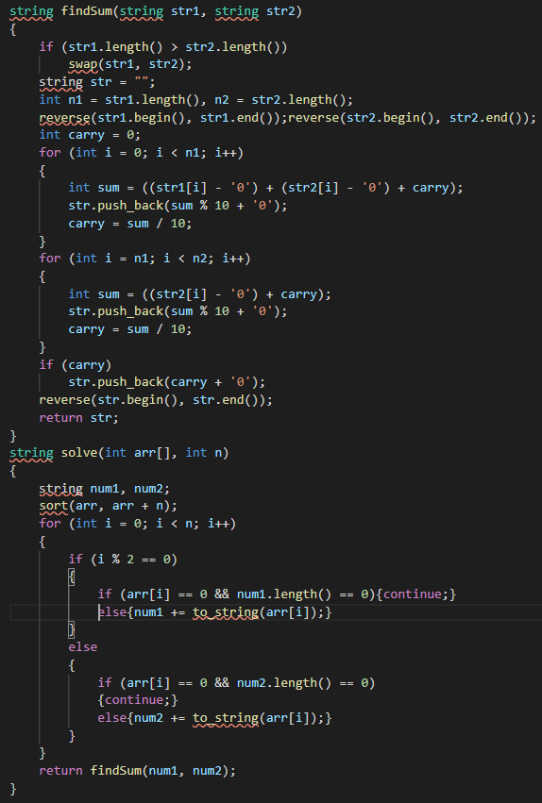

Ques 17) No two adjacent charachter same in a string

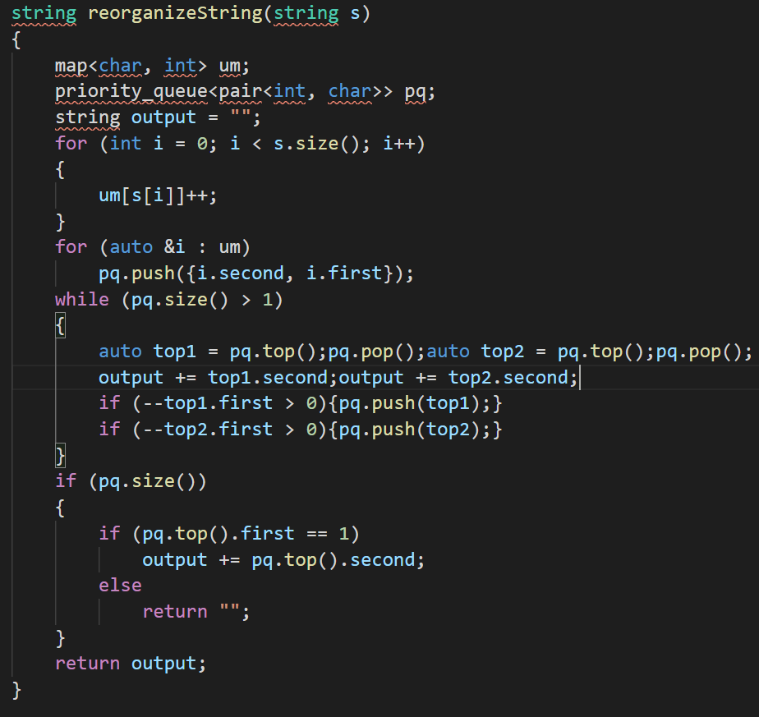

Ques 13) check if binary tree is is max heap or not?

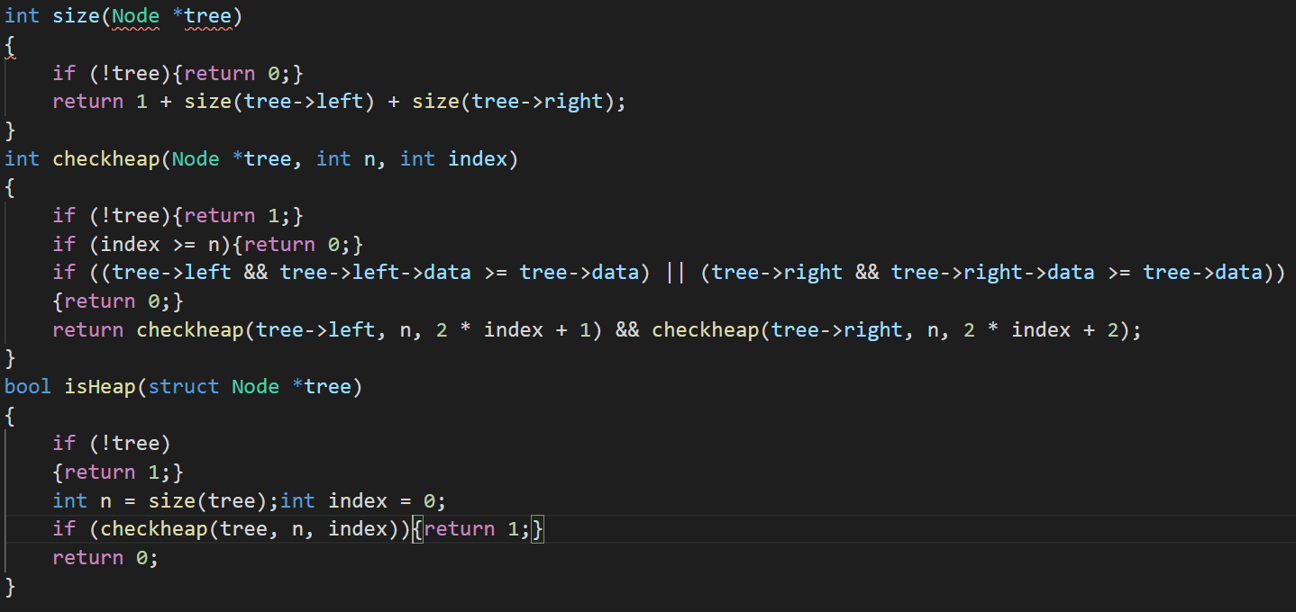

Ques 4) Find k largest elements from a array of elements

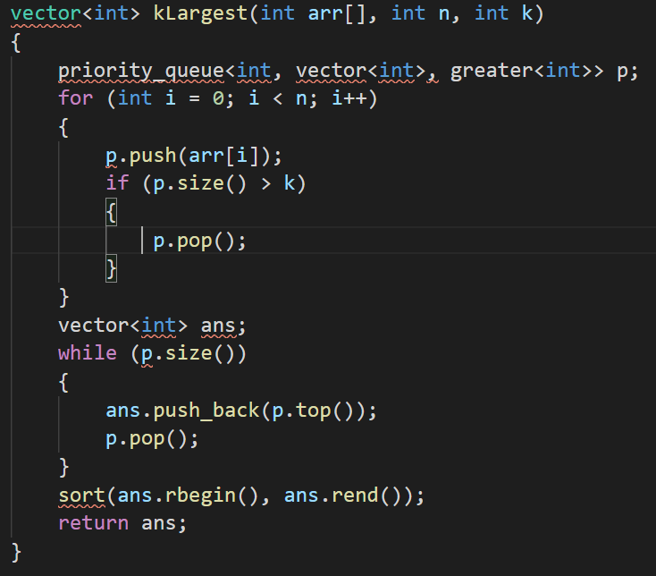

Ques 3) Maximum of all subarrays of size k

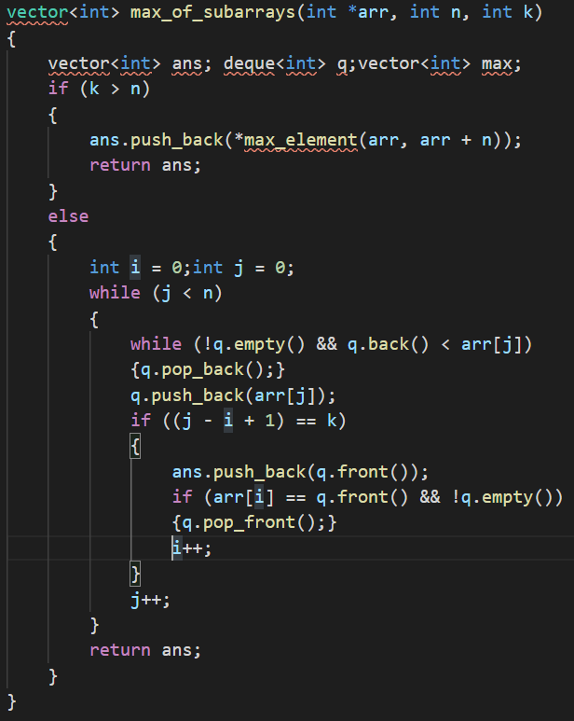

Ques 1 ) implement max heap or min heap in arrays

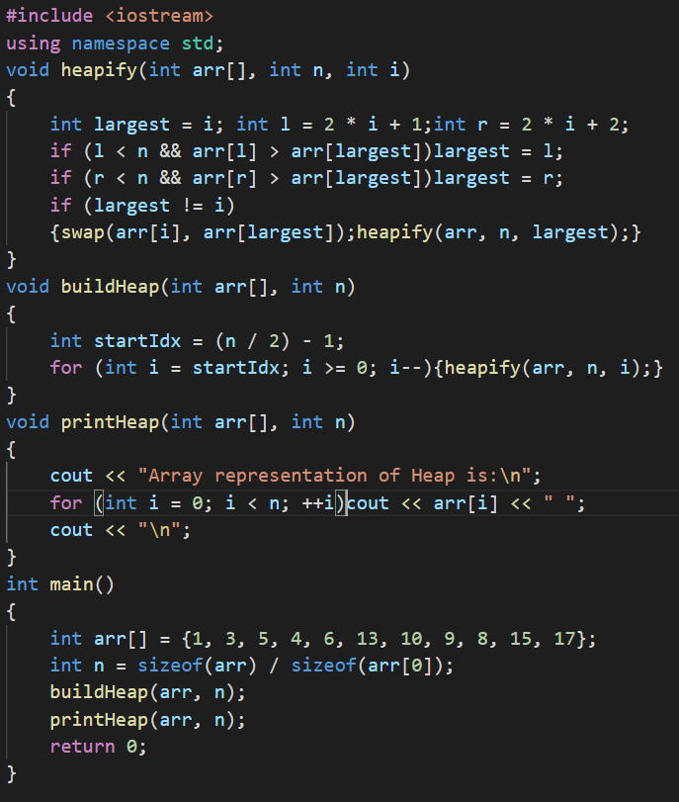

Ques 6) Merge k sorted arrays

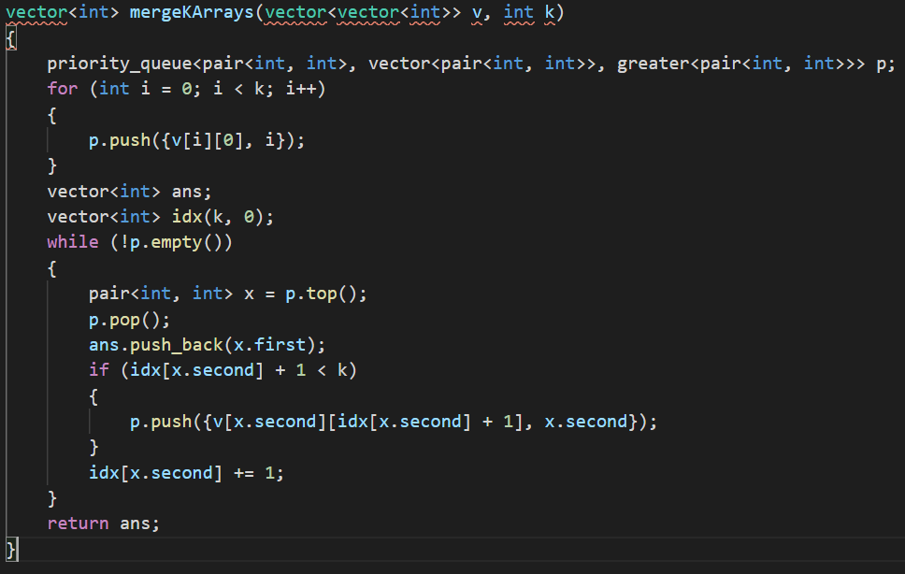

Ques 7) Merge two binary max-heaps

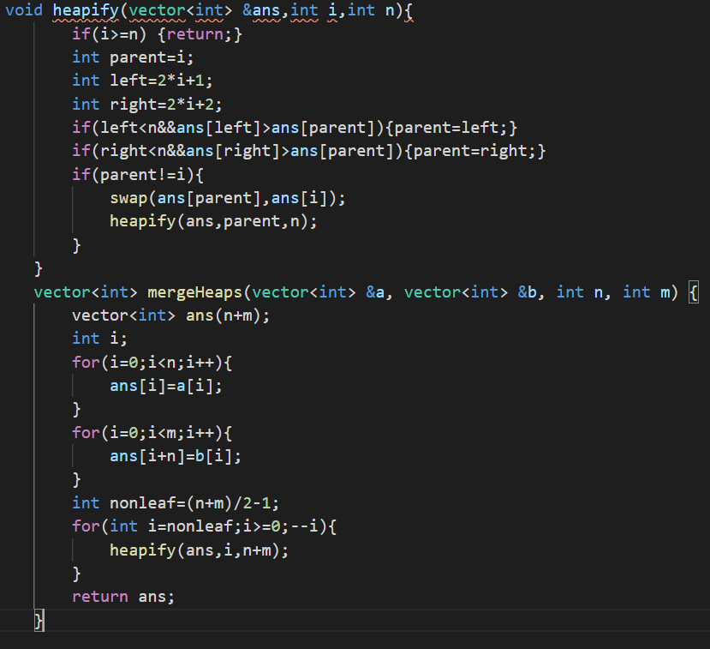

Ques 10) merge k sorted linked lists

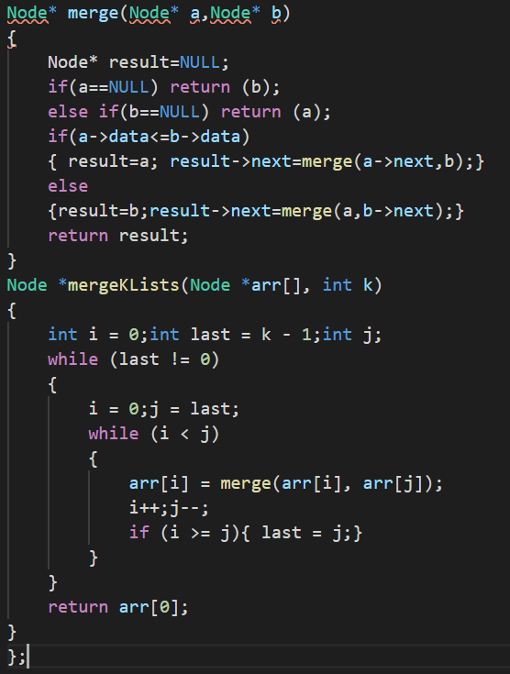

Ques 11) Smallest range in k lists

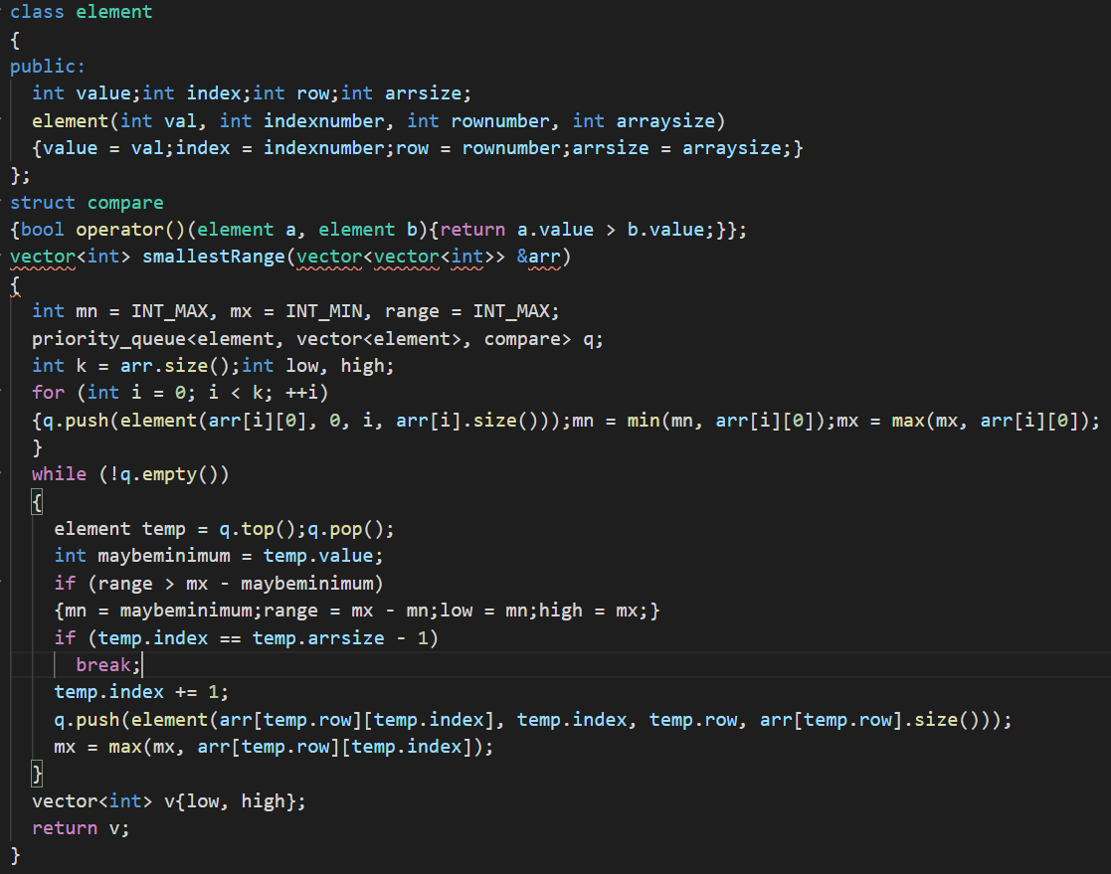

Ques 15) Convert BST to min heap

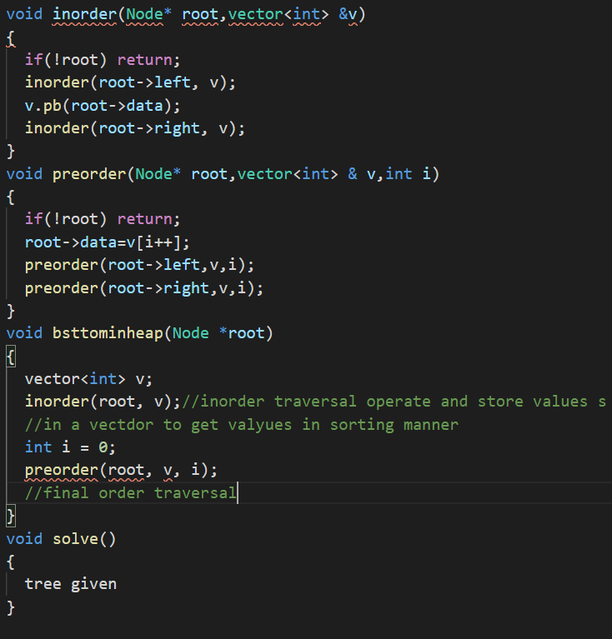

Ques 16) convert min heap to max heap

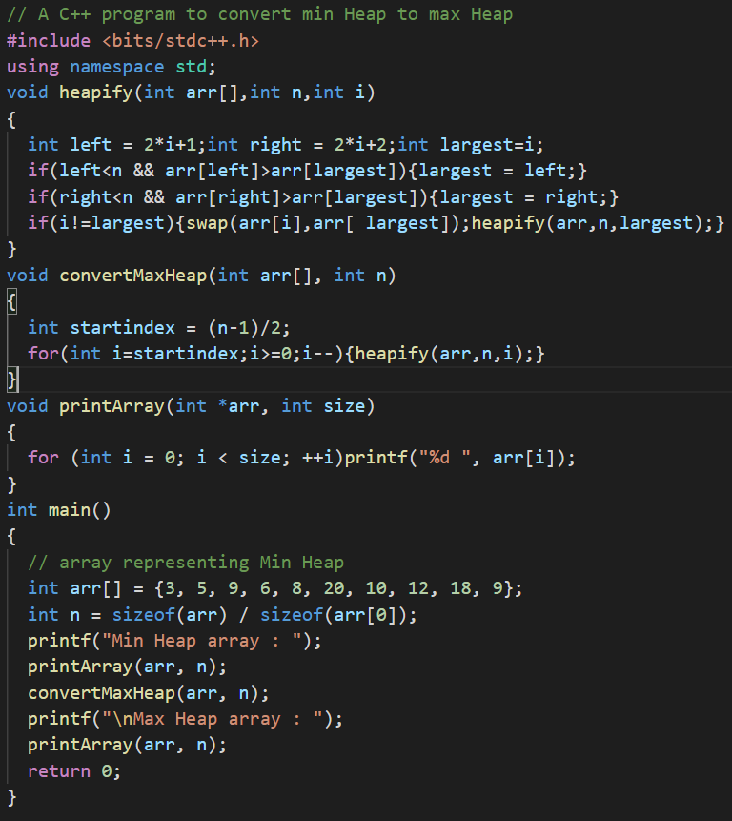

**BINARY TREE**

1. Level order traversal

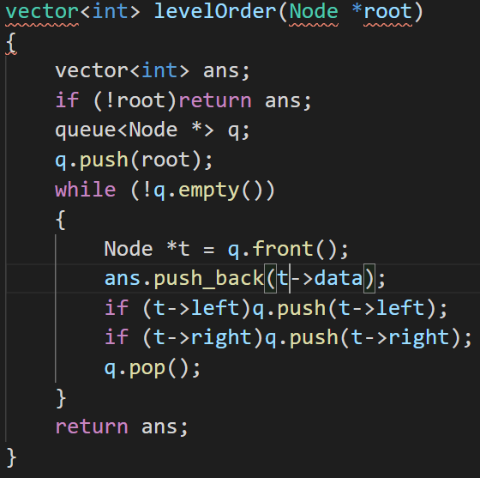

Ques 2) Reverse level order traversal

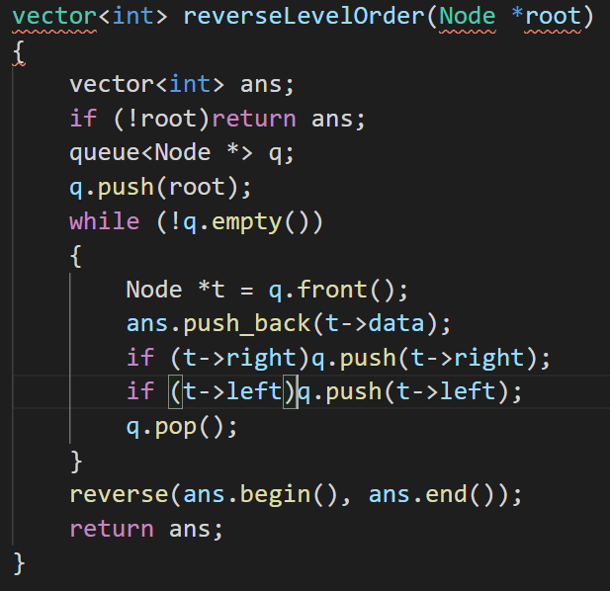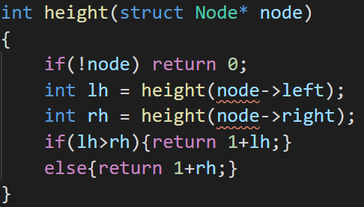

Ques 3) height of tree

Ques 4) Diameter of a binary tree

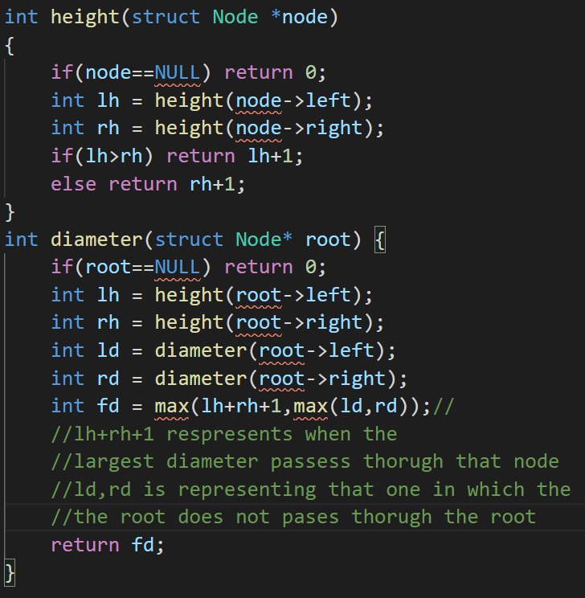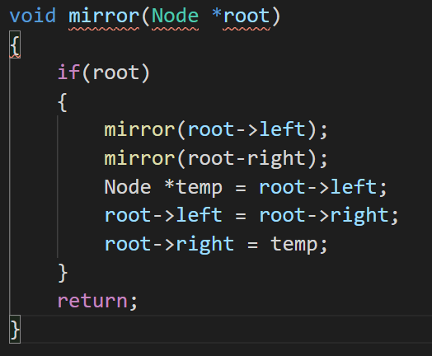

Ques 5) Mirror image of a binary tree

Ques 6) Inorder traversal

#include <iostream>

using namespace std;

struct Node

{

    int data;

    Node *left, *right;

    Node(int data)

    {

        this->data = data;

        this->left = this->right = nullptr;

    }

};

// Recursive function to perform inorder traversal on the tree

void inorder(Node* root)

{

    // return if the current node is empty

    if (root == nullptr) {

        return;

    }

    // Traverse the left subtree

    inorder(root->left);

    // Display the data part of the root (or current node)

    cout << root->data << " ";

    // Traverse the right subtree

    inorder(root->right);

}

int main()

{

    /* Construct the following tree

               1

             /   \

            /     \

           2       3

          /      /   \

         /      /     \

        4      5       6

              / \

             /   \

            7     8

    */

    Node* root = new Node(1);

    root->left = new Node(2);

    root->right = new Node(3);

    root->left->left = new Node(4);

    root->right->left = new Node(5);

    root->right->right = new Node(6);

    root->right->left->left = new Node(7);

    root->right->left->right = new Node(8);

    inorder(root);

    return 0;

}

Ques 7) Postorder traversal

#include <iostream>

using namespace std;

struct Node

{

    int data;

    Node *left, *right;

    Node(int data)

    {

        this->data = data;

        this->left = this->right = nullptr;

    }

};

// Recursive function to perform postorder traversal on the tree

void postorder(Node* root)

{

    // return if the current node is empty

    if (root == nullptr) {

        return;

    }

    // Traverse the left subtree

    postorder(root->left);

    // Traverse the right subtree

    postorder(root->right);

    // Display the data part of the root (or current node)

    cout << root->data << " ";

}

int main()

{

    /* Construct the following tree

               1

             /   \

            /     \

           2       3

          /      /   \

         /      /     \

        4      5       6

              / \

             /   \

            7     8

    */

    Node* root = new Node(1);

    root->left = new Node(2);

    root->right = new Node(3);

    root->left->left = new Node(4);

    root->right->left = new Node(5);

    root->right->right = new Node(6);

    root->right->left->left = new Node(7);

    root->right->left->right = new Node(8);

    postorder(root);

    return 0;

}

Ques 8) preOrder traversal

#include <iostream>

using namespace std;

struct Node

{

    int data;

    Node *left, *right;

    Node(int data)

    {

        this->data = data;

        this->left = this->right = nullptr;

    }

};

// Recursive function to perform inorder traversal on the tree

void preorder(Node* root)

{

    // return if the current node is empty

    if (root == nullptr) {

        return;

    }

    // Display the data part of the root (or current node)

    cout << root->data << " ";

    // Traverse the left subtree

    preorder(root->left);

    // Traverse the right subtree

    preorder(root->right);

}

int main()

{

    /* Construct the following tree

               1

             /   \

            /     \

           2       3

          /      /   \

         /      /     \

        4      5       6

              / \

             /   \

            7     8

    */

    Node* root = new Node(1);

    root->left = new Node(2);

    root->right = new Node(3);

    root->left->left = new Node(4);

    root->right->left = new Node(5);

    root->right->right = new Node(6);

    root->right->left->left = new Node(7);

    root->right->left->right = new Node(8);

    preorder(root);

    return 0;

}

Ques 9) left view of a tree

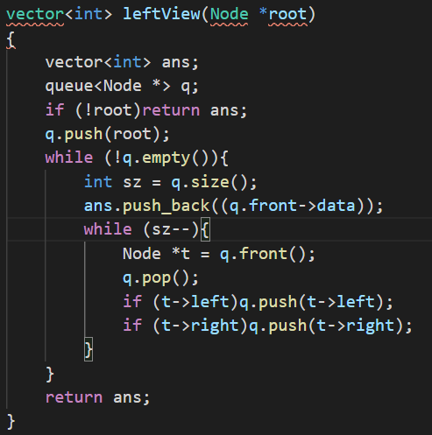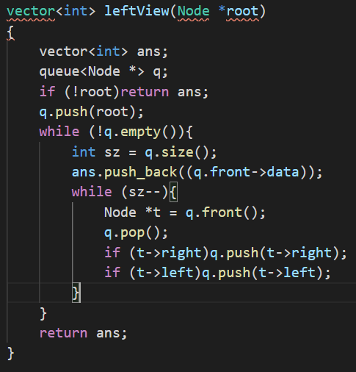

Ques 10) right view of a binary tree //observe the difference between left and right view of a tree

Ques 11) top view of a tree

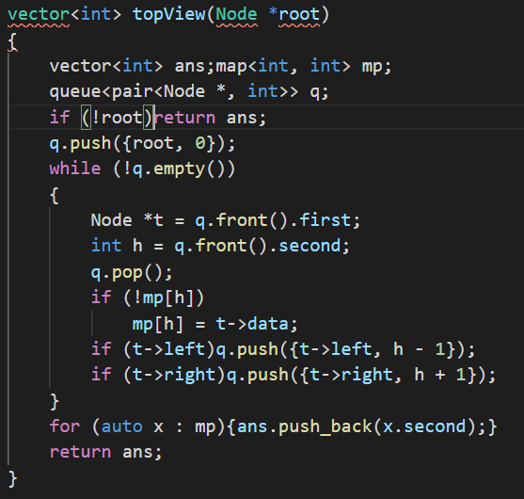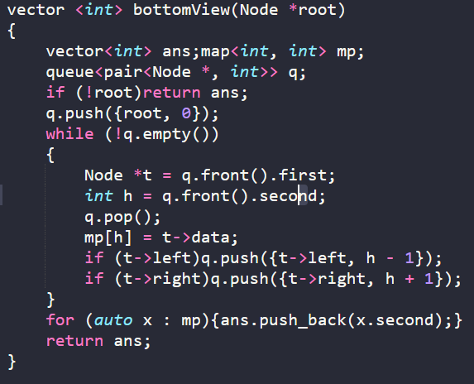

Ques 12) bottom view of a binary tree //observe the difference between left and right view of a tree

Ques 13) Zig zag traversal of a binary tree

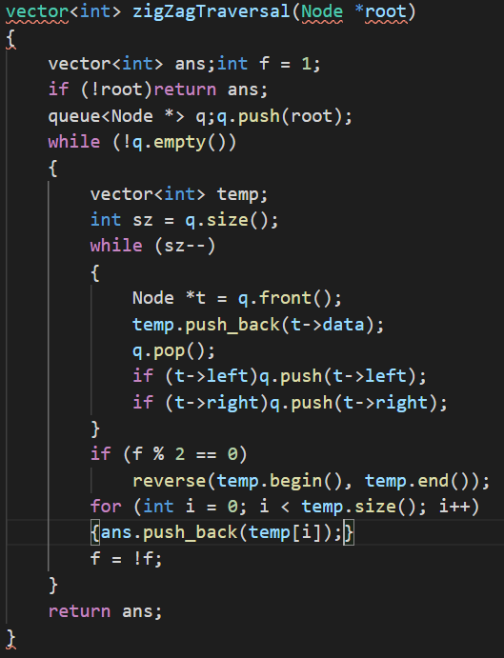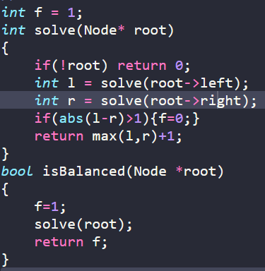

Ques 14) check tree is balanced or not

Ques 15) Diagonal traversal of a binary tree

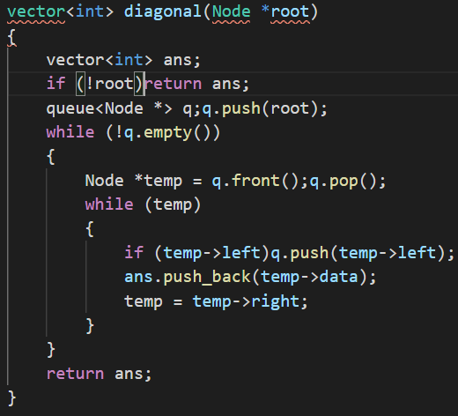

Ques 16) boundary traversal of a binary tree

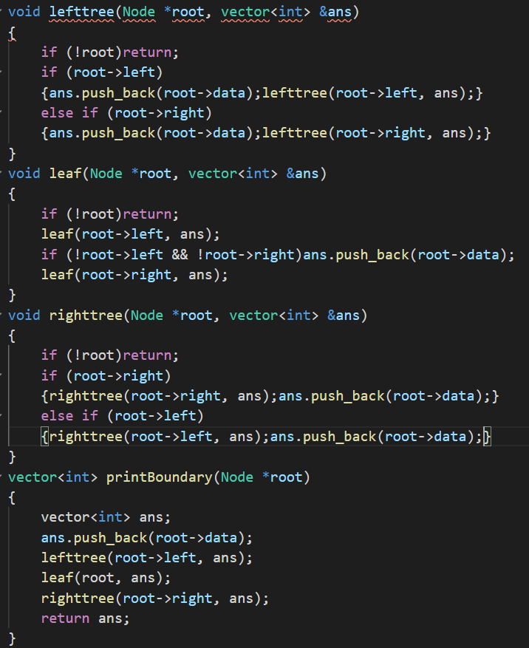

Ques 18) convert binary tree to double linked list

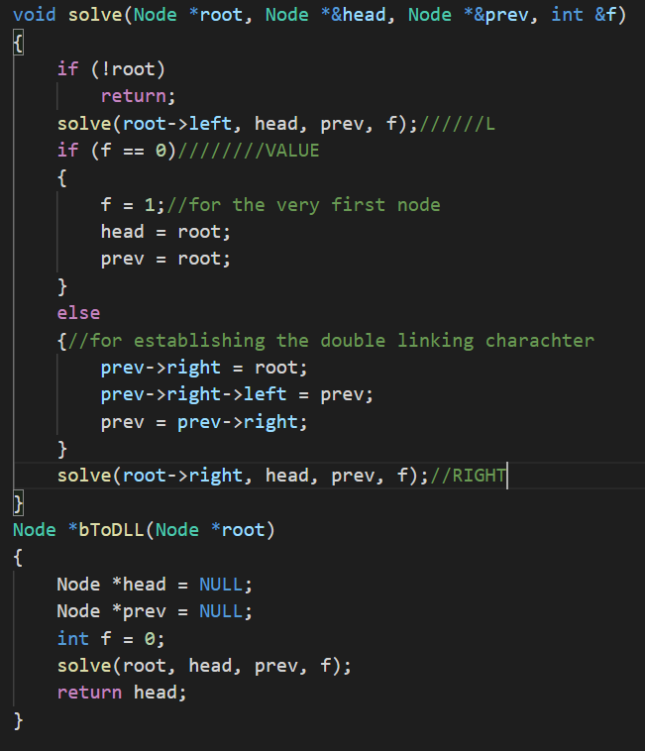

Ques 19) binary tree to sum tree

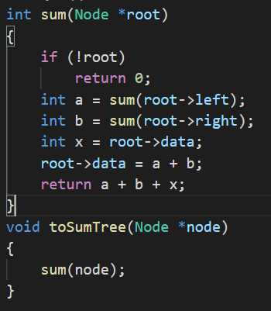

Ques 20) Construct tree from inorder and preorder traversal

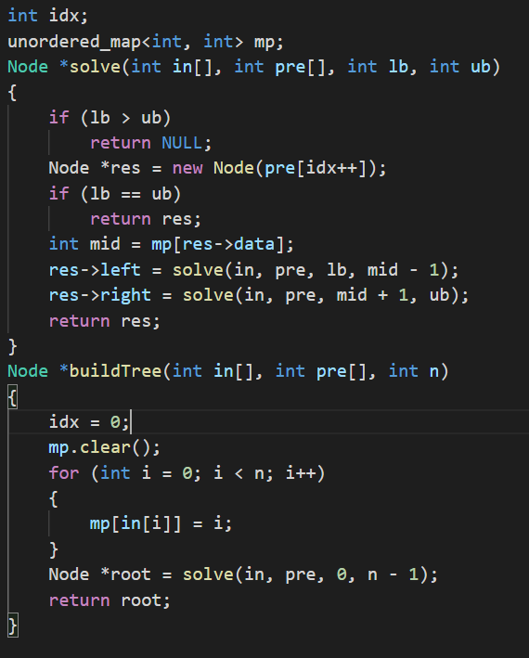

Ques 21 minimum number of swaps required to convert bt to bst

// C++ program for Minimum swap required

// to convert binary tree to binary search tree

#include <bits/stdc++.h>

using namespace std;

// Inorder Traversal of Binary Tree

void inorder(int a[], std::vector<int> &v, int n, int index)

{

    // if index is greater or equal to vector size

    if (index >= n)

        return;

    inorder(a, v, n, 2 * index + 1);

    // push elements in vector

    v.push_back(a[index]);

    inorder(a, v, n, 2 * index + 2);

}

// Function to find minimum swaps to sort an array

int minSwaps(std::vector<int> &v)

{

    std::vector<pair<int, int>> t(v.size());

    int ans = 0;

    for (int i = 0; i < v.size(); i++)

        t[i].first = v[i], t[i].second = i;

    sort(t.begin(), t.end());

    for (int i = 0; i < t.size(); i++)

    {

        // second element is equal to i

        if (i == t[i].second)

            continue;

        else

        {

            // swaping of elements

            swap(t[i].first, t[t[i].second].first);

            swap(t[i].second, t[t[i].second].second);

        }

        // Second is not equal to i

        if (i != t[i].second)

            --i;

        ans++;

    }

    return ans;

}

// Driver code

int main()

{

    int a[] = {5, 6, 7, 8, 9, 10, 11};

    int n = sizeof(a) / sizeof(a[0]);

    std::vector<int> v;

    inorder(a, v, n, 0);

    cout << minSwaps(v) << endl;

}

// This code is contributed by code_freak

Ques 22) check a tree is s asum tree or not

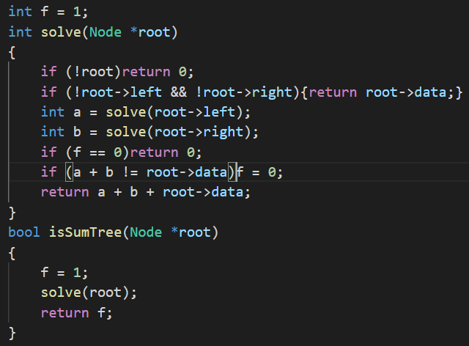

Ques 23) check if all the levels are at the same level or not?

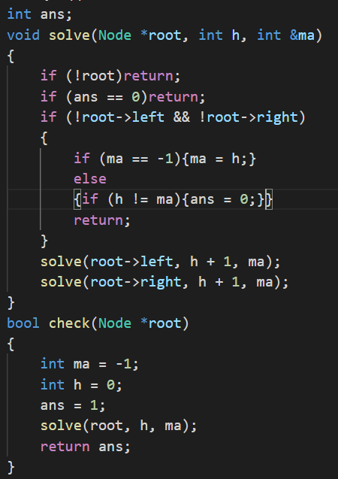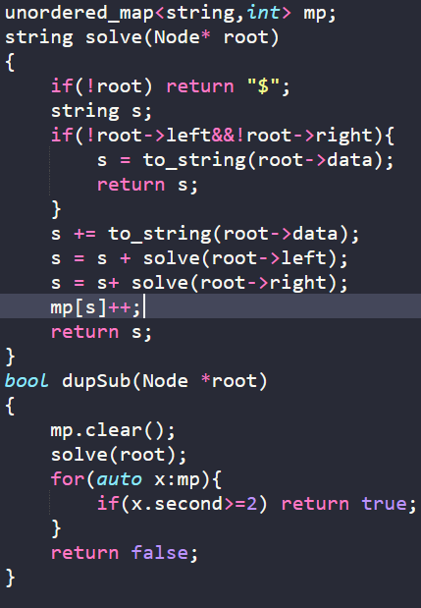

Ques 24) contains multiple subtress or not

Ques 25)sum of nodes on the longest path

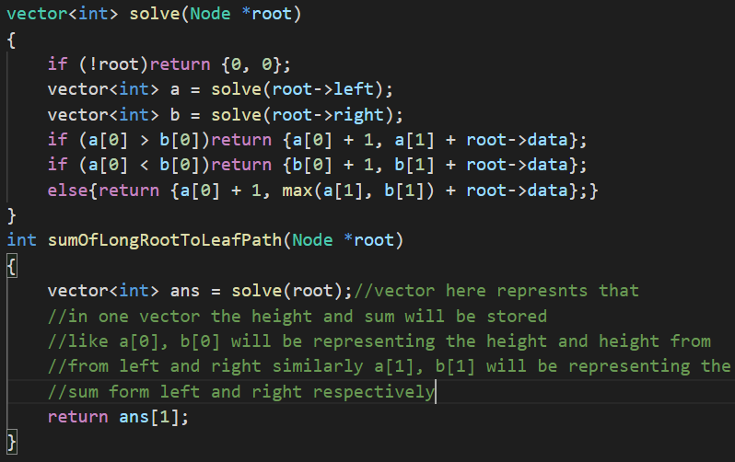

Ques 26)check if a graph is a tree or not

// A C++ Program to check whether a graph is tree or not

#include <iostream>

#include <list>

#include <limits.h>

using namespace std;

// Class for an undirected graph

class Graph

{

    int V;          // No. of vertices

    list<int> *adj; // Pointer to an array for adjacency lists

    bool isCyclicUtil(int v, bool visited[], int parent);

public:

    Graph(int V);               // Constructor

    void addEdge(int v, int w); // to add an edge to graph

    bool isTree();              // returns true if graph is tree

};

Graph::Graph(int V)

{

    this->V = V;

    adj = new list<int>[V];

}

void Graph::addEdge(int v, int w)

{

    adj[v].push_back(w); // Add w to v’s list.

    adj[w].push_back(v); // Add v to w’s list.

}

// A recursive function that uses visited[] and parent to

// detect cycle in subgraph reachable from vertex v.

bool Graph::isCyclicUtil(int v, bool visited[], int parent)

{

    // Mark the current node as visited

    visited[v] = true;

    // Recur for all the vertices adjacent to this vertex

    list<int>::iterator i;

    for (i = adj[v].begin(); i != adj[v].end(); ++i)

    {

        // If an adjacent is not visited, then recur for

        // that adjacent

        if (!visited[*i])

        {

            if (isCyclicUtil(*i, visited, v))

                return true;

        }

        // If an adjacent is visited and not parent of current

        // vertex, then there is a cycle.

        else if (*i != parent)

            return true;

    }

    return false;

}

// Returns true if the graph is a tree, else false.

bool Graph::isTree()

{

    // Mark all the vertices as not visited and not part of

    // recursion stack

    bool *visited = new bool[V];

    for (int i = 0; i < V; i++)

        visited[i] = false;

    // The call to isCyclicUtil serves multiple purposes.

    // It returns true if graph reachable from vertex 0

    // is cyclcic. It also marks all vertices reachable

    // from 0.

    if (isCyclicUtil(0, visited, -1))

        return false;

    // If we find a vertex which is not reachable from 0

    // (not marked by isCyclicUtil(), then we return false

    for (int u = 0; u < V; u++)

        if (!visited[u])

            return false;

    return true;

}

// Driver program to test above functions

int main()

{

    Graph g1(5);

    g1.addEdge(1, 0);

    g1.addEdge(0, 2);

    g1.addEdge(0, 3);

    g1.addEdge(3, 4);

    g1.isTree() ? cout << "Graph is Tree\n" : cout << "Graph is not Tree\n";

    Graph g2(5);

    g2.addEdge(1, 0);

    g2.addEdge(0, 2);

    g2.addEdge(2, 1);

    g2.addEdge(0, 3);

    g2.addEdge(3, 4);

    g2.isTree() ? cout << "Graph is Tree\n" : cout << "Graph is not Tree\n";

    return 0;

}

Ques 28 ) LARGEST SUBTREE SUM OF STREE

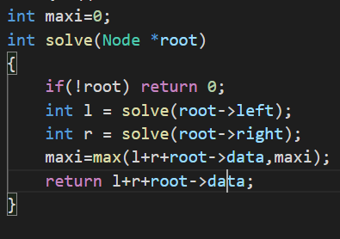

Ques 29) maximum sum of nodes in a tree such no two are adjacent

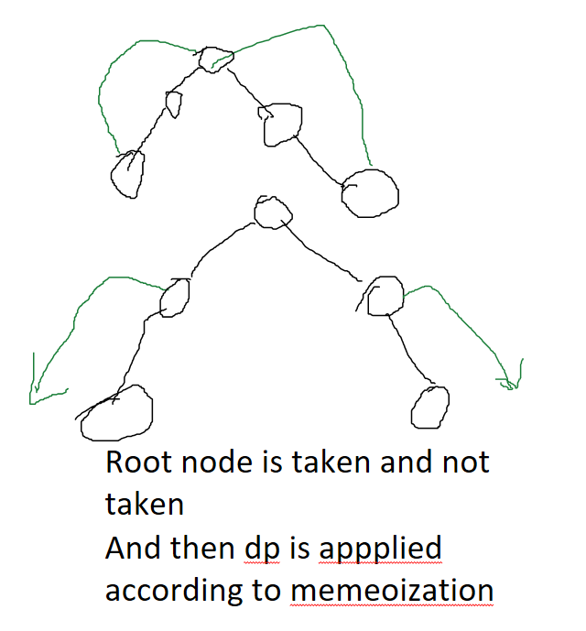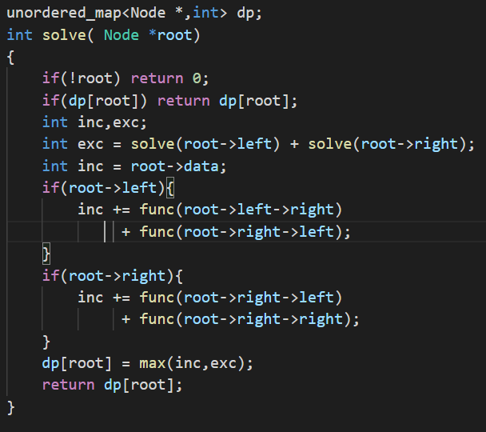

Ques 30) LCA in a binary tree

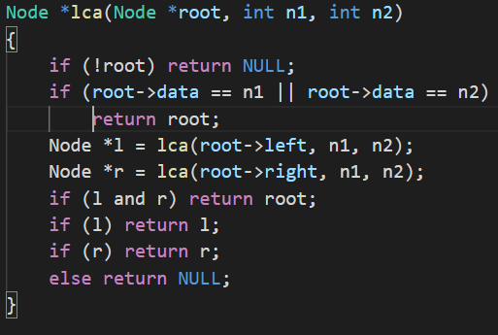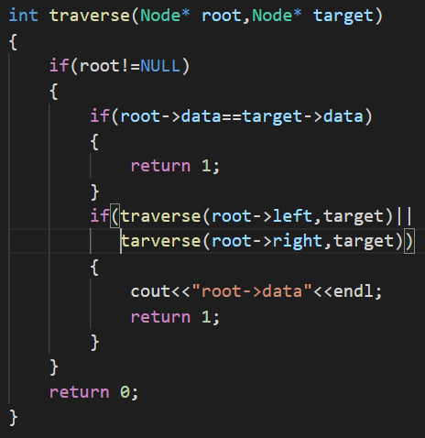

Ques 31) print all ancestors of a node in a binary tree

Ques 32)

Ques 33) check isomorphism

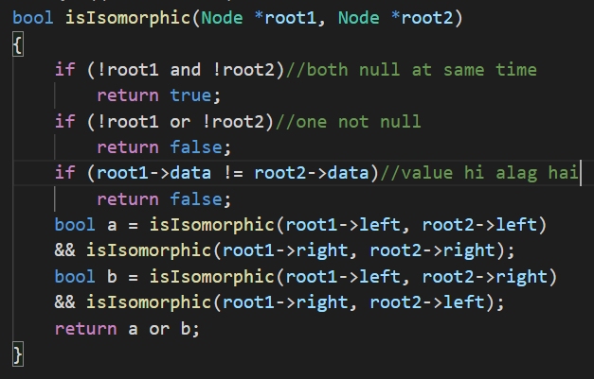

**BST**

1. Insert a values in BST

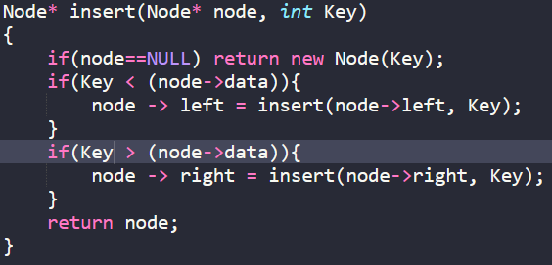

Ques 2) Deletion of a node in BST

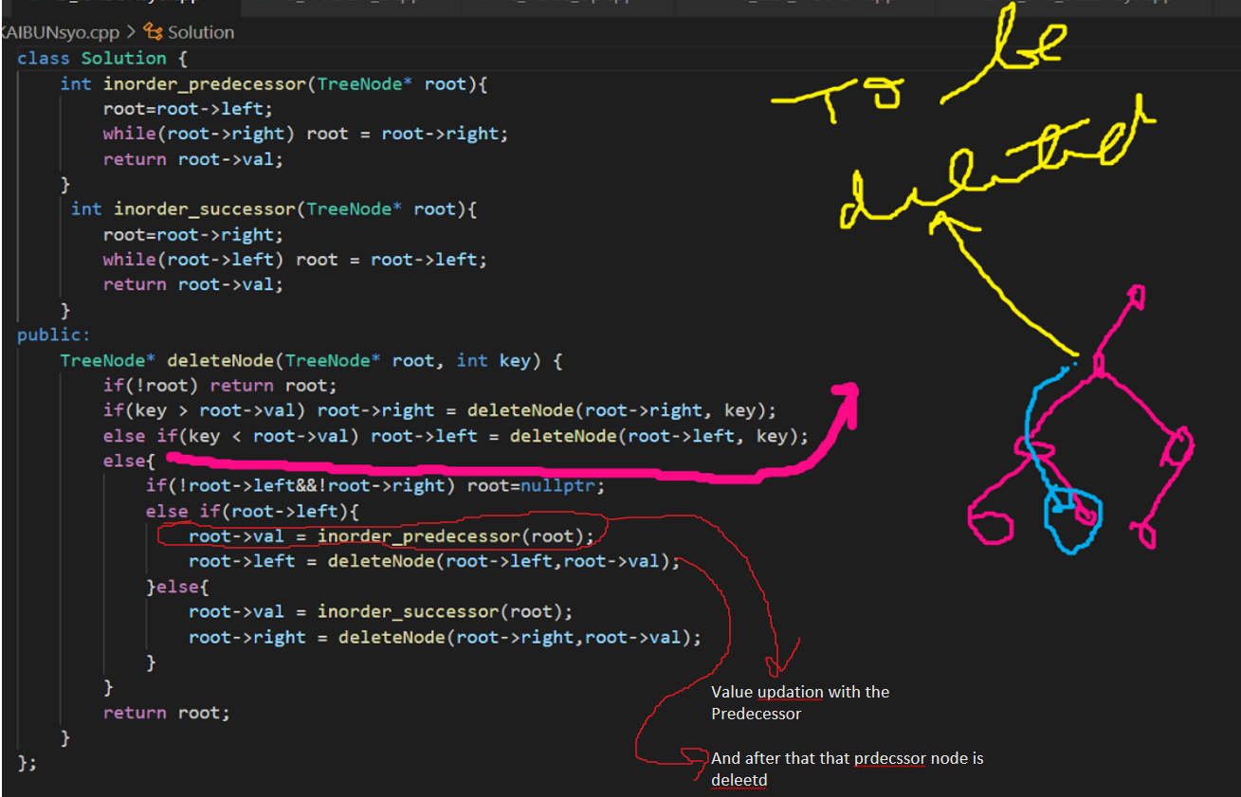

Ques 3) Minimum element in a binary tree

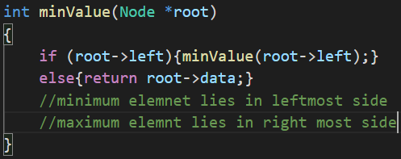

Ques 4) inorder predecssor and successor

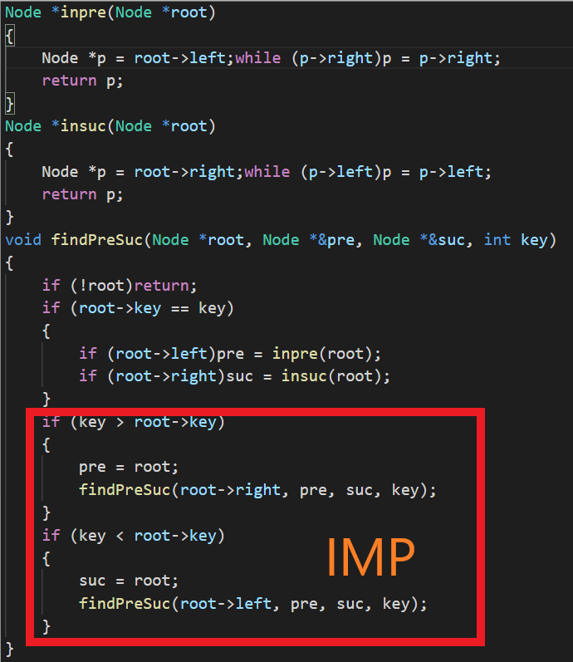

Ques 5) Check if a tree is a BST or not

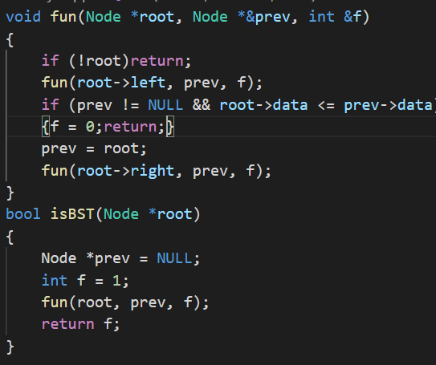

Ques 6) Populate inorder successor o0f all nodes

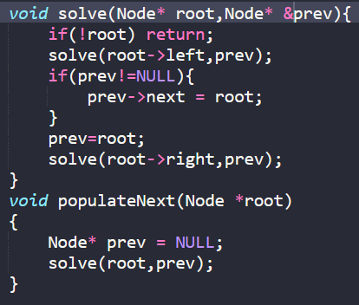

Ques 7) Find LCA of two nodes in BST

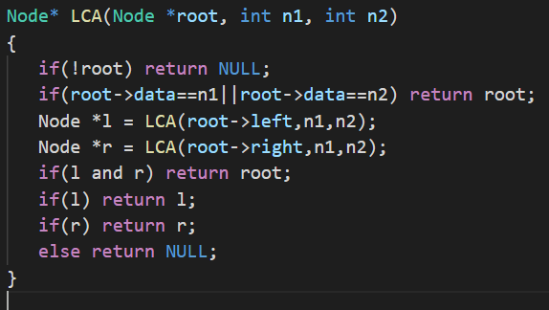

Ques 8) Construct BST from pre order traversal

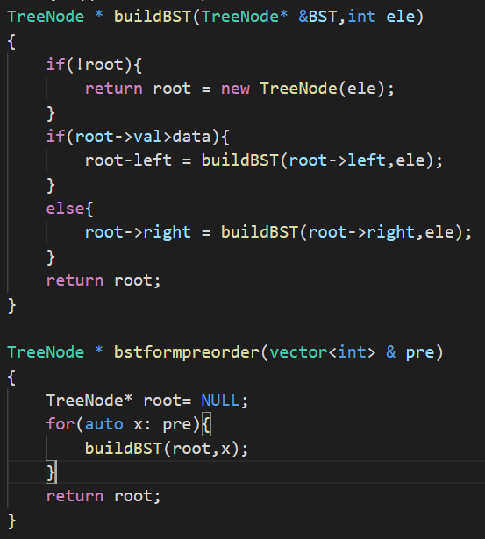

Ques 9) convert binary tree to BST

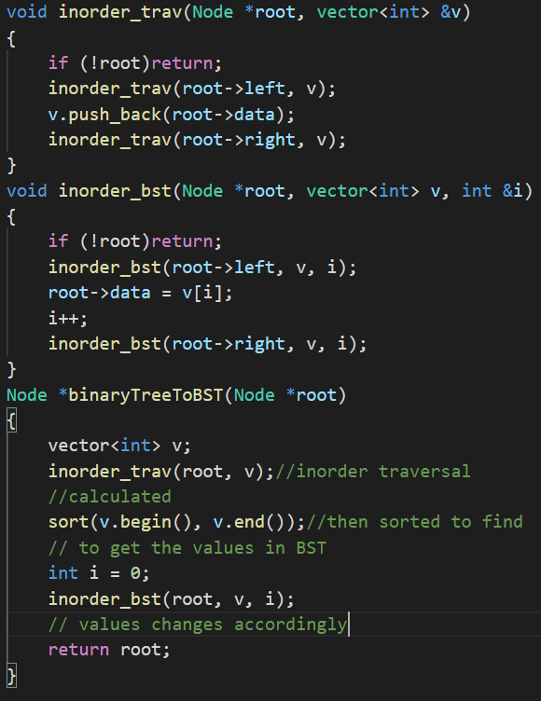

Ques 10) unbalanced BST to balanced one

A **Simple Solution** is to traverse nodes in Inorder and one by one insert into a self-balancing BST like AVL tree. Time complexity of this solution is O(n Log n) and this solution doesn’t guarantee

An **Efficient Solution** can construct balanced BST in O(n) time with minimum possible height. Below are steps.

1. Traverse given BST in inorder and store result in an array. This step takes O(n) time. Note that this array would be sorted as inorder traversal of BST always produces sorted sequence.
2. Build a balanced BST from the above created sorted array using the recursive approach discussed [here](https://www.geeksforgeeks.org/sorted-array-to-balanced-bst/). This step also takes O(n) time as we traverse every element exactly once and processing an element takes O(1) time.

Ques 11) merge two BST

Ques 12) K th largest element in a BST

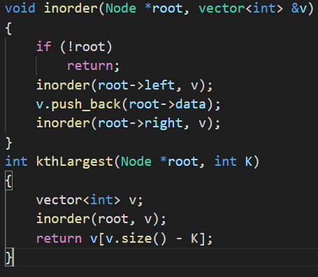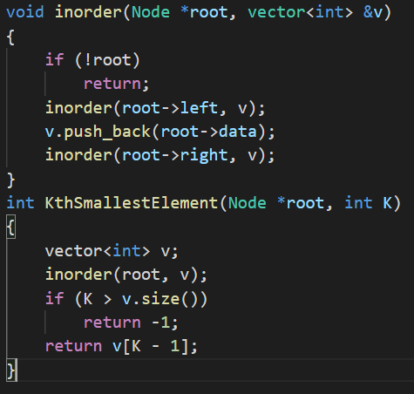

Ques 13) kth smallest element in BST

Ques 14) replace every element by next greater element

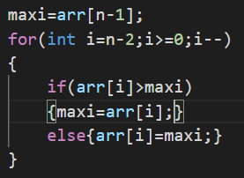

Ques 18) Array to post order traversal

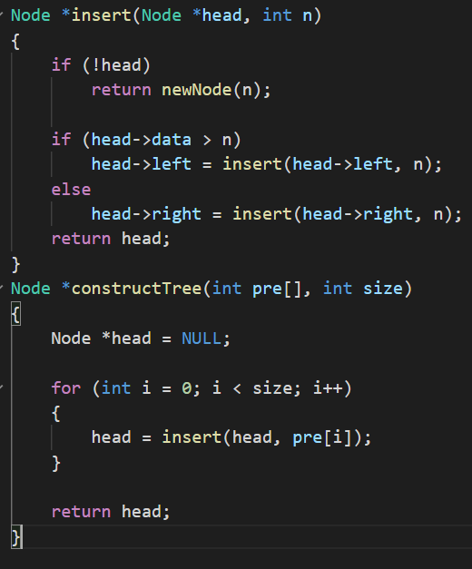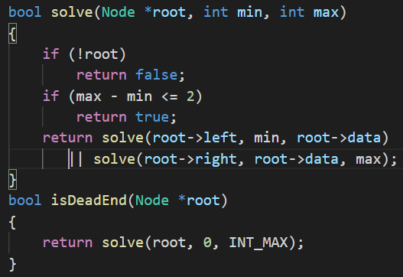

Ques 20) Dead end identification in BST

Ques 22) largest BST in a BT

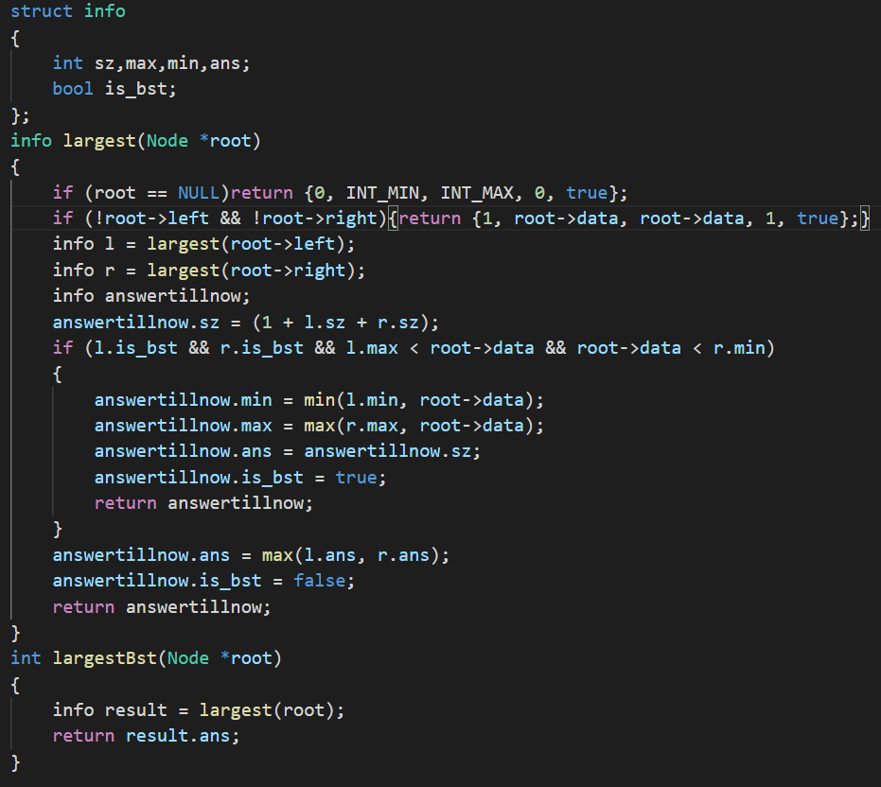

**Dynamic programming**

1. Coin change problem

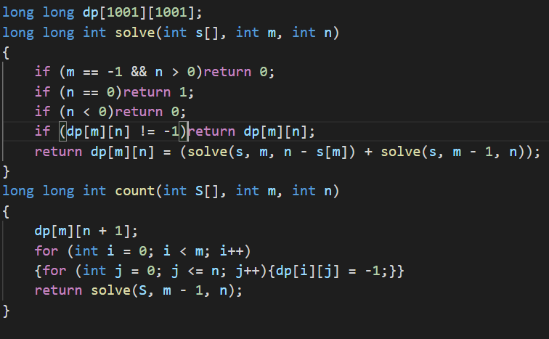

1. 0-1 knapsack problem

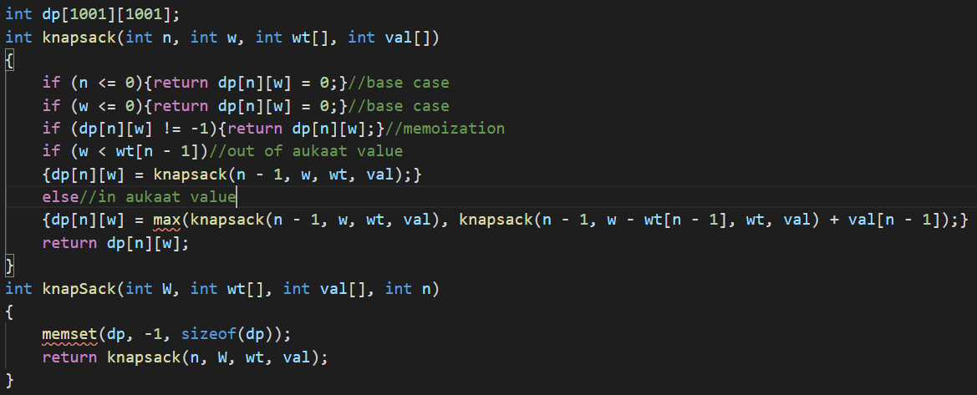

Ques 3) ncr

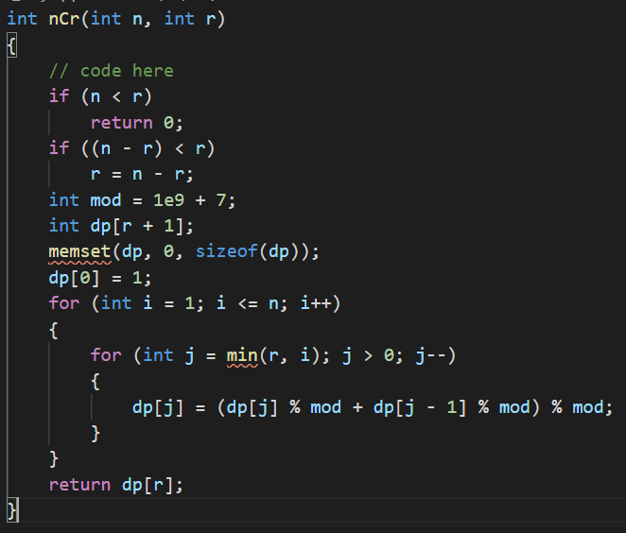

Ques 4) npr

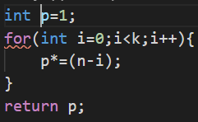

Ques 5) Catalan number

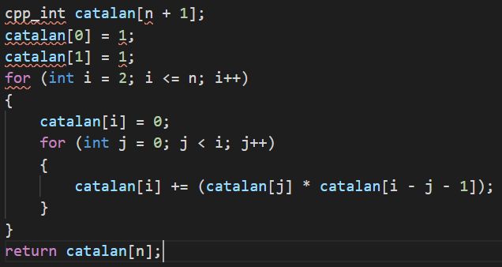

Ques 7) edit distance (insert, replace and remove)

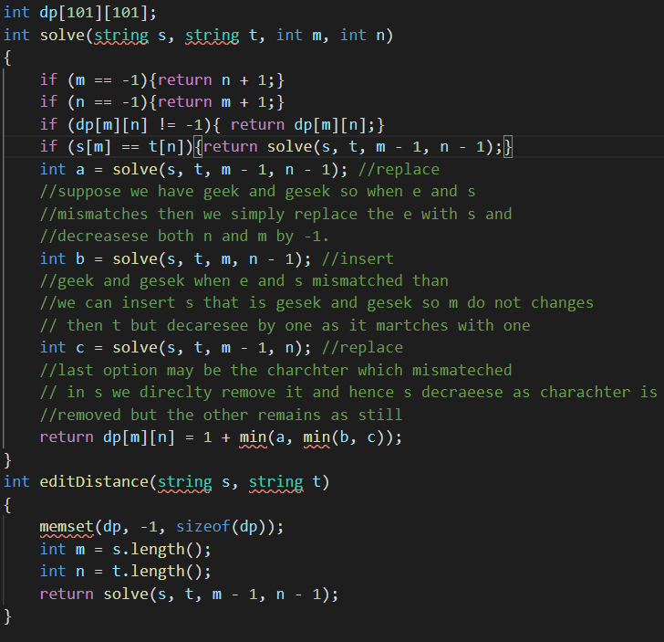

Ques 8) subset equal sum partition problem

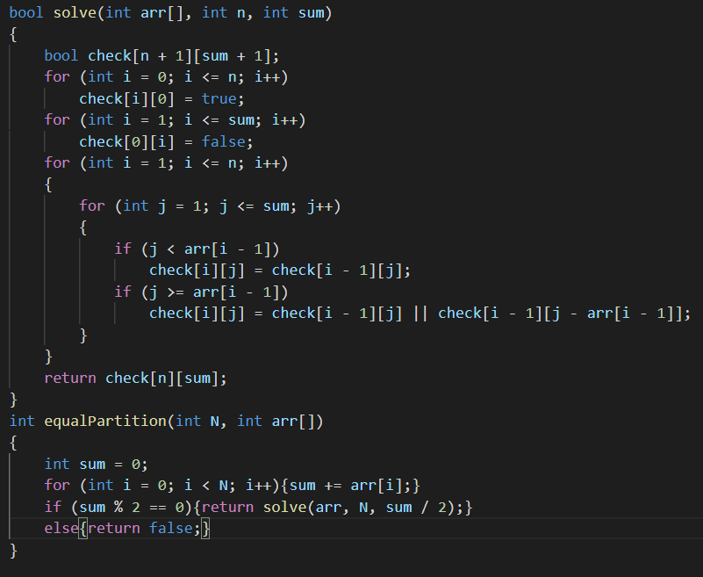

Ques 9) friends pairing problem

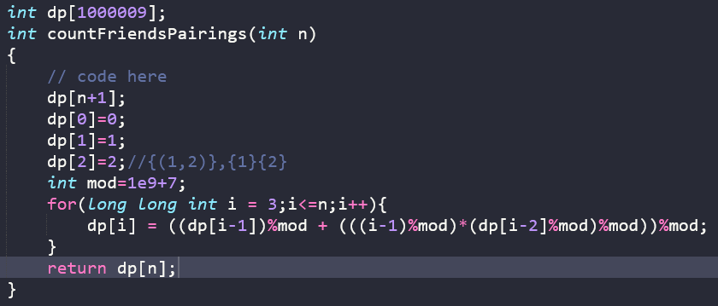

Ques 10) gold mine problem

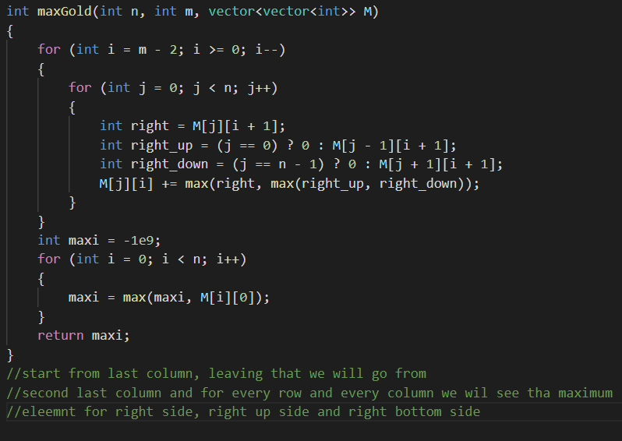

**GRAPH**

1. Print dfs of a graph

